Technology & Change: School Then vs. Now
Friday, January 22, 2016
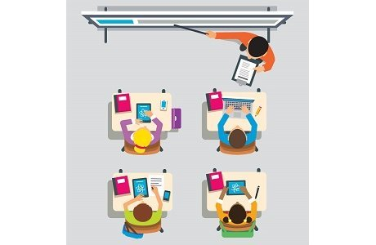
Advancements in technology have been a game changer for nearly all aspects of daily life over the past several decades. The way we look up an address, order takeout pizza, and communicate with friends, family and coworkers are just a few of the countless tasks that have been changed by computers and mobile devices. It’s no surprise that these advancements have impacted the education world. From chalk boards to smart boards and books to iPads, there have been significant changes in the classroom. Going to school is much different today than it was only 10 years ago. Think about it—Apple hadn’t even introduced the iPad at that point! So, let’s take a short trip down memory lane and highlight some of the most transformative changes in education in recent decades.
Then…
Ten years ago, classrooms were still equipped with white boards; some teachers even had old fashioned-chalkboards!
Now…
Smartboards, digital whiteboards, and other interactive screens are the norm. With just a few taps, educators can access the internet, present video content, and even save students’ written responses.
Then…
During the 1980s and 1990s, classrooms were lucky to have a single computer. Entire schools often had a single computer lab to be shared by all classes—likely filled with boxy Macintosh PCs.
Now…
More and more schools and classrooms operate as “1:1” environments where every student has their own laptop, tablet, or smartphone that is incorporated into many, if not all, classroom lessons.
Then…
Students passed notes across the aisles to oh-so-sneakily carry on the conversation with friends during class.
Now…
Students get caught with eyes oh-so-sneakily focused on their laps as they text their friends.
Then…
“Online learning” usually referred to the hour per week in the computer lab to play Oregon Trail or Frogger.
Now…
Blended learning, flipped classrooms, virtual classes, and many other innovative uses of technology are making online learning more and more common, rigorous, and effective for all students.
Technology has brought about changes in the classroom that would have been nearly unimaginable for educators and students a few decades ago. The only thing we can be certain of is that the changes will keep coming—who knows what the classroom of 2036 will look like!

