PRESS RELEASE

IIMA VS MICA Frisbee Match
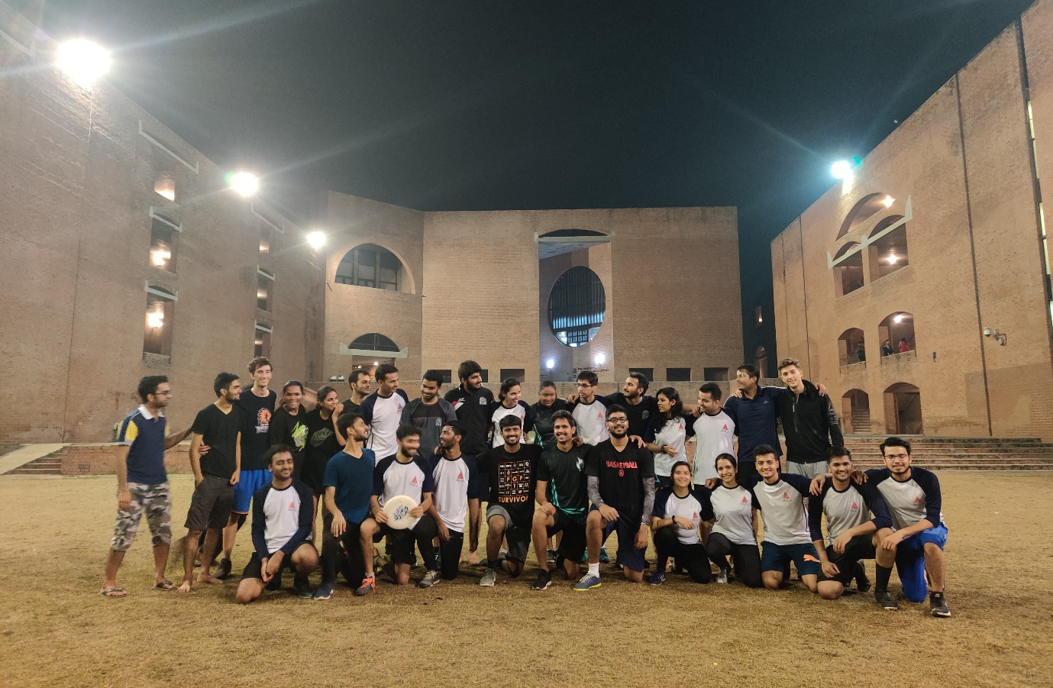
Frisbee team at IIMA

October 9, 2019 |Ahmedabad: A friendly match of Ultimate Frisbee was played between IIM Ahmedabad and MICA at the Louis Kahn Plaza in IIM Ahmedabad. The two teams had been practising for multiple upcoming tournaments. The match started with IIM Ahmedabad winning the toss, however, the first two points were scored by MICA. From then on, each teams traded points till the score was 5-5.
IIMA managed to get the lead over the next few plays, increasing the score to 7-5, before MICA retaliated with 3 straight points to close the first half at 8-7. Using long throws, MICA had been able to put a lot of pressure on IIMA’s defense in the first half.
In the second half, however, on the back of tight defense and accurate short passes, IIMA scored 7 straight points to take a lead of 14-8. MICA scored the next point before IIM Ahmedabad closed the game at 15-9. After the game, the teams assembled for the spirit circle to celebrate the spirit of the game. From IIMA, Mattia Maver, a dual degree student from Bocconi University was awarded the Most Valuable Player while captain, Srishit Minz and Sushil Kumar were awarded the Most Spirited Player award jointly. From MICA, Prerit was awarded the Most Valuable Player while Vikram was awarded the Most Spirited Player award.
-
ABOUT IIMA:
The Indian Institute of Management Ahmedabad (IIMA) was set up as an autonomous institution in 1961 by the Government of India in collaboration with the Government of Gujarat and the Indian industry. The Institute provides education, training, consulting, and conducts research in management.
The Post Graduate Diploma Programme in Advanced Business Analytics (PGP-ABA) is the newest addition to the list of long-duration management education programmes offered by IIMA. Other programmes include the Post-Graduate Programme in Management (PGP), the Post-Graduate Programme in Food and Agri-Business Management (PGP-FABM), the Post-Graduate Programme for Executives (PGPX), the Doctoral Programme in Management (Ph.D.), Programme for Faculty members of Business schools and Armed Forces and a number of Executive Education Programmes (EEP).
IIMA is the first management school in India to receive international accreditation for five years. It was the first business school in India to receive EQUIS (European Quality Improvement System) accreditation, by the European Foundation for Management Development (EFMD) in June 2008 and has maintained EQUIS accreditation since then.
In 2018, IIMA made it to the number 4 position in the Financial Times (FT) Asia Pacific Top 25 Business School Rank, ahead of all Indian B-School. FT conducted the ranking after considering the quality and breath of all the B-schools programmes. In addition, it has been ranked 19th in the Financial Times (FT) Masters in Management Rankings 2018 and 31st in the FT (Financial Times) Global MBA Ranking 2018. Over the years, the Post Graduate Programme in Food and Agri-business Management (PGP-FABM) of IIMA has been ranked number one globally in its category in the Eduniversal Best Masters’ Ranking in Agribusiness/Food Industry Management.
IIMA features at the top position in the India Ranking 2018 (National Institutional Ranking Framework) released by the Ministry of Human Resource Development (MHRD), Government of India.
For media queries, please contact:
Deepak Bhatt, Manager, Communication
Ph: (Cell) +91-9426229429, (O) +91-79-66324683, Email: mngr-comm@iima.ac.in

Mitaaly Naidu, Executive, Public Relations
Ph: (Cell) +91-7069074816, (O) +91-79-66324684, Email: pr@iima.ac.in

