

EMAIL MADE EASY

Gmail



**Objectives**

Last updated: October 2013

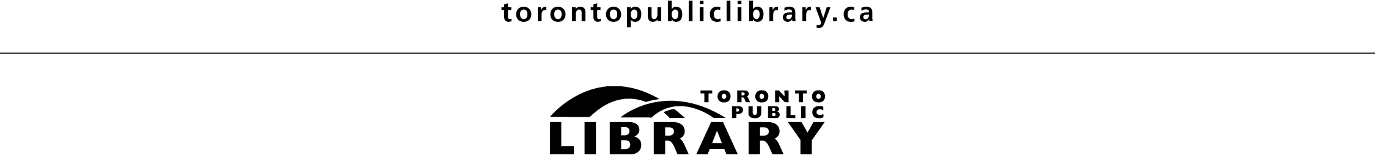

1. **Sign in to an email account**
2. **Read and reply to messages**
3. **Move messages into folders**
4. **Compose a new message**
5. **Build your contacts list**
6. **Star a message**
7. **Mark a message as unread**
8. **Use the Help section**
9. **Sign out**

**ADVANTAGES OF EMAIL**

* Fast and cheap (once you have Internet access)
* Send and receive email messages from anywhere in the world
* Organize and file your correspondence into folders
* Send one message to many people at the same time
* Attach documents or pictures to your message
* With Gmail, you get 15 gigabytes of storage space, plus built-in search functions to quickly find a message

# Gmail is a free web-based email service. There are other sites such as Yahoo Mail and Hotmail. If you have Internet access at home, you may have an email account already with your Internet Service Provider (e.g. Sympatico, Rogers).

In today’s class you will be provided with a Gmail username and password. This will allow you to log into an email account created specifically for computer classes at the library. If you wish to get your own email account, you will need to register with Gmail. You can complete the registration process at the end of the class if time allows.



**GETTING STARTED**

**gmail.com**

1. Type this address into the address bar:

2. Type your **username** and **password** into the corresponding boxes.

3. Click on **Sign in**.

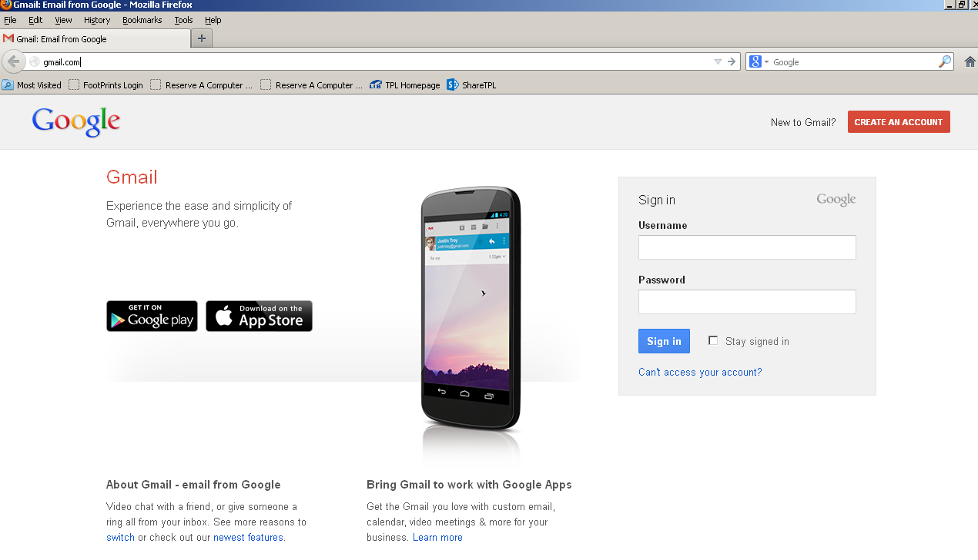

Welcome to your **Inbox**! This is the mailbox where all messages are delivered. Here you will see a list of emails you have received. The three columns indicate:

* who the message is **from**
* the **subject** line
* the **date** the message was sent

subject of email

date / time

name of sender

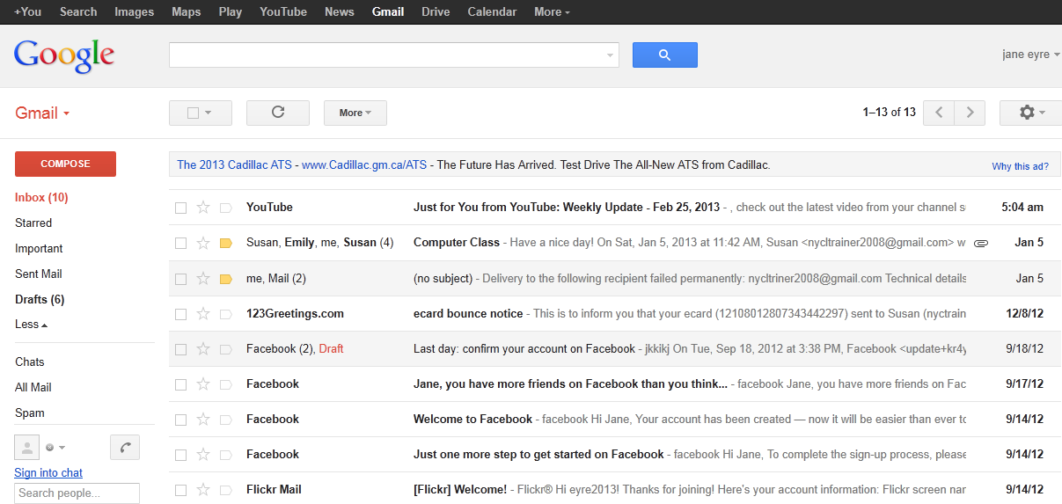

Navigate your email using the menu at the left side of the page:

* **Compose** – The Compose button is where you would click to write a new message to someone.
* **Inbox –** To return to your inbox at any time or to refresh it, simply click here or on the Google logo in the upper left corner of the page. If you see a number in brackets, it indicates the number of unread messages you have.
* **Folders** – Gmail comes with a number of default folders: Starred, Important, Sent Mail, Drafts, Chats, All Mail, Spam and Trash. You can also create your own folders (Exercise 2).

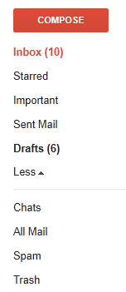

Your messages are automatically categorized into the following optional tabs, so that messages of the same type are grouped together:

|  |  |
| --- | --- |
| **Primary** | Messages from friends and family, as well as any other messages that don’t appear in other tabs. |
| **Promotions** | Deals, offers, and other promotional emails. |
| **Social** | Messages from social networks. |
| **Updates** | Notifications such as confirmations, receipts, bills and statements. |
| **Forums** | Messages from online groups, discussion boards and mailing lists. |

#### To choose which tabs to show or hide, click the **+** icon on the far right. Use the checkboxes to make your selections, then click **Save**. If you hide a tab, messages in that category will appear in your Primary tab instead.



**EXERCISE 1: Reading and Replying to Emails**

1. To open and read a message, you have to click on it. In the inbox you should see an email with the subject line **Welcome to Email Made Easy!** Click on it and read the message.
2. Once you open an email, a menu of options will be displayed above the message. If you move your cursor over each button, a text bubble will appear over it to tell you its function. We will learn more about these buttons throughout the class.



1. Click on **Reply** in thebox below the email.

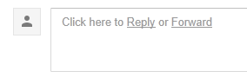

1. A compose message window will open, and the flashing cursor indicates you can start typing your reply. Write a short message to the instructor.

Notice that the original email is beneath what you are typing. You have the option of deleting it, but you may find it useful for keeping track of the email conversation.

The “**Re:**” at the beginning of the subject line indicates that this is a reply.

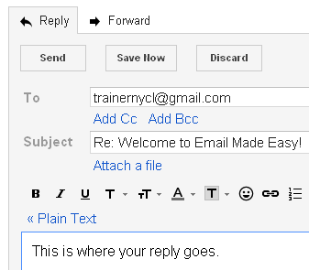

1. When replying to messages other people have sent you, there is no need to type in their email address because it automatically appears in the **To** box. When you are done writing, simply click the **Send** button.

**TIP:** If more than one person received the original message, you can reply to everyone in the email conversation at the same time by clicking on **Reply to all**.



Remember, replying to all means you are responding to everybody who received the original message, not just the sender!

**EXERCISE 2: Labelling Emails**

1. In the inbox you should see an email with the subject line **Using Labels**. Click on it and read the message.

3. A box will appear in the centre of the screen. Think of a label name (e.g. Library, Practice) and type it in the box below where it says **Please enter a new label name**. Then click **Create**.

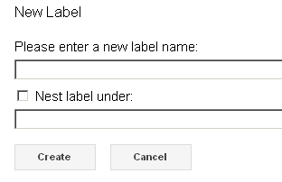

2. Click on the **Move to** button (a file folder icon), then on **Create new**.

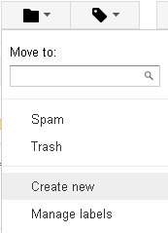





1. A

1. Your new label should appear on the menu at the left side of the page. It works like a folder: when you click on it to look inside, it should contain the message you just moved.
2. You can move/label more than one message at the same time. Click on **Inbox** to return to your mailbox. Select messages by clicking inside the checkbox to the left of the sender’s name, then click the **Move to** buttonto move multiple emails in a batch.

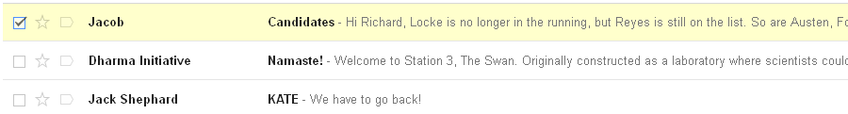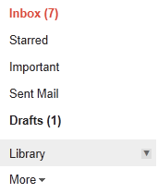

6. You can also use the **Labels** button to apply labels to your messages. After you open an email, click on the Labels button, then choose a previously created label (e.g. Library) or create a new one. You can apply more than one label to a single email.

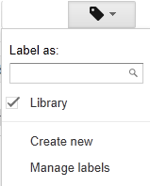

**TIP:** If you move your cursor over the label name on the menu at the left side of the page and click on the arrow that appears, you will see a drop-down menu where you can edit your label. You can also add different colours to your labels.

**EXERCISE 3: Sending New Emails**

With regular post, you must know someone’s address in order to send them mail. It is the same with email: you have to know their email address before you can send them messages. Take the slip of paper with the Gmail username you were provided with at the beginning of the class and exchange it with a fellow classmate. You now have your neighbour’s email address!

1. Click on the **Compose** button to send a new email.



1. In the **To** box, type the email address of the person to whom you are sending your message. If you don’t have a partner for this exercise, you can also send an email to the instructor. The instructor’s email address is:

**trainernycl@gmail.com**

1. **Cc** stands for **Carbon Copy**. You can address an email to one person in the **To** field, and send a copy of the email to another person. Simply click on **Cc** and type a second email address in the box that appears. You can copy more than one person on an email.   
     
     
   **Bcc** stands for **Blind Carbon Copy**. When you click on **Bcc** and type email addresses in the box, they are invisible to other recipients. No one else copied on the email will see that others received the same message.

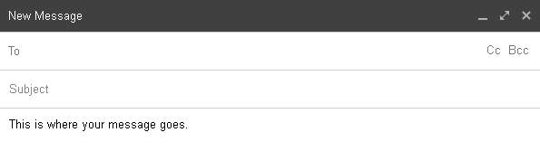

1. In the **Subject** box, give your message a subject line. It can be as simple as “Hello!”
2. Type your message. If you want to change the way the text looks, click the formatting icon next to the Send button at the bottom of the compose window.

**TIP:** Hover over the **+** icon to add website links, emoticons and more to your message.



Change the size of highlighted text.  
  
 Make highlighted text bold, italicized or underlined.



Change the colour of highlighted text, or add coloured highlighting to the selected text.   
  
 Change the alignment of the highlighted text. Choose from flush-left,   
 centered, or flush-right.



Create bulleted or numbered lists.



Move text to the left or right. Place the cursor where you would like to move the text, then click these buttons to increase or decrease the indent.



Create a block quote.



Remove formatting from selected text.



6. When you finish writing your message, click **Send**. A copy of your email will be saved to your **Sent** folder. Click on **Inbox** to refresh it and see if your fellow classmate has sent you a message yet!

**EXERCISE 4: Building Your Contact List**

1. Click on Gmail (beneath the Google logo in the upper left corner of the page) and then on **Contacts**. This is your email address book where you can save people’s email addresses.
2. Click on the **New Contact** button.



1. Type a person’s name in the **Add name** box.

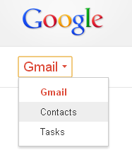

4. Type the person’s email address in the corresponding field. You can add other information such as the person’s phone number or birthday, but it is not necessary.

5. Click on **Save now**.

**TIP:** You can add contacts to a mailing list with the **Groups** feature.   
This way, you can send emails to a group of people at the same time, without having to type out the individual email addresses of each group member.

After you add someone to your contacts, click on the **Groups** button. Click on **Create new** and type in a name for the group (e.g. Family, Work), then click OK. The group will now appear on the list at the left side of the page. Now when you are sending an email to a group of people, you can just type the name of the group in the **To** field!



**EXERCISE 5: Starring a Message**

1. Click on the Google logo in the upper left corner of the page to return to your **Inbox**. Look at your messages. Do you see the star icons to the left of the senders’ names? They are used to mark important messages. Choose an email or two and click on their stars.



To remove a star, simply click on it again.

2. If you want to see all your starred messages, click on **Starred** on the menu at the left side of the page.

3. You can also star messages after they are opened by clicking the star to the right of the date.

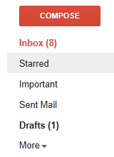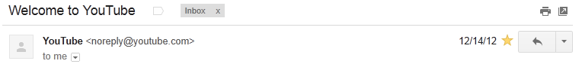

**EXERCISE 6: Marking a Message as Unread**

1. Return to your **Inbox**. Unread messages are displayed in **bold**. When you open a message, it will no longer show up **bold** in your Inbox. Choose any message and click on it.

2. If you click on the **More** button above the message and then on **Mark as unread**, it will appear in **bold** again when you return to your inbox. This is useful if you want to remember to read the message again or forward it later.

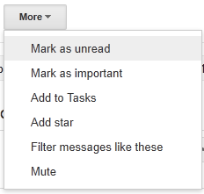

3. You can also mark multiple messages as unread using the checkboxes. Select emails in your inbox by clicking inside the checkbox to the left of the name of the sender, then click on **More** and **Mark as unread**.

# **EXERCISE 7: Using Help**

# 

1. To access Gmail Help, click on the gear/wheel icon in the upper right corner of the page. When the drop-down menu appears, click on **Help**.
2. Search for a help topic by typing keywords in the **Search Help** box. Then press the **Enter** key on your keyboard OR click the magnifying glass.
3. You can also click on **Help Center** to open a new tab in your browser. Find out about more Gmail features by clicking on the different categories.

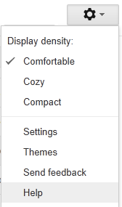

**OTHER EMAIL FEATURES**

**Archiving a Message**

Tidy up your Inbox by storing your emails in **All Mail**. After you open and read an email, simply click on the Archive button. To find all your archived messages, click on **More** and then All Mail on the menu at the left side of the page.



**Attaching a File**

To attach something to an email you are writing, such as a photo or a Word document, click on the paper clip icon at the bottom of the compose window. Select a file to upload and click **Open**.

**TIP:** If you see a paper clip icon in an email you receive, it has an attachment.



If you receive an email with an attachment, click on **View** to see the attached file in a separate tab, or click **Download** to save it to your computer or removable USB flash drive.

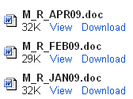

**Chat**

Gmail has a live instant messaging feature, located below the folders on the menu at the left side of the page.

Click on **Sign into chat** to chat with any of your contacts who are online at the same time. When the person is online and available, a green dot appears next to their name. Click on their name to send them an instant message. Chats are automatically saved in the **Chats** folder on the left menu.

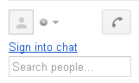

**Deleting a Message**

Gmail has 15 GB of free storage space for your emails, but you have the option of deleting your messages. Just click on the **Delete** button.



You can also delete multiple messages from your Inbox by using the checkboxes, similar to moving messages in Exercise 2. Deleted messages are routed to the **Trash** folder and permanently deleted by Gmail after 30 days.

**TIP:** If you receive unsolicited junk mail, you can mark the messages as Spam by clicking on the **Spam** button.



Periodically check your Spam folder to make sure that messages are not identified as spam by mistake.

If you receive an email that you would like to pass on to someone else, you can click on **Forward** in the box below the message.

Just like when you reply to an email, a compose message window opens with the original email in the body of the message.

**Forwarding a Message**



In the **To** box, enter the email addresses of anyone to whom you want to forward the message. Add any additional message you would like to include above the original text, then click **Send**.

**Saving a Draft**

As you are typing a message, Gmail automatically saves it for it so you don’t have to worry about losing it. The message will go into your **Drafts** folder (on the menu at the left side of the page) where you can continue working on it later. You can pick up where you left off and send it when you are ready.

REMINDER: Always log out of your email account when using a public computer. Click on the name or email address in the upper right corner of the page. Then click on **Sign Out**.

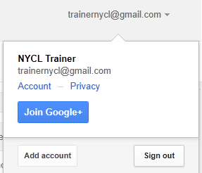

**GMAIL REGISTRATION**

You can register for a free Gmail account.

1. Type **gmail.com** into the address bar if you are not already on the **Sign in** page.
2. Click on the **Create an account** button in the upper right corner.



1. Fill out the registration form. The **username** is the start of your email address. If someone else has taken the name you want, try adding another word or number to make it unique, or choose one of Gmail’s alternate suggestions.

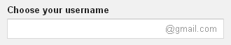

1. The **password** must be at least eight characters. You can use letters, numbers or other characters.

5. You can skip the mobile phone and current email address fields because they are optional.

6. Where it says **“Type the two pieces of text,”** you must enter the words or numbers exactly as they appear above the box. This word verification challenge is a security feature so the characters are distorted on purpose. If you have difficulty reading the text, you can get a new text challenge or an audio one.

7. Check the first box to agree with Google’s Terms of Service. Uncheck the second box to prevent Google from using your account information to personalize ad content.

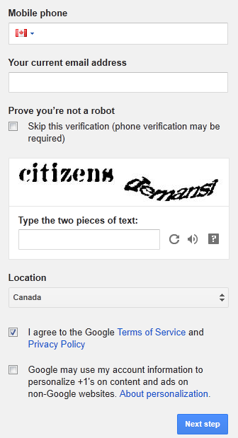

8. Click **Next step** to complete the registration.

Congratulations – you have successfully created an email account! Click **Continue to Gmail** to proceed.

**Emoticons and Acronyms**

* Emoticons personalize your messages by adding the idea of an emotion. Here are a few “facial expressions” you can create using characters from your keyboard:

:) or :-) :( or :-( :o or :-o

Happy Sad Surprised

;) or ;-) :D or :-D :-I

Winking Laughing Indifferent

:-P or :p >:c or >:-< :$

Sticking out tongue Angry Embarrassed

* Acronyms are often used as typing shortcuts in informal communication. Here are a few popular ones:

BFN = bye for now

BRB = be right back

BTW = by the way

FYI = for your information

HTH = hope this helps

IMO = in my opinion

J/K = just kidding

LOL = laughing out loud

OTOH = on the other hand

TIA = thanks in advance

TTYL = talk to you later

**Tell us what you thought of this workshop: tpl.ca/trainingsurvey**

Thank you for attending!