Paytm
CEO: Vijay Shekhar Sharma
- Paytm is an Indian e-commerce website headquartered in Noida, India.
- It was launched in 2010 and adds to the industry of FinTech in India.
- The firm started by offering mobile recharging, adding bill payment and e-commerce, with products similar to businesses such as Flipkart, Amazon.com, Snapdeal.
- In 2015, it further added booking bus travel.
- Paytm also launched movie ticket booking by partnering with Cinépolis in the year 2016

PAYMENTS BANK
- In 2015 Paytm received a license from Reserve Bank of India for starting India's first payments bank.

- Paytm is also approved as an operating unit for Bharat Bill Payment System, as a result of which users can pay their bills anytime and anywhere.[

How To Use Paytm App All Step By Step Guide
1. First visit www.Paytm.com / Download Paytm App
2. If you have Smartphone then download Paytm app for better experience
3. Install & Open Paytm app
4. Register or login
5. You can register with your any email address
6. After successfully register make login to Paytm
7. To use Paytm features you have to add some Paytm wallet Money
8. Use any given payment method to add money in wallet
1) Debit card
2) Credit card
3) Net banking
4) ATM
5) IMPS
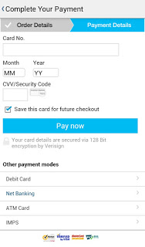

How To Add Money In Paytm Wallet All Steps
1. Open Paytm app or site
2. Login on Paytm
3. Click on wallet (wallet icon)
5. Enter amount which you want to add

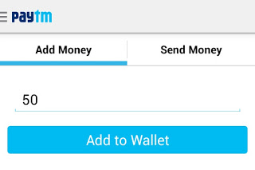
6. Click “Add to wallet” option
7. Apply promo code if you have any in promotional/voucher field
Note – You can see All Paytm Promo Code Using Above Given Paytm Promo Code Link
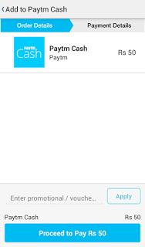
8. If you have not promo code then leave field blank and click on “Proceed to pay Rs.”
Checkout – Mobikwik Working Promo Codes 100% Cashback Offers
9. Choose suitable method to pay amount, complete payment process
10. your amount will be credited instantly in your Paytm wallet.

Steps To Use Paytm Wallet Cash : How To Use Paytm Promo Code

1. You can use Paytm for below listed transaction
– Recharge mobile phones
– Data cards Recharge
– Dth Recharge
– Electricity bill payment
– Landline/broadband bill payment
– Gas bill payment
– Postpaid mobile bill payment
– Book bus tickets
– Online shopping from 5000+ products
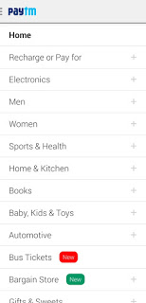

2. Select any one to make online transaction through Paytm
~ You want to make recharge on your mobile no. then make click on recharge option in side Paytm site / app fill all details about your recharge. Proceed to pay using your Paytm wallet online, your recharge will be done instantly.

How To Send Money From Paytm
1. Open your Paytm app & login
2. Click on “Wallet” & select option “Send Money” (First option on top at App)
3. Choose “Mobile” or “Bank Account”
For Mobile
- Enter mobile number (enter the number of receiver)
- Fill the amount, type some thing about your transaction (normally type send money)
- Click on “Send Money” & proceed to pay
For Bank Account
- Write Bank account holder name
- Account number
- Type amount (How much you need to transfer)
- type some thing about your transaction (normally type send money)
- Click on “Send Money” & proceed to pay

