A-level Biology (7401/7402)  Year 12 End of Topic Test  Topic 1 – Biological Molecules | Name:  Class:

Author:
Date:
Time: | 50 minutes
Marks: | 45
Comments:

Qs | Marks | Targets
1 | /7
2 | /15
3 | /10
4 | /6
5 | /7
Total | /45
Q1. The equation shows the breakdown of lactose by the enzyme lactase.
Lactose + water galactose + monosaccharide X
(a) (i) Name the type of reaction catalysed by the enzyme lactase.
.............................................................................................................
(1)
(ii) Name monosaccharide X.
.............................................................................................................
(1)
(b) (i) Describe how you would use a biochemical test to show that a reducing sugar is present.
.............................................................................................................
.............................................................................................................
.............................................................................................................
.............................................................................................................
.............................................................................................................
(2)
(ii) Lactose, galactose and monosaccharide X are all reducing sugars.
After the lactose has been broken down there is a higher concentration of reducing sugar. Explain why.
.............................................................................................................
(1)
(c) A high concentration of galactose slows down the breakdown of lactose by lactase.
Use your knowledge of competitive inhibition to suggest why.
......................................................................................................................
......................................................................................................................
......................................................................................................................
......................................................................................................................
......................................................................................................................
(2)

(Total 7 marks)

Q2. Read the following passage.
Straw consists of three main organic substances – cellulose, hemicellulose and lignin.
Cellulose molecules form chains which pack together into fibres. Hemicellulose is a small
molecule formed mainly from five-carbon (pentose) sugar monomers. It acts as a cement
holding cellulose fibres together. Like hemicellulose, lignin is a polymer, but it is not a
5 carbohydrate. It covers the cellulose in the cell wall and supplies additional strength. In
addition to these three substances, there are small amounts of other biologically important
polymers present.
The other main component of straw is water. Water content is variable but may be determined
by heating a known mass of straw at between 80 and 90°C until it reaches a constant mass.
10 The loss in mass is the water content.
Since straw is plentiful, it is possible that it could be used for the production of a range of
organic substances. The first step is the conversion of cellulose to glucose. It has been
suggested that an enzyme could be used for this process. There is a difficulty here, however.
The lignin which covers the cellulose protects the cellulose from enzyme attack.
Use information from the passage and your own knowledge to answer the following questions.
(a) (i) Give one way in which the structure of a hemicellulose molecule is similar to the structure of a cellulose molecule.
.............................................................................................................
.............................................................................................................
(1)
(ii) Complete the table to show two ways in which the structure of a hemicellulose molecule differs from the structure of a cellulose molecule.

 | Hemicellulose | Cellulose
 | ..........................................................  .......................................................... | ..........................................................  ..........................................................
 | ..........................................................  .......................................................... | ..........................................................  ..........................................................

(2)
(b) Name one biologically important polymer, other than those mentioned in the passage, which would be found in straw.
......................................................................................................................
(1)

(c) Explain why the following steps were necessary in finding the water content of straw:
(i) heating the straw until it reaches constant mass (line 9);
.............................................................................................................
.............................................................................................................
..............................................................................................
(1)
(ii) not heating the straw above 90°C (line 9).
.............................................................................................................
.............................................................................................................
.............................................................................................................
.............................................................................................................
(2)
(d) A covering of lignin protects cellulose from enzyme attack (line 14). Use your knowledge of the way in which enzymes work to explain why cellulose-digesting enzymes do not digest lignin.
......................................................................................................................
......................................................................................................................
......................................................................................................................
......................................................................................................................
(2)
(e) Describe the structure of a cellulose molecule and explain how cellulose is adapted for its function in cells.
......................................................................................................................
......................................................................................................................
......................................................................................................................
......................................................................................................................
......................................................................................................................
......................................................................................................................
......................................................................................................................
......................................................................................................................
......................................................................................................................
......................................................................................................................
......................................................................................................................
......................................................................................................................
......................................................................................................................
......................................................................................................................
(6)
(Total 15 marks)
Q3.Omega-3 fatty acids are found in cows’ milk. Scientists investigated changes in the concentration of omega-3 fatty acids in milk when cows were moved from eating grass in fields to eating corn in cattle sheds. The following figure shows the results of one investigation.
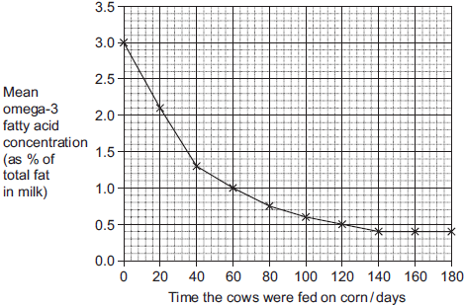
(a) The concentration of omega-3 fatty acids in milk changed when cows were fed on corn instead of grass. Describe how.
........................................................................................................................
........................................................................................................................
........................................................................................................................
........................................................................................................................
(2)

(b) (i) Calculate the rate of decrease in the mean omega-3 fatty acid concentration between 0 and 40 days.
Show your working.

Answer.......................................................% per day
(2)
(ii) The omega-3 fatty acid concentration is expressed as a percentage of total fat.
Explain the advantage of this.
...............................................................................................................
...............................................................................................................
...............................................................................................................
...............................................................................................................
(2)
(iii) One farmer concluded from the graph that feeding cows on corn reduces the omega-3 fatty acid content in milk. Evaluate this conclusion.
...............................................................................................................
...............................................................................................................
...............................................................................................................
...............................................................................................................
...............................................................................................................
...............................................................................................................
...............................................................................................................
...............................................................................................................
Extra space ...........................................................................................
...............................................................................................................
...............................................................................................................
...............................................................................................................
(4)

(Total 10 marks)

Q4.The enzyme tyrosine kinase (TK) is found in human cells. TK can exist in a non-functional and a functional form. The functional form of TK is only produced when a phosphate group is added to TK.
This is shown in Figure 1.
Figure 1
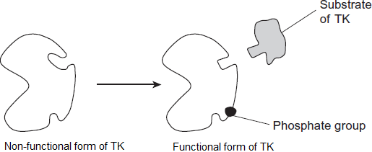
(a) Addition of a phosphate group to the non-functional form of TK leads to production of the functional form of TK.
Explain how.
........................................................................................................................
........................................................................................................................
........................................................................................................................
........................................................................................................................
........................................................................................................................
(2)
(b) The binding of the functional form of TK to its substrate leads to cell division. Chronic myeloid leukaemia is a cancer caused by a faulty form of TK. Cancer involves uncontrolled cell division.
Figure 2 shows the faulty form of TK.
Figure 2
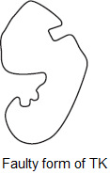
Suggest how faulty TK leads to chronic myeloid leukaemia.
........................................................................................................................
........................................................................................................................
........................................................................................................................
........................................................................................................................
........................................................................................................................
(2)
(c) Imatinib is a drug used to treat chronic myeloid leukaemia. Figure 3 shows how imatinib inhibits faulty TK.
Figure 3
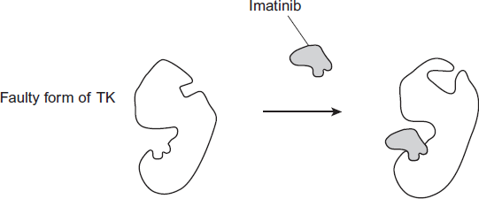

Using all of the information, describe how imatinib stops the development of chronic myeloid leukaemia.
........................................................................................................................
........................................................................................................................
........................................................................................................................
........................................................................................................................
........................................................................................................................
(2)
(Total 6 marks)
Q5. (a) Explain why the replication of DNA is described as semi-conservative.
......................................................................................................................
......................................................................................................................
......................................................................................................................
......................................................................................................................
(2)
(b) Bacteria require a source of nitrogen to make the bases needed for DNA replication. In an investigation of DNA replication some bacteria were grown for many cell divisions in a medium containing ¹⁴N, a light form of nitrogen. Others were grown in a medium containing ¹⁵N, a heavy form of nitrogen. Some of the bacteria grown in a ¹⁵N medium were then transferred to a ¹⁴N medium and left to divide once.
DNA was isolated from the bacteria and centrifuged.
The DNA samples formed bands at different levels, as shown in the diagram.
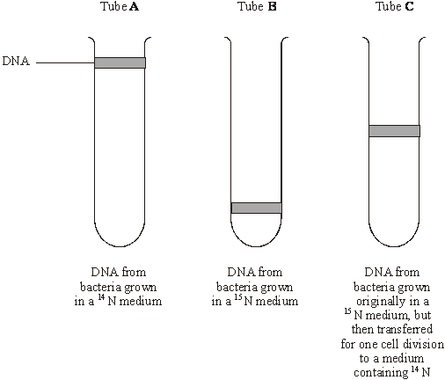
(i) What do tubes A and B show about the density of the DNA formed using the two different forms of nitrogen?
.............................................................................................................
.............................................................................................................
(1)
(ii) Explain the position of the band in tube C.
.............................................................................................................
.............................................................................................................
.............................................................................................................
.............................................................................................................
(2)

(c) In a further investigation, the DNA of the bacterium was isolated and separated into single strands. The percentage of each nitrogenous base in each strand was found. The table shows some of the results.

 | Percentage of base present
DNA sample | Adenine | Cytosine | Guanine | Thymine
Strand 1 | 26 |  | 28 | 14
Strand 2 | 14

Use your knowledge of base pairing to complete the table.
(2)
(Total 7 marks)

Markscheme

M1. (a) (i) Hydrolysis;
Accept phonetic spelling.
Ignore reaction.
1
(ii) (Alpha) glucose;
Accept α glucose.
Reject β glucose / beta glucose
1
(b) (i) Add Benedict’s (reagent) and heat / warm;
Red / orange / yellow / green (colour);
Reject Add HCl
Accept brown, reject other colours
2
(ii) 2 products / 2 sugars produced;
Look for idea of two
Accept named monosaccharides produced.
“More” insufficient for mark
Neutral if incorrect products named
Neutral “lactose is a polysaccharide”
Neutral “lactose is not a reducing sugar”
Neutral: Reference to surface area.
1
(c) 1. Galactose is a similar shape / structure to lactose / both complementary;
Q Reject: Same shape / structure
2. (Inhibitor / Galactose) fits into / enters / binds with active site (of enzyme);
Accept blocks active site
3. Prevents / less substrate fitting into / binding with (active site) / fewer or no E-S complexes;
Look for principles:
1. Shape
2. Binding to active site
3. Consequence
2 max

[7]

M2. (a) (i) both are polymers / polysaccharides / built up from many sugar units / both contain glycosidic bonds / contain (C)arbon, (H)ydrogen and (O)xygen;
1
(ii) hemicellulose shorter / smaller than cellulose / fewer carbons;
hemicellulose from pentose / five-carbon sugars and cellulose from
hexose / glucose / six-carbon sugars;
(only credit answers which compare like with like.)
2
(b) protein / nucleic acid / enzyme / RNA / DNA / starch / amylose / amylopectin polypeptide;
1
(c) (i) to make sure that all the water has been lost;
1
(ii) only water given off below 90 °C;
(above 90°C) other substances straw burnt / oxidised / broken down; and lost as gas / produce loss in mass;
2
(d) enzymes are specific;
shape of lignin molecules will not fit active site (of enzyme);
OR
shape of active site (of enzyme);
will not fit molecule;
2 max
(e) 1. made from β-glucose;
2. joined by condensation / removing molecule of water / glycosidic bond;
3. 1 : 4 link specified or described;
4. “flipping over” of alternate molecules;
5. hydrogen bonds linking chains / long straight chains;
6. cellulose makes cell walls strong / cellulose fibres are strong;
7. can resist turgor pressure / osmotic pressure / pulling forces;
8. bond difficult to break;
9. resists digestion / action of microorganisms / enzymes;
(allow maximum of 4 marks for structural features)
6 max
[15]

M3.(a) (Omega-3 concentration) falls more rapidly at first;
Levels out at 140 days / concentration of 0.4%;
2
(b) (i) Two marks for correct answer of 0.04 or 0.043;;
One mark for incorrect answer which clearly identifies total fall of 1.7;
2
(ii) To take into account variation in fat content of milk / fat content varies from cow to cow;
Allows comparison;
2
(iii) The graph shows a decrease with time feeding on corn;
No control group;
Might have fallen anyway / might decrease with time rather than with time spend feeding on corn;
Other factors / other named factor might also have changed;
Only one investigation so might not be representative;
4 max
[10]
M4.(a) 1. (Phosphate) changes shape of TK / changes shape of enzyme /
changes the active site;
It = phosphate
Accept ‘alters’ for changes
Reject that phosphate is an inhibitor
Accept adding energy / affecting charged / affects polar groups (on amino acids)
2. Active site forms / becomes the right shape / can bind to substrate / complementary to substrate / E-S complex can form;
Reject similar / same shape as substrate
2
(b) 1. Faulty TK has functional active site without phosphate;
Accept ‘works without phosphate’
2. (So, faulty) TK functional all the time / TK not controlled (by phosphate);
2
(c) 1. Non-competitive inhibitor / binds to site other than active site;
Accept allosteric site
Do not accept ‘changes shape’ unqualified
2. Causes TK to be in non-functional form / active site not formed / wrong shape / E-S complex not formed;
3. So, (uncontrolled) cell division stopped / slowed / controlled;
2 max
[6]

M5. (a) each strand copied / acts as a template;
(daughter) DNA one new strand and one original / parent strand;
2
(b) (i) ¹⁵N / tube B (DNA), more / greater density;
(reject heavier)
1
(ii) DNA with one heavy and one light strand;
new / synthesised strand, made with ¹⁴N / light strand;
2
(c) 32;
28 32 26;
2
[7]

E1. (a) (i) Most candidates correctly named the type of reaction as hydrolysis.
(ii) Most candidates correctly named glucose.
(b) (i) Most candidates gained full marks for describing the test for reducing sugars accurately. Some did not mention the need for heat, and a few could not recall the correct test – the biuret test being the most common error. A few candidates lost credit because they described the non-reducing sugar test and hydrolysed with hydrochloric acid first.
(ii) The majority of the candidates could explain the idea that one molecule of lactose was being hydrolysed to give two molecules of product, both of which were reducing sugars. The commonest reason for missing the mark was when students paraphrased the stem of the question, stating that the reason there was a higher concentration of reducing sugar was because there was more reducing sugar present. A surprising number of candidates gave answers relating to an increase in surface area.
(c) Although many candidates gained full marks on this question there was a significant number who were confused about the position of the active site, placing it on the sugar rather than the enzyme. A number of candidates thought that galactose would bind to lactose rather than lactase.
E2. (a) (i) Answers to parts of this question were not infrequently marred by lack of knowledge of the basic structure of cellulose as a polymer of β-glucose. Thus, although all that was required here was to note that both molecules were polymers, many disqualified their answers by referring to cellulose as also being a pentose.
(ii) Limited question technique frequently restricted the credit available. Many candidates concentrated on functional rather than structural differences. As a consequence, the answer boxes were often so full that they rarely compared like with like and offered a valid comparison. Among the better, more focused, answers were some which unfortunately were a little too concise, referring to hemicellulose as a pentose and cellulose as a hexose. Questions requiring structural similarities are likely to remain a feature of BYA1. Candidates clearly need an effective strategy for answering them.
(b) Starch and protein were correctly identified by many, but a range of incorrect responses included glycogen, phospholipid and various monosaccharides.
(c) (i) Answers suggested that, although candidates were clearly familiar with the term “constant mass”, they were by no means all conversant with the idea that it represented the point at which all water had been lost.
(ii) There were many correct answers. Answers to this second part, such as “Going over 90 °C would start to boil the water so that we would be unable to calculate the water content” were frequent and suggested that candidates had failed to focus on the information provided in the second paragraph of the passage. The better candidates at whom this question was directed were generally able to point out, however, that high temperatures might lead to other substances being broken down and a consequent loss in mass.

(d) Although most candidates were aware of the specific nature of enzyme action, they experienced varying degrees of difficulty in relating the general concepts involved to the context of this question. Those candidates who gained least credit were inclined to reword the question and offer an explanation in terms of the lignin covering. Others offered responses centred around lignin acting as an enzyme inhibitor. Better candidates clearly understood the concepts of molecular shape and fit and were able to apply them to this situation.
(e) Answers to this part of the question ranged from those of the more able candidates who wrote clearly and logically about cellulose structure and function, often with a pleasing level of accuracy and detail, to those which did not gain credit. Among the latter were many who failed to attempt this part of the question and others who confused cellulose with other molecular components of plant cells such as starch and plasma membranes. There was much confusion between hydrogen bonds and glycosidic bonds, and between α-glucose and β-pleated sheets.
Other incorrect assertions which frequently arose were that cellulose is formed from alternating α- and β-glucose residues, and that it contains both 1-4 and 1-6 linkages. Many candidates correctly identified strength as one of the molecule’s properties and went further in discussing the importance of this in withstanding pressures resulting from osmosis. A frequent error, however, was to assign the function of energy storage to cellulose.

E3.(a) Many centres gave credit to descriptions which only indicated that the omega-3 concentration fell but made no reference to the rapidity of fall. Similarly credit was given to any answer which stated that the concentration reached 0.4% at 140 days, even if there was no mention of the concentration levelling out.
(b) (i) The calculation was carried out correctly by many, and two marks were scored. A large number gained one mark for correctly identifying a fall of 1.7.
(ii) It was rare to see more than one mark awarded. This was almost universally for the idea of being able to make comparisons between the cattle or milk. Often any reference to a comparison was awarded credit.
(iii) A large majority of candidates recognised that the graph showed the omega-3 concentration decreasing with time. A variety of suggestions was offered to account for the decrease, but few suggested that the concentration might have fallen anyway.

E4.This was a question where many students failed to use the information given, or were let down by poor expression of ideas.
(a) Sixty percent of students obtained both marks and thirty percent obtained one mark. Those who obtained one mark frequently stated that phosphate was a non-competitive inhibitor and then went on to say that it made the enzyme active. Some students made more considered observations along the lines of, ‘Like a non-competitive inhibitor, phosphate binds to a site other than the active site, changes the shape of the enzyme and causes the active site to form’. These answers were given full credit.

(b) This proved very difficult for the majority of students. Many failed to make any use of the information or diagrams in the question and resorted to vague statements about cancer and uncontrolled division. Some wrote about TK as though it was a cancerous cell, rather than an enzyme. Many got confused between faulty and non-functional forms of TK.
(c) This proved to be accessible, with marks awarded being very similar to those for (a). The context was obviously more familiar to students. Weaker answers often involved references to there being two active sites on the faulty TK. It has been noted in many papers that some students think any binding site, on any protein, is an active site.
E5. This question produced a large spread of marks. Inaccurate use of terminology compromised the marks gained by many candidates in parts (a) and (b).
(a) Generally this part was poorly done. Most candidates seemed unaware that both strands were replicated. Answers lacked clarity because candidates used the word ‘strand’ loosely when trying to explain DNA replication. They seemed aware that DNA is a double helix but not that this is a double polynucleotide or that the polynucleotides are the strands and the double helix a molecule.
(b) Again, the imprecise use of the word ‘strand’ revealed a lack of understanding of DNA replication. The most common error described half the new DNA strand as ¹⁴N and half ¹⁵N.
(c) The vast majority of candidates could apply their knowledge of base pairing to complete the table correctly.

