A Brief Update of News Around Arizona
August 2017
The Arizona Office of Tourism is pleased to provide this monthly update of new and noteworthy items within Arizona’s tourism industry. For more information, contact Becky Blaine at bblaine@tourism.az.gov, Kim Todd at ktodd@tourism.az.gov or Marjorie Magnusson at mmagnusson@tourism.az.gov.

Adventure

Grand Canyon Scenic Airlines launches three new language sites
Grand Canyon Scenic Airlines (GCSA) has launched three new language sites: Japanese, Mandarin and Korean. GCSA operates from our neighboring state, but offers multilingual options for tours from Grand Canyon National Park, Grand Canyon West and Page, Arizona. In 2017, nearly 85 percent of GCSA visitors were international with approximately five percent from Japan, approximately 18 percent from China and approximately 12 percent from Korea. Celebrating its 90th anniversary in 2017, Grand Canyon Scenic Airlines is the world's largest aerial tour operator. GCSA offers fixed wing tours of the Grand Canyon and Page, Arizona. The company carries approximately 300,000 passengers annually on sightseeing tours which offer narration in 16 languages. The company is family-owned and operated by Papillon Group.
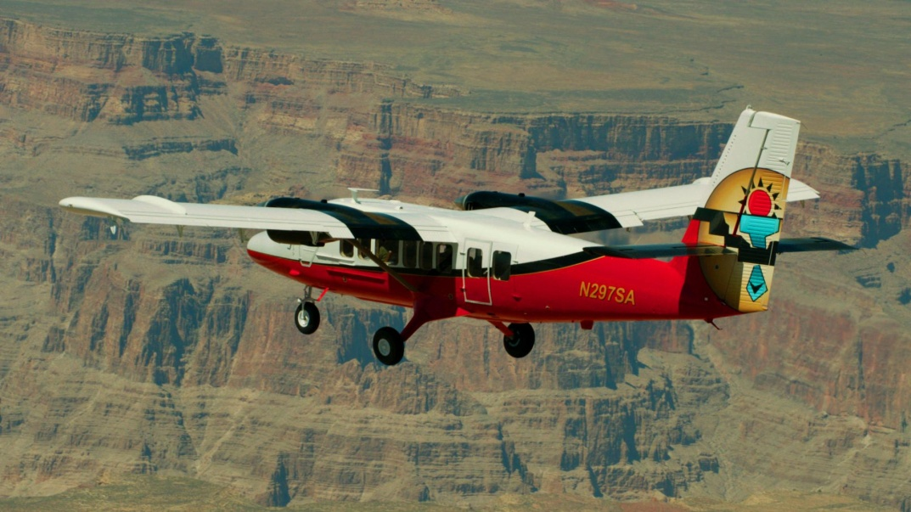
Courtesy of Grand Canyon Scenic Airlines
A new adventure company opened in Sedona – Sedona Trail Zen
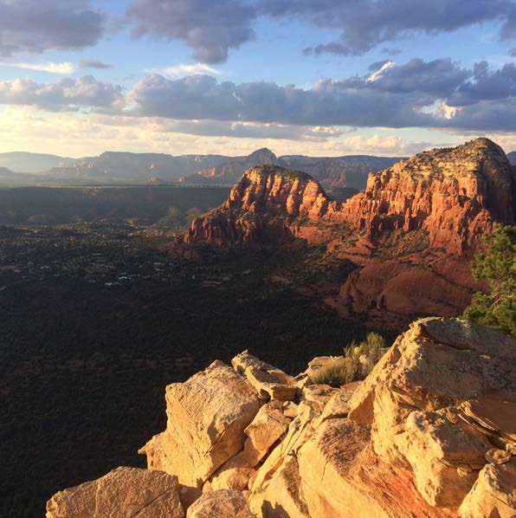
Sedona Trail Zen opened this past year to offer adventure experiences for any size group. Local guides lead solo adventure seekers to Sedona’s wonders as well as guide and manage large team building events for as many as 30 on the red rock trails of Sedona. Guides take guests to scenic vistas and provide information on the diverse ecosystems of Sedona on both hiking and biking trails. Certified instructors can lead visitors into the wilderness to practice yoga in Sedona’s most pristine locations. They are permitted to guide on more than 100 miles of Red Rock District Trails. Their shop offers information, hiking and mountain bike gear and a bike fleet for rent. A smoothie bar serves healthy refreshments to rehydrate after the trail. Sedona
Culinary
New Scottsdale Wine and Ale Trail Maps available for download
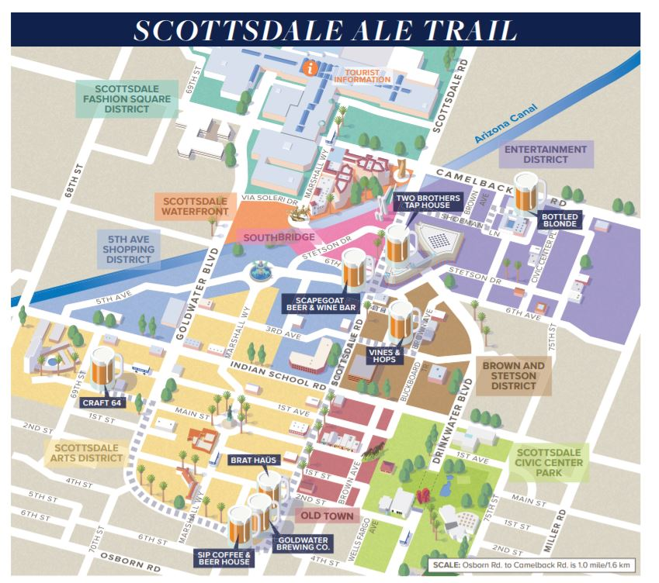
Downtown Scottsdale is home to notable wine tasting rooms and breweries, where visitors can sample Arizona-grown varietals and locally-brewed suds. Visitors looking to traverse the Scottsdale Wine Trail and explore the budding ale trail can now download Experience Scottsdale’s new maps of the locales. The Scottsdale Wine Trail map directs visitors to Carlson Creek Vineyards, LDV Winery and more. The Scottsdale Ale Trail map points to Two Brothers Tap House, Craft 64, and Goldwater Brewing Co., among others. Visitors can download additional Scottsdale maps and guides of other attractions such as Downtown’s districts, Old Town’s historic sites, and the area’s public art. A section of the Scottsdale Ale Trail map

Culture/Heritage

New interpretive site at Grand Falls on Navajo Nation
The public experience at Grand Falls, on the Navajo Nation near Leupp, and one of Northern Arizona’s famous desert water features, was enhanced in the fall of 2016 with the construction of a new interpretive site. Interpretive panels explaining the Navajo culture can be found under a ramada structure shaped like a traditional Hogan and new waterless restrooms are now close by. The concrete floor of the ramada features a stamped design of the four sacred Navajo plants: maize, beans, tobacco and squash. Grand Falls typically flows only during snow melt, in the spring, or during monsoon season.

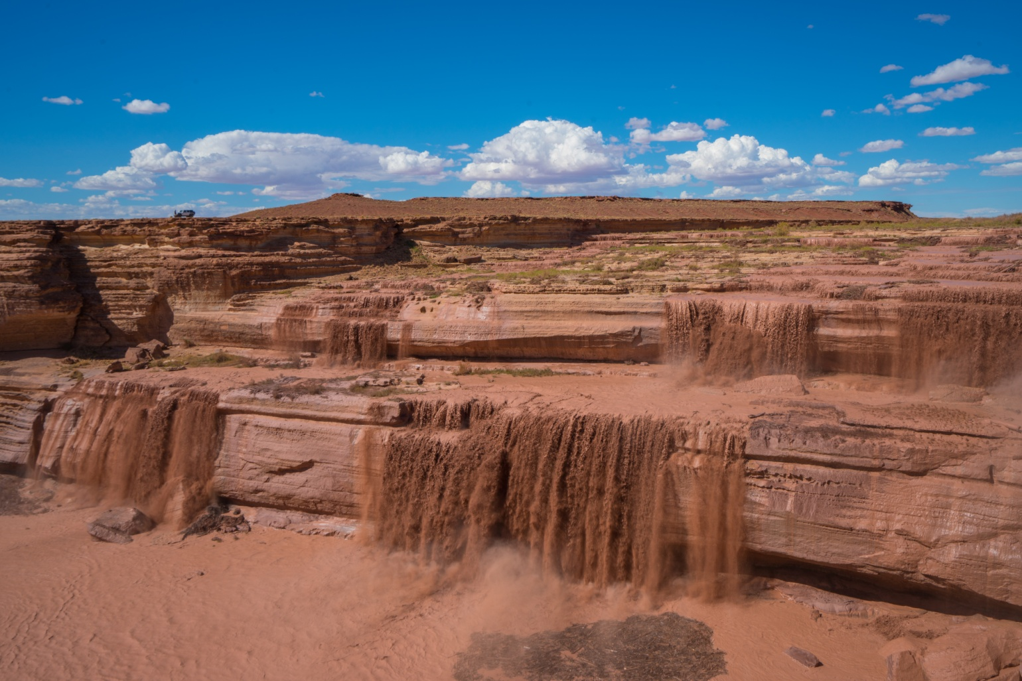
Grand Falls, (also known as Chocolate Falls) Navajo Nation, near Leupp

The Navajo Nation Zoo in Window Rock eases the way for everyone
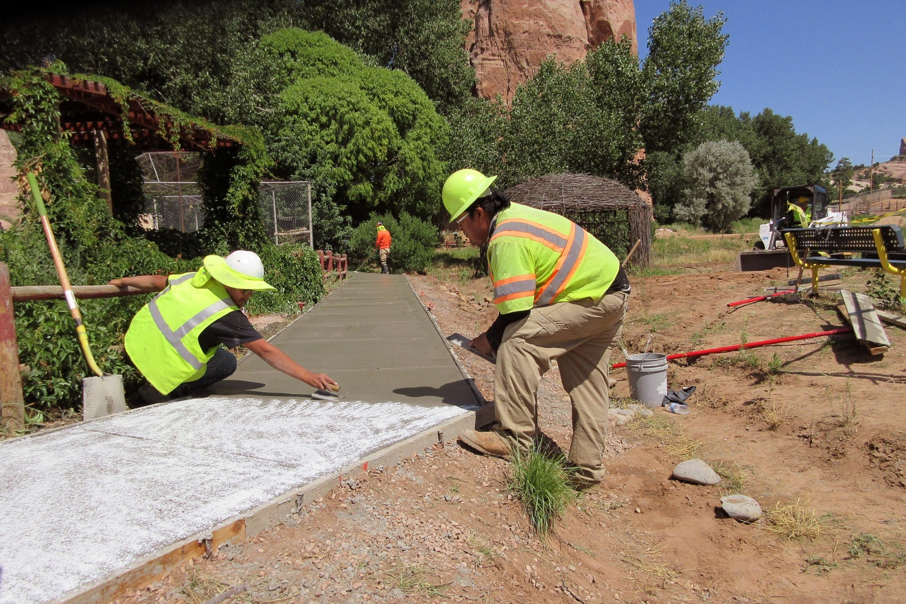
Thanks to a partnership from the Navajo Tourism Department, the Navajo Nation Zoo can now accommodate all visitors. M.O.B. Construction Company from Navajo, New Mexico paved a new pathway to make the entire zoo grounds accessible to the public. The modification now helps those with baby strollers and wheel chairs and helps keep visitor feet dry during the winter and summer rains. This partnership has made the Navajo Nation Zoo a wonderful venue for the Navajo people and world-wide visitors. The Zoo recently held a 40th anniversary celebration in June 2017. The Navajo Nation Zoo and Botanical Park is the only Native American owned-and-operated zoo in the country.
New pathways at the Navajo Nation Zoo
Hotel News
A new renovation in Sedona – Arabella Hotel Sedona
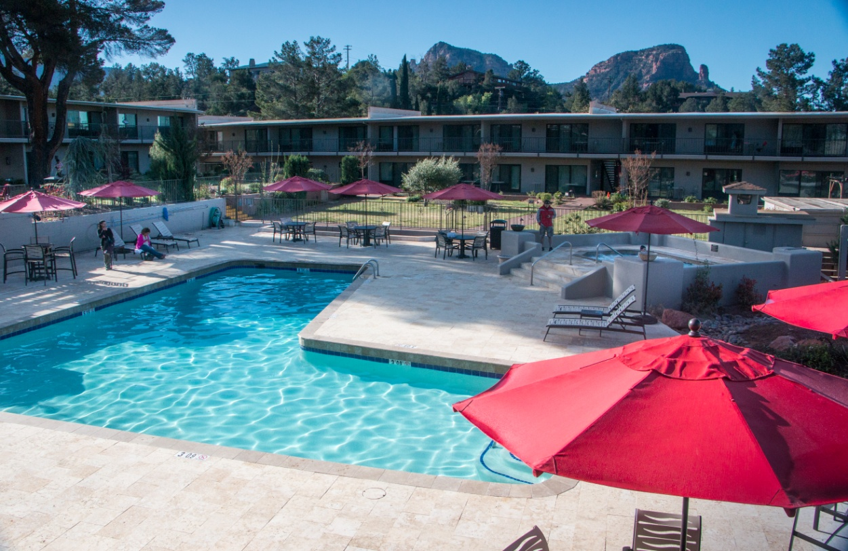
Arabella Hotel Sedona will undergo renovations in 2017 to revamp its eight-acre property located among the Red Rocks of Sedona. Renovations will enhance landscaping on the hotel grounds, bring new décor to the hotel's premier "Trailhead" rooms and include guestroom bathroom renovations. Plans for renovations come shortly after the management takeover of Arabella by San Diego-based hotel management company, RAR Hospitality. Arabella Hotel Sedona has 144 guestrooms on its property. It is also home to Elote Cafe, which offers Mexican inspired dishes with a modern, upscale twist. The Arabella Hotel Sedona is located at 725 Highway 179, in Sedona.
Overlooking the pool at Arabella Hotel Sedona

Classic Hotels & Resorts renovates, rebrands and renames Scottsdale’s Firesky Resort – The Scott
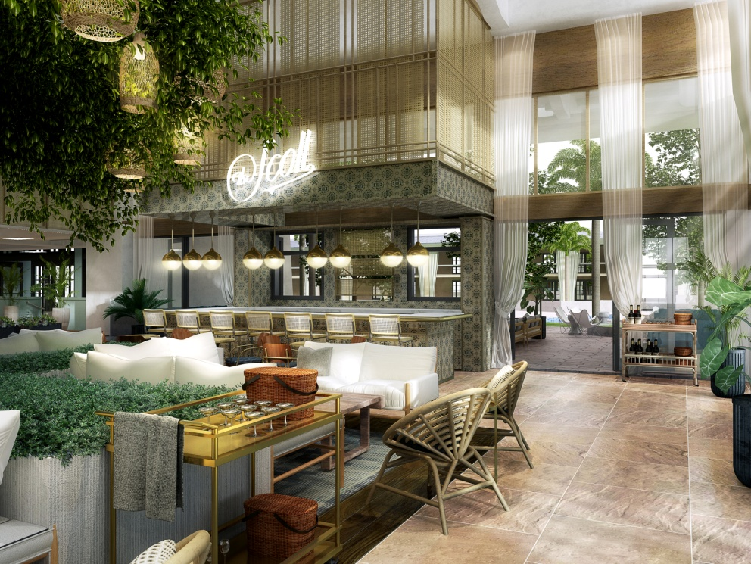
Classic Hotels & Resorts, has rebranded and renamed Firesky Resort & Spa, as The Scott. With phase one of the renovation slated to debut in Fall 2017, Classic Hotels & Resorts is investing $15M to make the resort even better. The reinvention consists of all guest rooms, suites and public spaces, including the resort’s 14,000 square feet of meeting space, two pools, lobby bar and restaurant. The redesign will celebrate the historic building’s iconic architecture, while introducing a new look and feel and elevated guest service culture, creating a new personality for the resort alongside an all-new restaurant concept. The first phase of the redesign is almost complete and includes an upgraded lobby from the inside out. The signature Lobby Bar and Restaurant, The Canal Club, is completely renovated and re-concepted with an all-new menu designed by Executive Chef Christopher Bailey. The resort’s two lagoon-like pools include additional cabanas and new landscaped surrounds. Guests and locals will continue to enjoy cocktails and light bites from The Canal Club Pool Bar and may dip their toes in the resort’s signature sandy beach pool. The meeting and function space includes upgrades which are underway for the two ballrooms and the event lawn, the resort’s main wedding venue. The second phase will revamp all 204 guestrooms, each of which features private outdoor patios or balconies. Significant upgrades will include redesigned bathrooms. The renovation will also unveil an all-new Presidential Suite and the addition of four one-bedroom suites.
Rendering of the new lobby at The Scott
Wellness

Sedona’s new Secret 7 campaign offers guidance to lesser-known parts to create a unique travel experience
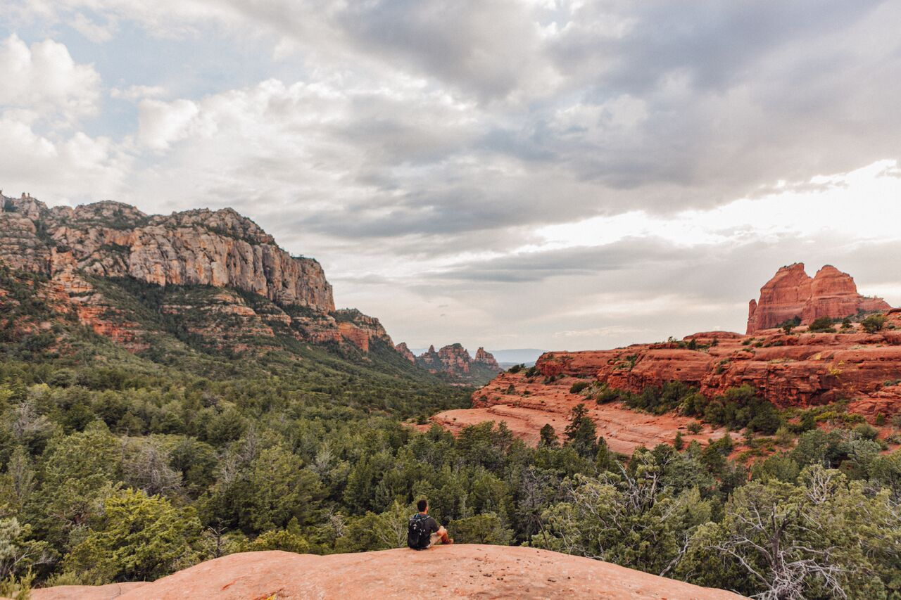
The Sedona Chamber of Commerce & Tourism Bureau has launched Sedona’s Secret 7, an innovative campaign that reveals hidden trails and locations across Red Rock Country. The campaign gives even frequent Sedona visitors more reasons to return and extend their stay by providing a list of unfamiliar places. The Chamber also wants to move visitors away from trails that are heavily traveled in order to help sustain the natural resources for generations to come. Sedona’s Secret 7 is broken into seven categories: Picnics; sunrise/sunset vistas; stargazing; spiritual; arts and culture; biking trails; and hiking trails. Within each category there are seven different places that offer a doorway to lesser-known parts of Sedona. It also offers secret tips, like the quiet site with sweeping sunrise views that goes mostly undiscovered by Sedona visitors, or best bets to find reflective pools of water after summer monsoons and even tips on how to be a responsible traveler.
The red rocks of Sedona
General

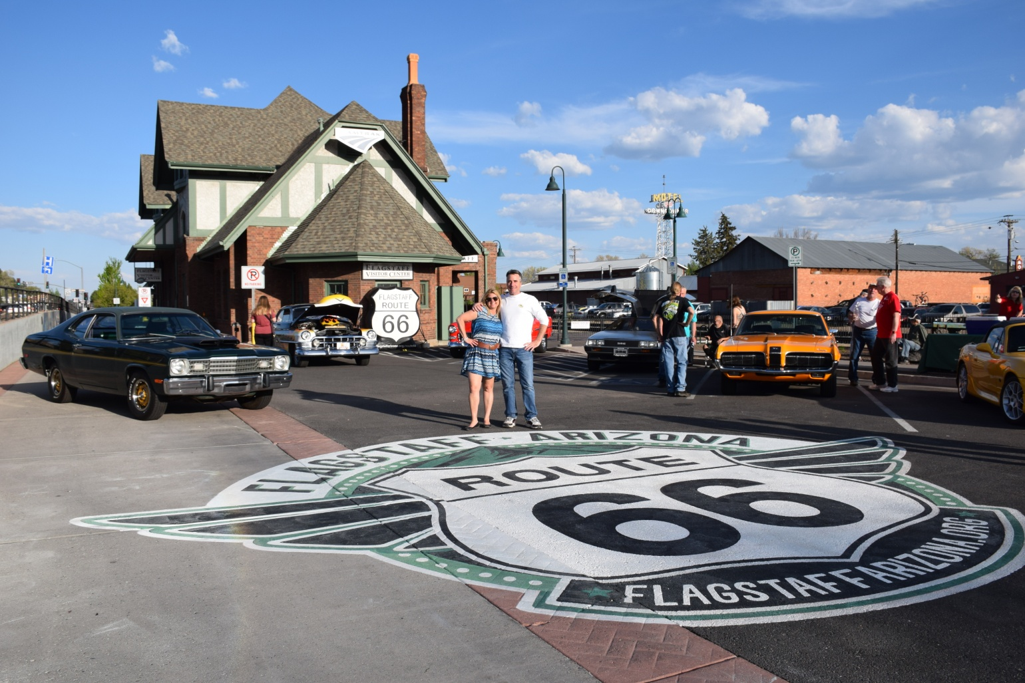
Get your “Pic’s on Route 66” with new street art at Flagstaff Visitor Center
No Route 66 trip is complete without selfies from the road, so cruise over to the Flagstaff Visitor Center (1 E. Route 66) to snap a picture with Arizona’s newest mother road themed street art. Unveiled in May 2017 in the west parking lot of Flagstaff’s historic train station building, the large scale, 25 feet wide public art was painted by local mural artists, the Mural Mice, to provide a permanent Route 66 photo opportunity for Flagstaff visitors.
Taking a picture at the Flagstaff Visitor Center on Route 66

Train enthusiasts drop by Benson to conduct some fun
Benson Arizona was created in 1880 by the Southern Pacific Railroad. It was the hub of Southern Arizona connecting former mining communities and even connecting with the Sonoran Railroad line into Mexico. The railroad history of Benson is an important part of what Benson is today. Thousands of train enthusiasts come to Benson each year just to see the trains come through town. They watch and take pictures of the locomotives and cargo for their railroad photo collections. Now, with a grant from the Union Pacific Foundation, the visitor center has add a “G” scale model train and 96 feet of track around the inside perimeter of the office. A former train control stand was added to allow visitors an opportunity to drive the train and receive an official Benson Train Engineer certificate.
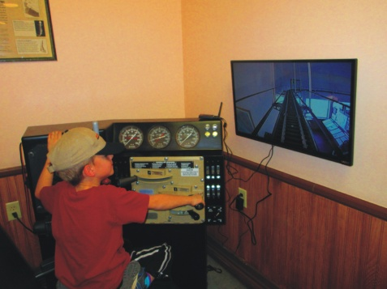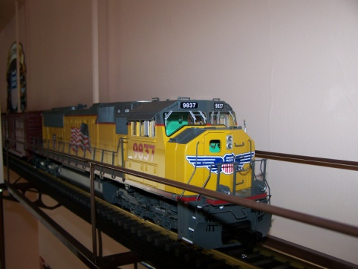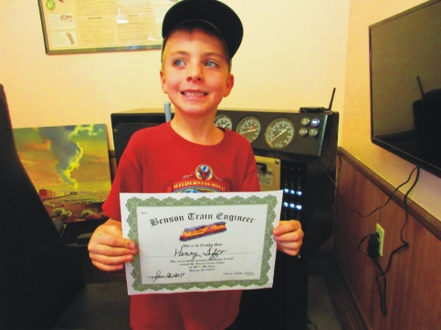
Driving the train and receiving a certificate
Frontier Airlines launches service to two new cities from Phoenix
Frontier Airlines will launch new low-fare service between Phoenix and two new central Texas cities starting this fall. The new cities include Austin and San Antonio. The announcement made earlier this week is part of a national announcement where Frontier is bringing low fares to 21 new cities and 85 new routes, which will include 90 percent of the U.S. population. Flights will begin October 2017.
Reservations will be required for the “Boneyard” tours in Tucson beginning November 1, 2017
The Pima Air & Space Museum is contracted by the USAF to give tours of the 309th Aerospace Maintenance and Regeneration Group/Boneyard at Davis Monthan Air Force Base. Starting November 1, 2017 there will be new security measures in place for individuals interested in taking this tour. The museum will still offer the tours Monday—Friday, excluding Federal holidays, however it is going to a reservation system (currently it is first come first serve). Beginning November 1, all guests interested in taking this tour must have made a reservation and received a security clearance in advance. The security clearance will be given by Davis-Monthan Air Force Base from information collected at the time of reservation. They will begin taking reservations for November 1, 2017 on August 10, 2017. Reservations must be made 10 business days in advance of the desired tour date, and can be made up to 90 days in advance. Reservation requests can be made by calling 520-618-4805 or emailing: boneyardtour@pimaair.org. Planes parked at the Tucson desert “boneyard”

Connect:
@arizonatravel
@visit_arizona
www.youtube.com/user/ArizonaTourism
Newsroom: http://newsroom.visitarizona.com/
Official State Visitors Guide: http://www.visitarizona.com/visitors-guide
Additional inspiration: http://www.visitarizona.com/planning/local-word

