Blind Community Center of San Diego
1805 Upas Street San Diego CA 92103
Phone: 619-298-5021 www.BCCSD.org
Donate with PayPal at donation@bccsd.org

DECEMBER 2018 NEWSLETTER CELEBRATING 69 YEARS
BCC MISSION: To enrich the lives of blind and visually impaired adults preparing them for a normal, active life in a society that is principally sighted by encouraging independence.
The Blind Community Center gives blind and visually impaired people in our community a place to gather. Participants are able to socialize, make crafts, play games and enjoy a free lunch.
BUSINESS HOURS:
Monday – Friday 9:00 am - 3:00 pm
Doors close at 4:00 pm
Saturday – 8:30 am -Noon Closed Sunday

BCC CLOSED SATURDAY DECEMBER 22 THROUGH JANUARY 1 OPEN WEDNESDAY, JANUARY 2
Wishing you joy and peace during this Holiday season.
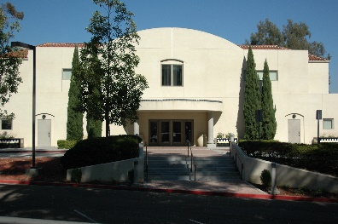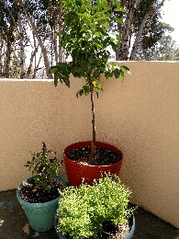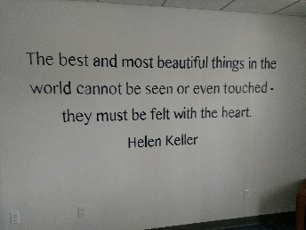

DOCKLESS SCOOTERS POSE DANGER TO BLIND COMMUNITY CENTER MEMBERS AND VISITORS
As many of you know, dockless scooters and bicycles are obstructing the pedestrian right-of-way on sidewalks leading to the BCC, in violation of municipal code 54.0110. Last week, as one of our blind members was trying to get to the bus stop at Park and Upas, he got his white cane caught on a scooter blocking his path. He fell onto a group of scooters, which lacerated his leg. Paramedics were called. The member’s wounds were bandaged from the ankle to the knee, and he is still under his doctor’s care.

In spite of numerous contacts with various scooter companies, the illegally placed scooters remain a danger to pedestrians. BCC volunteers move the scooters every morning; the scooter company representatives place them back on the sidewalks during the day, at the end of the day, and in the morning.

Please be extra careful when walking between the bus stop and the center and watch out for these scooters.

If you see illegally placed scooters or bicycles and want to report it, the City of San Diego’s Code Enforcement Division of the Development Services Department can be reached at 619-236-5500 or https://www.sandiego.gov/ced/.

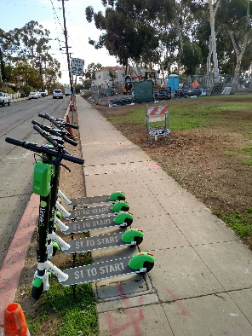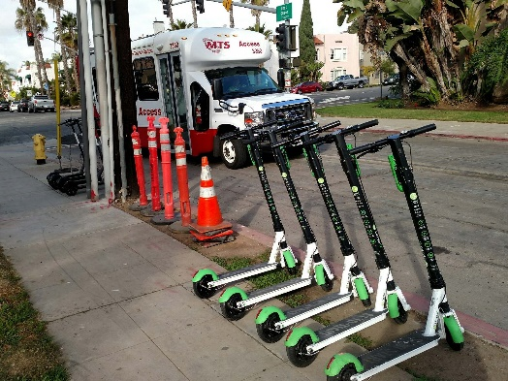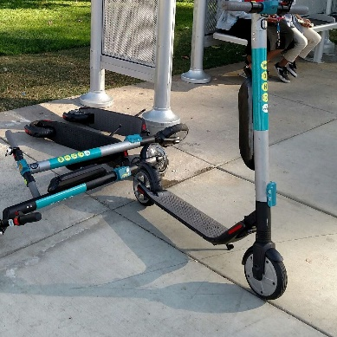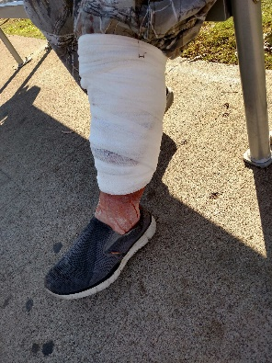

Contacts:
619-298-5021 x203 Admin./Program Assistant, Karla Collins
619-298-5021 x206 Sign Up and Reservations
619-298-5021 x208 President Sharlene Ornelas
619-997-8058 Christie Greene
MEMBER INFORMATION;
Are you interested in becoming a BCC Member? Annual membership is $40. Members have special privileges, including discounts on selected events such as Bingo and free MTS transportation for membership meetings and certain other events.
CALENDAR
COFFEE PARTY AT THE BCC
Monday – Friday
Have a cup of coffee with friends and a sweet treat any time the BCC is open. Attend a class, play a board game or cards, or just relax and visit. Newcomers always welcome!
WEEKLY CLASSES
MONDAYS
CRAFT CLASS
Craft Room 9:00 am – 1:00 pm
In this free class, participants learn to use beads, safety pins, fabric, yarn, corks, felt and other items to make a variety of fun crafts.
CRIBBAGE
Auditorium 11:00 am - 1:00 pm
Join longtime volunteer Pat Newman and learn a fun game that uses cards and a pegboard to keep score. Don’t know how to play? Pat is a great teacher. We have a variety of card styles to choose from. We hold two championship tournaments every year. RSVP - 619-417-1844
LUNCH AT THE BCC
Craft Room 11:30 am – 12:30 pm
Enjoy a free, nutritious lunch every weekday. Reservations by 10:30 am please. Call 619-298-5021 and leave a message with our receptionist.
BCC CHOIR – YOUNG AT HEART
Youth Room 1:00 pm – 3:00 pm
The choir requires an audition with our Choir Director Glynn Daniels. Members of the choir memorize their music and sing their part in 3-4-part harmony.
TUESDAYS
CRAFT CLASS
Craft Room 9:00 am – 1:00 pm
In this free class, you can learn to make beaded Holiday decorations, fabric wreaths, and many other fun crafts.
LUNCH AT THE BCC
Craft Room 11:30 am – 12:30 pm
Enjoy a free, nutritious lunch every weekday. Reservations by 10:30 am please. Call 619-298-5021 and leave a message with our receptionist.

WEDNESDAYS

EASY DOES IT EXERCISES FOR OLDER ADULTS
Check in at Front Desk 9:00 am - 10:00 am
This class features easy chair exercises, low impact movement and stretches. Our goal is to feel better and enhance our quality of life.
DECEMBER NIGHTS AND SPECIAL CRAFTS
Craft Room 9:00 am – 1:00 pm
Handmade-by-the-Blind Crafts are featured every year at the BCC December Nights Booth in Balboa Park. Learn how to make button bracelets, candy elves, coasters and other fun crafts and help the BCC at the same time.

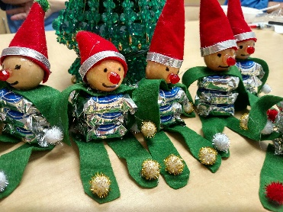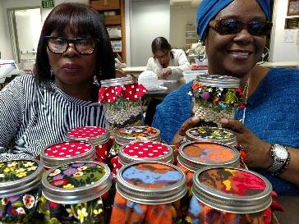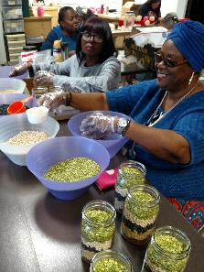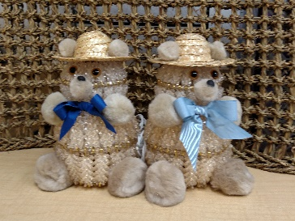
Pictures of candy elves, bean soup mix and crafters, and beaded teddy bear lamps

PAINTING
Craft Room 9:15 am – 10:15 am
LUNCH AT THE BCC
Craft Room 11:30 am – 12:30 pm
Enjoy a free, nutritious lunch every weekday. Reservations by 10:30 am please. Call 619-298-5021 and leave a message with our receptionist.

CHORUS - BCC SINGERS
Youth Room 1:00 pm - 3:00 pm
Last practice for December Nights. No auditions and no experience are required. Come and sing those Christmas songs. Free MTS Access ticket for members who stay for full practice.

THURSDAYS

THERAPEUTIC MARTIAL ARTS
Auditorium 9:00 am - 11:00 am
Martial arts are an ancient method of training your mind, body and spirit to act as one. Benefits of martial arts include a healthy lifestyle, self-confidence, improved cardiovascular health, improved reflexes, focus and stillness, muscle tone, stress relief and a better mood. Therapeutic Martial Arts can increase positive peer and social interactions, as well as lower anxiety, increase self-esteem and build self-discipline. All ages and abilities are welcome.
CREATIVE WRITING WITH CLYTIE KOEHLER
Every Thursday except the first Thursday.
Conference Room 10:30 am - noon
Clytie Shares her knowledge about writing. This is a fun, open workshop where you can explore your own writing desires. Whether, you want to write a letter, a term paper, a book or something else, we are here to encourage and coach each other in whatever you feel motivated to write.

WALK ABOUT IN BALBOA PARK
Every Thursday of each Month except the first Thursday.
Clytie Koehler has spent many hours wandering in her beloved park. She loves to share that pleasure with others who are interested. On every Thursday of each month, except the first Thursday, Clytie will walk with one or two cane or guide dog users through easily accessible areas in the Prado. This offering is by appointment only and is available from 12:30 pm until 2:00 pm. or as previously arranged. Please call Clytie at least one day ahead to make plans. 760-271-8138

LUNCH AT THE BCC
Craft Room 11:30 am – 12:30 pm
Enjoy a free, nutritious lunch every weekday. Ice cream for dessert on Thursdays. Reservations by 10:30 am please. Call 619-298-5021 and leave a message with our receptionist.

THURSDAY MATINEE
Auditorium 1:00 pm - 3:00 pm
Enjoy a movie and popcorn and soda from the snack bar. Those in attendance will decide which movie will play. Free MTS access ticket for members who arrive by MTS.

FRIDAYS

GAMES AND FUN FOR ALL
Craft Room 9:00 am - 11:15 am
Second and Fourth Fridays
Come and enjoy games like Skip-Bo, Uno, and Poker, while socializing with new friends. We have many games that are adapted for use by the blind.
LUNCH AT THE BCC
Craft Room 11:30 am – 12:30 pm
Enjoy a free, nutritious lunch every weekday. Reservations by 10:30 am please. Call 619-298-5021 and leave a message with our receptionist.

ALL SIDES OF MUSIC
Youth Room 1:00 pm – 3:00 pm
After lunch, Join Glynn Daniels as he helps us explore different aspects of music.

SATURDAYS

THERAPEUTIC MARTIAL ARTS
Auditorium 9:00 am - 11:00 am
Martial arts are an ancient method of training your mind, body and spirit to act as one. Benefits of martial arts include a healthy lifestyle, self-confidence, improved cardiovascular health, improved reflexes, focus and stillness, muscle tone, stress relief and a better mood. Therapeutic Martial Arts can increase positive peer and social interactions, as well as lower anxiety, increase self-esteem and build self-discipline. All ages and abilities are welcome.

SPECIAL AND MONTHLY ACTIVITIES
BALBOA PARK DECEMBER NIGHTS
Friday, December 7, and Saturday, December 8
The BCC will have a booth again this year at Balboa Park December Nights. Join the fun with our annual crafts sale, Santa Clause and the BCC Chorus.

SATURDAY BINGO
Craft Room
Saturday December 15 10:30 am – 1:30 pm
Meet with friends and play BINGO! Accessible Bingo cards and assistance as needed is provided. Can’t beat it; Lunch is provided for those on reservation list. Please pay in advance to speed up getting started. First number is called at 11:00 am. Members: $5 Everyone else: $10 for 1 or 2 cards. Please RSVP Wednesday before the game by 3:00 pm to ensure adequate assistance and food. 619-298-5021 x 206
BOARD OF DIRECTORS MEETING
No meeting in December.
The BCC Board meets every odd numbered month on the second Tuesday of the month. Please call 619-298-5021 x208, 24 hours prior to the meeting to be added to the agenda.

MEMBERSHIP MEETING
No Meeting in December

BCC EXPERIENCES

RAINBOW BRIDGE
Remembering the Guide dogs who have gone to the Rainbow bridge.

The story of Rainbow Bridge tells of a lush green meadow just this side of Heaven. Rainbow Bridge is the name of both the meadow and the bridge connecting it to Heaven. According to the story, when a pet dies, it goes to the meadow, restored to perfect health and free of any injuries. The pet runs and plays all day with the others; there is always fresh food and water, and the sun is always shining. However, it is said that while the pet is at peace and happy, they also miss their owner whom they left behind on Earth. When their owner dies, they too arrive at the meadow, and that is when the pet stops playing, turns, sniffs at the air and looks into the distance where they see their beloved owner.
Excited, they run as fast as they can until they are one jump away from their owner's arms. The pet licks its owner in joy while the human looks into the soft eyes of their pet—who might have been absent on Earth, but never absent in their heart. Then side by side, they cross the Rainbow Bridge together into Heaven, never again to be separated. (Wikipedia)

PARTNER AGENCIES
Lions Optometric Vision Clinic (LOVC)
Monday through Friday, 9am – 1 pm
The LOVC is located on the third floor of the Blind Community Center building. The LOVC provides vision services to individuals who, based on income, do not qualify for public assistance or other vision programs, and typically fall through the cracks. In many cases, these are individuals who have no health coverage. The LOVC accepts donations of used eyeglasses in good condition. The frames are re-purposed and then used to fulfill new prescriptions.
Braille Club Membership Meeting
First Friday from 1:30 pm – 3:00 pm
Please call President Brian Ostosh at 619-200-7203 to be included for lunch. The Braille Club is a chapter of the California Council of the Blind that is an advocacy, support and educational organization of the blind. Visitors are always welcome.
National Federation of the Blind Membership Meeting
Second Saturday from 11:00 am – 1:30 pm
Meet at Wings and Ribs at 2940 El Cajon Blvd. by 10:45 am to be escorted to the apartment complex’s community room. Please call Lyn at 619-405-5554 for more information.

San Diego Chapter of the California Council of the Blind Meeting
Third Saturday from 9:00 am – 11:00 am. Please call President Lee Morton at 619-992-1259 for details.

Guide Dogs of America Puppy Raisers Meeting
First Monday 6:30pm – 7:30pm
Auditorium

THANK YOU
To all of our generous donors: Thank you for your continued, faithful support of our Blind Community Center. You make a difference in the lives of our blind and low vision participants, every day!
FRIENDS OF THE BCC - SUSTAINING DONORS
Sustaining Donors are making a monthly or quarterly commitment to the BCC with their regular support. By making a recurring donation, you make an on-going commitment to help blind and low vision members of our community stay healthy and motivated to live a better life.

Becoming a sustaining donor is a great way to show your support and ensure the stability and effectiveness of the Blind Community Center.

Chula Vista Host Lions Club
Thank you for supporting our vehicles. You help us with registration, maintenance, and repair costs. Your donations help the BCC with MTS transportation and other vital projects. Thank you, CV Host members for keeping the BCC in motion!
North Park Lions
Thank you for your continued, generous, quarterly donations. You are helping the BCC provide program and recreational opportunities to our blind and low vision participants Monday through Saturday, every week.

Mission Lions Club
Thank you for donating to our Programs Fund. The money you donate is used for MTS transportation, our lunch program and other activities designed to give our participants a fun time at the BCC. Thank you so much for your continued support.

Valley Center Lions Club
Thank you for your continued sustaining donations which help the BCC offer recreational and fun activities to the blind and low vision people of our community. You make it possible for field trips, and other fun activities. Thank you!

Thank you Sailing Ship America
BCC Members and participants were treated to a whale watching cruise aboard the Maritime Museum Sailing Vessel America. Thank you for the once in a lifetime experience! Everyone had a wonderful adventure thanks to you!
National Charity League Del Norte
Thank you, National Charity League for new carpeting in our elevator. You saw a need and jumped in to help. Thank you!

Volunteer Crystal Deatherage and Mom,
Thank you for sponsoring our Thanksgiving dinner! BCC members and participants enjoyed five turkeys, potatoes, gravy, stuffing, cranberry sauce, sweet potatoes, rolls, veggies and pumpkin pie. Yum!

Thanksgiving Dinner Volunteers
AT&T Pioneers, family, and friends did an outstanding job preparing those five turkeys and all the sides. They cooked, served, escorted guests, cleaned and did everything possible to ensure a smooth-running event. Thank you – you were awesome!

Chula Vista Eastlake Sprouts Farmers Market
Thank you for your generous donation of pie and bread. We appreciated every delicious pie and every loaf of healthy bread.

Randy Rollf and Larry Hall
Thank you for getting our bus up and running. It was a puzzle and you figured it out! It was great seeing you both at the center, thanks for your diligence and persistence.

December Nights Crafters
Crafters outdid themselves this year. The BCC has lots and lots of crafts to sell at December Nights. Our usual lighted Santa’s and snowmen are joined this year by pink elephants, teddy bears and penguins. Also featured are beaded angels, hand knitted scarves, hats, fabric wreaths, milk jug Santa’s, bean soup mason jars and other crafts. Thanks to all who worked all year long to make December Nights a huge success.

La Mesa Lions Club
Thank you, La Mesa Lions Club and President Rick Hannum for supporting the blind and low vision people of the Blind Community Center. You are helping the BCC provide quality programs and support to our VIP’s (Visually Impaired Persons). We are so very grateful for your continued support.

Rick Hannum
Our re-established ceramics class was made possible by your generous donation. Thanks to you Rick, we have very happy ceramics class students every week.

The UPS Store
Thank you for printing our 20-point font newsletter for our low vision participants each month. The newsletter is always printed quickly, is easy to read, stapled neatly and ready for us to fold and mail.
HOW CAN YOU HELP?
YOU CAN DONATE
The Blind Community Center depends on donations from community members and organizations. Your donation today can help provide food for our lunch program, transportation, program supplies, and building maintenance. It is easy to donate through PayPal. Our email is donation@bccsd.org.
YOU CAN BECOME A MEMBER OR VOLUNTEER
Be part of our BCC Community. Are you or someone you know blind or visually impaired?

The BCC has two classes of membership, Blind and visually impaired members, and Associate members.
Associate members are individuals who support the mission of the BCC.

Are you interested in participating or volunteering? Do you want to learn more? Call the BCC at 619 298-5021 for more information.

Volunteers are needed for:
- Lunch program
- Reception desk
- Craft class helpers
- Ceramics class helpers
- Exercise class leader
YOU CAN HELP US WITH OUR WISH LIST
1. Under counter dishwasher
High water temperatures with a dishwasher will leave dishes sanitized and we can be more energy and water efficient.
2. Cleaning Supplies needed every month
2 gallons bleach
2 gallons Fabuloso
1 gallon Simple Green
1 gallon Clorox Clean-Up Cleaner with Bleach
2 large containers of disinfecting cleaning wipes for tables, door handles, phones, etc.
2 large Comet or Ajax cleaners
1 large box 35-gallon trash bags
3. For our Computer Center
We need screen reading software developed for computer users whose vision loss prevents them from seeing screen content or navigating with a mouse. All of our computers have Windows 10, which includes a magnifier and a narrator. Some of our members require other software such as Fusion which is JAWS and ZOOMTEXT in one application.

4. Small undercounter ice maker

5. Staples for our lunch program:
#10 cans of Marinara Sauce, black beans, pinto beans, baked beans, green beans, chopped tomatoes
#10 cans of sliced peaches, pears, mixed fruit
Large cans of canned tuna, canned chicken, mushroom soup, cream of chicken soup
Large cans of Las Palmas mild enchilada sauce
Frozen ground beef or turkey or chicken pieces
Taco seasoning - Chili seasoning
Cake mixes, cookies, chips
Bottled water

BOARD OF DIRECTORS
President: Sharlene Ornelas, Blind BCC Member
Vice President: Ethel Kirtley, Blind BCC Member
Treasurer: Vacant
Secretary: Claude Edwards, Blind BCC Member
Past President: Gwendolyn Edwards, Blind BCC Member
Directors:
Lion Christie Greene
Magdalena Guillen, Blind BCC Member
Rochelle Harris, Blind BCC Member
Lucy Dolan, Blind BCC Member
Marlene Wall, Blind BCC Member
Lion PDG Neil Seefeldt, Jr.
Eric Linebarger, MD, Ophthalmologist
Lions Optometric Vision Clinic Rep.: Marcia DeRuntz

