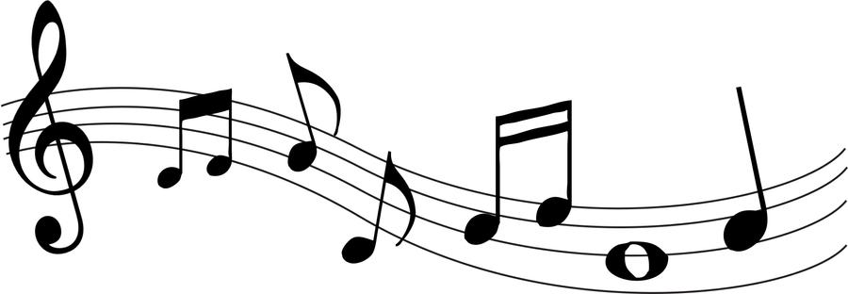
Music Class Week of Sept. 21
All Grades
Ms. Card says hello to all Distance Learners
https://www.youtube.com/watch?v=ESd8HqgvlgE\
Thrive This song is our prayer focus for this year. You might remember in past years we sang songs like “Be a Blessing” and “Build Your Kingdom Here.” If you don’t know what the word “thrive” means, have your parents help you look it up, then think about why this is a great prayer focus for this school year. We’ll be singing this song a lot this year. It’s already a favorite of your classmates! I think you’ll like it, too!
https://www.youtube.com/watch?v=3jNJ59o4QgE

K-5 Evaluations & Assessments: Unless otherwise indicated, please send a photo or video of your child participating in a lesson of their choice to mcard@stpaulsbeach.com
Middle School Evaluations & Assessments: Please see instructions in Schoology

Kindergarten
The God of All Grace This is a song we’ll sing when we go to church later this year. Just sing along on the chorus…the section of words that repeat.
https://www.youtube.com/watch?v=zytdftplk_8
Lord, Be Glorified This is a song we’ll sing when we go to church later this year. It’s a little prayer we offer with our singing voice. When you sing to God, it’s like praying twice! Use your best voice.
https://www.youtube.com/watch?v=QLTsI72ohZc
• beat – a pulse like a heartbeat that is steady and even. We notice the beat in our music, but there are other non-musical things that can also make a beat.
Things That Make a Beat Click on a sound image & create a motion to go with the sound
https://www.eemusicclass.com/lessons/display?sc=true&lessonid=114&variationid=&stepid=1150
Things That Do Not Make a Beat Click on a sound image & create a random motion to go with the sound
https://www.eemusicclass.com/lessons/display?sc=true&lessonid=114&variationid=&stepid=2891

2nd Grade
See Kindergarten
I Got the Beat, Beat, Beat The beat in music is like the beat of your heart. It doesn’t suddenly speed up, slow down, or stop then restart. You don’t have short heartbeats & long heartbeats. They’re all alike. In music, the beat stays the same through the whole song. This is a fun song to move to the beat in different ways. Can you march, clap, nod, & jump on the beat of the song?
https://www.eemusicclass.com/view/songs?id=3286#

3rd /4th/5th Grades
Words of the Week: This is new for 3rd Graders, but 4th & 5th Graders should find these to be review words from last year. Each week, we will learn various words from music vocabulary that will be part of present & future lessons. Here are the words & definitions so far this year:
- BEAT: the pulse of a piece of music
- INTRODUCTION: an opening section of music found at the beginning of a piece
- VERSE: a changing section of text often followed by the refrain or chorus
- REFRAIN or CHORUS: the repeated section after each verse
- BRIDGE: a section of music that connects 2 different sections (HINT: It sounds completely different than the sections it’s connecting!)
These can also be found in our Google Classroom https://drive.google.com/drive/folders/1nPkH9QZcuWg8uJXMHLlnuXsgT0_X8B2p

The God of All Grace This is a song we’ll sing when we go to church later this year. Just sing along on the chorus…the section of words that repeat.
https://www.youtube.com/watch?v=zytdftplk_8
Thrive Sing along to the link above. This song also has a bridge. Send Ms. Card an email with the words you think are in the bridge. mcard@stpaulsbeach.com
The Fox 4th & 5th graders may remember singing this fun song last year. This song has only verses & a bridge. Notice the note patterns of the verses & the note patterns of the bridge. Since they are different, this tells you that the bridge will sound different than the verses. Do you know what the word “kin” means in this song? Have fun singing this one.
https://drive.google.com/drive/u/0/folders/1coUFsbpawoTuqa-Z-1Lm6oCNziL_IXtC
Lil’ Liza Jane Notice the Introduction, Verse & Chorus. We are working on moving to the beat of this song & may have some dance moves ready to show you soon! Check it out in my Google Classroom: https://drive.google.com/drive/folders/1zUYHhNHPYA4nv_K97QmKcauMpqRLgXTA
6th
Join 6th Grade Choir 2020-21 on Schoology with Access Code: 24WJ-SKZM-NTB33
Assignments are due. Please message on Schoology or email mcard@stpaulsbeach.com with any issues
7th
Join 7th Grade Choir 2020-21 on Schoology with Access Code: 5ZGN-HZD7-7N2W3
Assignments are due. Please message on Schoology or email mcard@stpaulsbeach.com with any issues

