ACCESSING THE Parent portal
Register, Access, Attach, and View Your Student’s Information.

What Is the parent portal?
The myPolkSchools.Net Parent Portal is a new on-line service offered to parents and guardians in Polk County. The service will bring together into one single web page information about ALL of the students for a particular parent. Instead of visiting several different websites, making telephone calls or visiting the school to access records or information, the parent may access them all from any Internet-connected computer. The most important goal of the Parent Portal is to enhance district-to-school-to-home communication as outlined in the Polk County Schools Strategic Plan item 7(1): “Establish an effective system of communication linking district, school and home.”

where is it? How Do I Get there?
Go to http://parent.mypolkschools.net .

how do i register?
In order to access the Parent Portal you must first register. Please visit the portal and click the “Register” button. Follow the prompts and enter your information, once you’ve completed the form, click on “Create Account”. If you are a Polk County School Board employee with a “@polk-fl.net” email address, you DO NOT need to register. Use your firstname.lastname username and corresponding password to login.

I’VE REGISTERED, Now what?
Welcome to the Parent Portal. Now, you must attach yourself to each of your students. You should have received one P.I.N. per student from your student(s’) school(s). This P.I.N. is unique to you and only you. Please DO NOT share this P.I.N. with anyone, including your spouse and children. You must follow the steps below for each student you wish to attach.

How To attach your Students
- 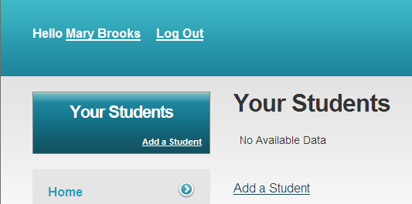Click the “Add a Student” link as seen below.

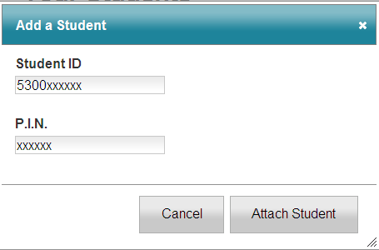2. Enter the Student ID including the 5300 as shown below and the corresponding P.I.N. number for the student you are attaching. Click “Attach Student” when you are finished.

Once you have clicked “Attach Student”, the screen will reload and information for that student will appear. Repeat steps 1 and 2 to attach additional students.

using the parent portal
Now that you are attached to all of your students, you are at the homepage. To view details on particular category click on one of your students then click on the category you wish to look at.

