How to activate your UCL provided Laptop
You are required by Microsoft to activate Windows when you receive your Laptop, please follow the instructions below to activate the new license.
You can find the 25-digit licence key on a sticker attached to the underside of your laptop. This sticker is your windows 10 “Certificate of Authenticity”, which guarantees your licence to use Windows 10 without restriction on this laptop.

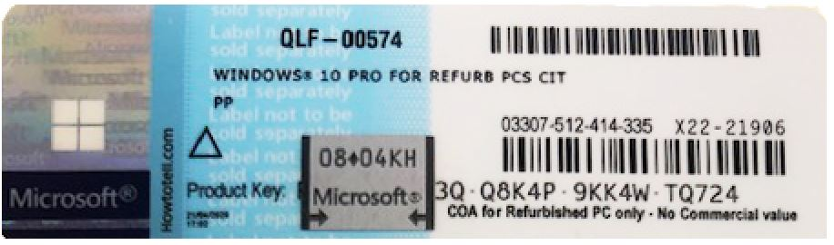

Note:
To remove the grey coating that conceals the product key, gently scratch it off using your fingernail.
The below letters and numbers look very similar, please be extra careful when entering the key.
(G & 6, O & 0, Q & O, B & 8,S & 5)
Please ensure you are connected to the internet before following the steps below:
- Select the Start button, then select Settings > Update & security > Activation
- Select Change product key
- Type in the product key found the Certificate of Authenticity, which will be found underneath the laptop battery and follow the instructions
- If Windows detects an internet connection, select Activate Windows online now. You might be asked for an admin password or to confirm your choice.
If the machine does not activate then try running Windows Update first and then try again.
If you have any issues, please contact the team on 03332420543 or via email
insight@apexevolution.co.uk

