Military History Anniversaries 1 thru 15 Oct

Events in History over the next 15 day period that had U.S. military involvement or impacted in some way on U.S military operations or American interests

- Oct 00 1943 – WW2: USS Dorado (SS–248) missing » Date of loss unknown. Most likely either accidently bombed and sunk by friendly Guantanamo–based flying boat on 13 October or sunk by a German submarine mine in the West Indies. 77 killed.

- Oct 01 1776 – American Revolution: Patriots learn of increased French support » Benjamin Franklin and Robert Morris receive information that the French are going to purchase arms and ammunition in Holland and send them to the West Indies for use by the American Patriots.

- Oct 01 1864 – Civil War: Rose Greenhow dies » Confederate spy Rose O’Neal Greenhow drowns off the North Carolina coast when a Yankee craft runs her ship aground. She was returning from a trip to England.

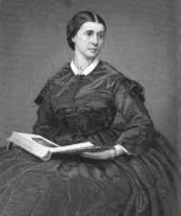

At the beginning of the war, Maryland native Rose O’Neal Greenhow lived in Washington, D.C., with her four children. Her deceased husband was wealthy and well connected in the capital, and Greenhow used her influence to aid the Southern cause. Working with Lieutenant Colonel Thomas Jordan, she established an elaborate spy network in Washington. The effectiveness of the operation was soon demonstrated when Greenhow received information concerning the movements of General Irvin McDowell’s army shortly before the First Battle of Bull Run in July 1861. A female courier carried messages from Greenhow to Confederate General Pierre G.T. Beauregard at his Fairfax, Virginia, headquarters. Beauregard later testified that because of the gained intelligence, he requested extra troops from General Joseph Johnston’s nearby command, helping the Confederates score a dramatic victory against the Yankees in the first major battle of the war. Confederate President Jefferson Davis sent Greenhow a letter of appreciation the day after the battle.

Federal authorities soon learned of the security leaks, and the trail led to Greenhow’s residence. She was placed under house arrest, and other suspected female spies were soon arrested and joined her there. The house, nicknamed “Fort Greenhow,” still managed to produce information for the Rebels. When her good friend, Massachusetts Senator Henry Wilson, visited Greenhow, he carelessly provided important intelligence that Greenhow slipped to her operatives. After five months, she and her youngest daughter, “Little Rose,” were transferred to the Old Capitol Prison in Washington. She was incarcerated until June 1862, when she went into exile in the South.

Greenhow and Little Rose spent the next two years in England. Greenhow penned a memoir titled My Imprisonment and traveled to England and France, drumming up support for the Southern cause. She then decided to return to the Confederacy to contribute more directly to the war effort. Greenhow and her daughter were on board the British blockade-runner Condor when it was intercepted by the U.S.S. Niphon off Cape Hatteras, North Carolina. The Yankee ship ran Condor aground near Forth Fischer. Greenhow was carrying Confederate dispatches and $2,000 in gold. Insisting that she be taken ashore, she boarded a small lifeboat that overturned in the rough surf. The weight of the gold pulled her under, and her body washed ashore the next morning. Greenhow was given a hero’s funeral and buried in Oakdale Cemetery in Wilmington, North Carolina, her body wrapped in the Confederate flag.

- Oct 01 1880 – U.S. Marine Corps: John Philip Sousa becomes leader of the United States Marine Band.

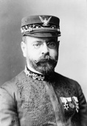

- Oct 01 1918 – WWI: Lawrence of Arabia captures Damascus » A combined Arab and British force captures Damascus from the Turks during World War I, completing the liberation of Arabia. An instrumental commander in the Allied campaign was T.E. Lawrence, a legendary British soldier known as Lawrence of Arabia.

Lawrence, an Oxford-educated Arabist born in Tremadoc, Wales, began working for the British army as an intelligence officer in Egypt in 1914. He spent more than a year in Cairo, processing intelligence information. In 1916, he accompanied a British diplomat to Arabia, where Hussein ibn Ali, the emir of Mecca, had proclaimed a revolt against Turkish rule. Lawrence convinced his superiors to aid Hussein’s rebellion, and he was sent to join the Arabian army of Hussein’s son Faisal as a liaison officer.

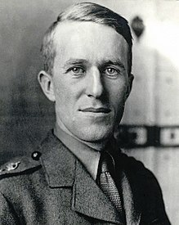

Under Lawrence’s guidance, the Arabians launched an effective guerrilla war against the Turkish lines. He proved a gifted military strategist and was greatly admired by the Bedouin people of Arabia. In July 1917, Arabian forces captured Aqaba near the Sinai and joined the British march on Jerusalem. Lawrence was promoted to the rank of lieutenant colonel. In November, he was captured by the Turks while reconnoitering behind enemy lines in Arab dress and was tortured and sexually abused before escaping. He rejoined his army, which slowly worked its way north to Damascus. The Syrian capital fell on October 1, 1918.

Arabia was liberated, but Lawrence’s hope that the peninsula would be united as a single nation was dashed when Arabian factionalism came to the fore after Damascus. Lawrence, exhausted and disillusioned, left for England. Feeling that Britain had exacerbated the rivalries between the Arabian groups, he appeared before King George V and politely refused the medals offered to him. After the war, he lobbied hard for independence for Arab countries and appeared at the Paris peace conference in Arab robes. He later wrote a monumental war memoir, The Seven Pillars of Wisdom, and enlisted in the Royal Air Force (RAF) under an assumed name to escape his fame and acquire material for a new book. Discharged from the RAF in 1935, he was fatally injured in a motorcycle accident a few months later.

- Oct. 1, 1918 – WWI: Heavy rains and mechanical failures are bogging down First Army tanks, slowing forward movement of artillery and delaying resupply in the Meuse-Argonne Campaign. Delays have given the Germans time to strengthen their lines. Of nine U.S. divisions on the move, only three have significant combat experience, the 4th, 28th and 77th. They are being shifted to the front. One division, the 79th, has been in France for less than two months.

- Oct. 1, 1918 – WWI: Crisis in Germany » At four o’clock in the morning Max von Baden arrives in Berlin to take office as the new German chancellor, after conflict within the German military and government leadership causes his predecessor, Georg von Hertling, to resign. Although the Allies had breached the mighty Hindenburg Line—the heavily fortified defensive zone envisioned as the last line of German defenses on the Western Front—in the last days of September 1918, German forces in general continued to hold. The news that German ally Bulgaria had sought and been granted an armistice, however, caused German Quartermaster General Erich Ludendorff to lose his once-steely nerve. At a crown council convened by Kaiser Wilhelm II at Spa on September 29, Ludendorff demanded that the German government seek an immediate armistice based on the Fourteen Points outlined by U.S. President Woodrow Wilson the previous January. This abrupt switch by Ludendorff—who until then had claimed the German forces were far from defeat—and his direct appeal to the kaiser angered government leaders like Hertling, who arrived too late to actively participate in the meeting and promptly resigned the chancellorship. When von Baden arrived in Berlin the next morning, he made it clear that his policy was not to seek an armistice until the German army was able to reestablish its stability at the front.

- Oct 01 1939 – WW2: After a one-month Siege of Warsaw, hostile Nazi forces enter Poland’s capital city.

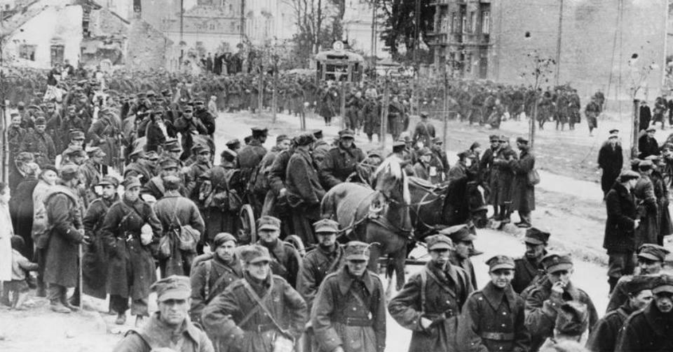

- Oct 01 1942 – WW2: USS Grouper torpedoes Lisbon Maru not knowing she is carrying 1800 British POWs from Hong Kong. Over 800 died in the sinking.

- Oct 01 1942 – WW2: First flight of the first American jet fighter aircraft Bell XP–59 'Airacomet'. The USAF was not impressed by its performance and cancelled the contract when fewer than half of the aircraft ordered had been produced.

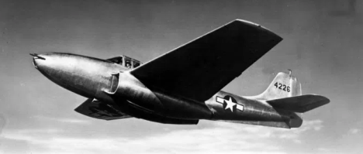

- Oct 01 1942 – WW2: Battle of Stalingrad - During Operation Winter Tempest the German Army grinds to a complete halt within the city of Stalingrad.

- Oct 01 1943 – WW2: British troops in Italy enter Naples and occupy Foggia airfield.

- Oct 01 1944 – WW2: Experiments begin on homosexuals at Buchenwald » The first of two sets of medical experiments involving castration are performed this day on homosexuals at the Buchenwald concentration camp, near Weimar, Germany. Buchenwald was one of the first concentration camps established by the Nazi regime. Constructed in 1937, it was a complement to camps north (Sachsenhausen) and south (Dachau), and was built to hold slave laborers, who worked in local munitions factories 24 hours a day, in 12-hour shifts. Although not technically a death camp, in that it had no gas chambers, nevertheless hundreds of prisoners died monthly, from malnutrition, beatings, disease, and executions.

The camp boasted a sophisticated-sounding facility on its grounds called the Division for Typhus and Virus Research of the Hygiene Institute of the Waffen SS. In truth, it was a chamber of horrors where medical experiments of the cruelest kind were carried out on prisoners against their will. Victims were often intentionally infused with various infections to test out vaccines. Euthanasia was also performed regularly on Jews, Gypsies, and mentally ill prisoners. Among the cruelest of Buchenwald’s overseers was the infamous Ilsa Koch, wife of SS commandant Karl Koch and known as the “Witch of Buchenwald.” Among her fetishistic tendencies was her penchant for lampshades, gloves, and other items made from the tattooed skin of dead inmates. She also had a reputation for forcing prisoners to participate in orgies. She was ultimately sentenced to life in prison for her sadism, but she hanged herself after 16 years behind bars.

Buchenwald was liberated by the Allies on April 11, 1945, one day before the death of President Franklin Roosevelt. It was later used by the Soviet Union as a concentration camp for the enemies of East Germany.

- Oct 01 1944 – WW2: The U.S. First Army begins the siege of Aachen, Germany.

- Oct 01 1946 – PostWW2: Nazi war criminals sentenced at Nuremberg » 12 high-ranking Nazis are sentenced to death by the International War Crimes Tribunal in Nuremberg. Among those condemned to death by hanging were Joachim von Ribbentrop, Nazi minister of foreign affairs; Hermann Goering, founder of the Gestapo and chief of the German air force; and Wilhelm Frick, minister of the interior. Seven others, including Rudolf Hess, Adolf Hitler’s former deputy, were given prison sentences ranging from 10 years to life. Three others were acquitted.

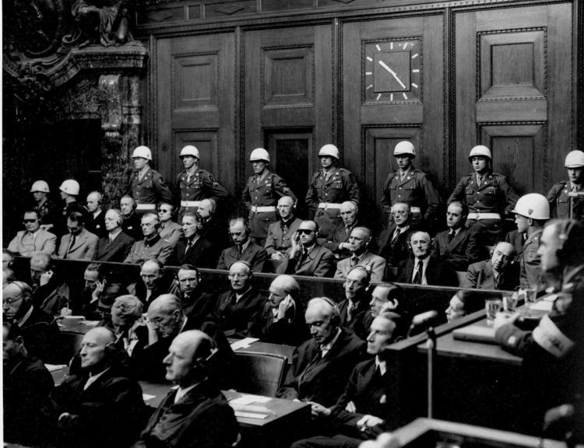

The trial, which had lasted nearly 10 months, was conducted by an international tribunal made up of representatives from the United States, the USSR, France, and Great Britain. It was the first trial of its kind in history, and the defendants faced charges ranging from crimes against peace to crimes of war and crimes against humanity. On October 16, 10 of the architects of Nazi policy were hanged one by one. Hermann Goering, who at sentencing was called the “leading war aggressor and creator of the oppressive program against the Jews,” committed suicide by poison on the eve of his scheduled execution. Nazi Party leader Martin Bormann was condemned to death in absentia; he is now known to have died in Berlin at the end of the war.

- Oct 01 1947 – U.S. Air Force: The first flight of an F-86 Sabre jet fighter, which would win fame in the Korean War takes place.

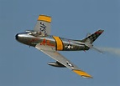

- Oct 01 1949 – Cold War: Mao Zedong proclaims People's Republic of China » Naming himself head of state, communist revolutionary Mao Zedong officially proclaims the existence of the People’s Republic of China; Zhou Enlai is named premier. The proclamation was the climax of years of battle between Mao’s communist forces and the regime of Nationalist Chinese leader Chiang Kai-Shek, who had been supported with money and arms from the American government. The loss of China, the largest nation in Asia, to communism was a severe blow to the United States, which was still reeling from the Soviet Union’s detonation of a nuclear device one month earlier.

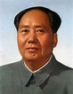

State Department officials in President Harry S. Truman’s administration tried to prepare the American public for the worst when they released a “white paper” in August 1949. The report argued that Chiang’s regime was so corrupt, inefficient, and unpopular that no amount of U.S. aid could save it. Nevertheless, the communist victory in China brought forth a wave of criticism from Republicans who charged that the Truman administration lost China through gross mishandling of the situation. Other Republicans, notably Senator Joseph McCarthy, went further, claiming that the State Department had gone “soft” on communism; more recklessly, McCarthy suggested that there were procommunist sympathizers in the department.

The United States withheld recognition from the new communist government in China. The outbreak of the Korean War in 1950, during which communist Chinese and U.S. forces did battle, drove an even deeper wedge between the two nations. In the ensuing years, continued U.S. support of Chiang’s Republic of China, which had been established on the island of Taiwan, and the refusal to seat the People’s Republic of China at the United Nations made diplomatic relations impossible. President Richard Nixon broke the impasse with his stunning visit to communist China in February 1972. The United States extended formal diplomatic recognition in 1979.

- Oct 01 1951 – U.S. Army: 24th Infantry Regiment, last all–black military unit, deactivated.

- Oct 01 1957 – Cold War: B–52 bombers begin full–time flying alert in case of USSR attack.

- Oct 01 1957 – Vietnam: South Vietnam requests a bilateral defense treaty » President John F. Kennedy was faced with a serious dilemma in Vietnam. The government of Ngo Dinh Diem in Saigon was increasingly unpopular with the South Vietnamese people because of his refusal to institute political reform and the suppression of opposing political and religious factions. However, Diem was staunchly anticommunist, which made him attractive to the American president, who was concerned about the growing strength of the Communists in Southeast Asia. The United States had taken over the fight against the Communists in Vietnam from the French, who had been defeated by the Viet Minh at the Battle of Dien Bien Phu in May 1954. The United States had been providing military aid to the South Vietnamese through the French since 1951. In 1955, this aid, which included American military advisers, was provided directly to the Diem government in Saigon. With the formal request for a bilateral defense treaty, the number of U.S. personnel in South Vietnam grew to more than 3,000 by the end of 1961, and the American commitment to Saigon grew steadily over the next two years.

- Oct 01 1979 – Panama: The United States returns sovereignty of the Panama Canal to Panama.

- Oct 01 1988 – Cold War: Mikhail Gorbachev becomes head of Supreme Soviet » Having forced the resignation of Soviet leader Andrei Gromyko, Mikhail Gorbachev names himself head of the Supreme Soviet. Within two years, he was named “Man of the Decade” by Time magazine for his role in bringing the Cold War to a close. Beginning in 1985, when he became general secretary of the Communist Party in the USSR, Gorbachev moved forward to both liberalize the Soviet economy (perestroika) and political life (glasnost), as well as decrease tensions with the United States. By late 1991, the Soviet Union was moving toward dissolution, and Gorbachev retired from office in December 1991.

- Oct 01 1992 – U.S. Navy: U.S. aircraft carrier Saratoga cripples Turkish destroyer TCG Muavenet (DM–357) causing 27 deaths and injuries by negligently launched missiles.

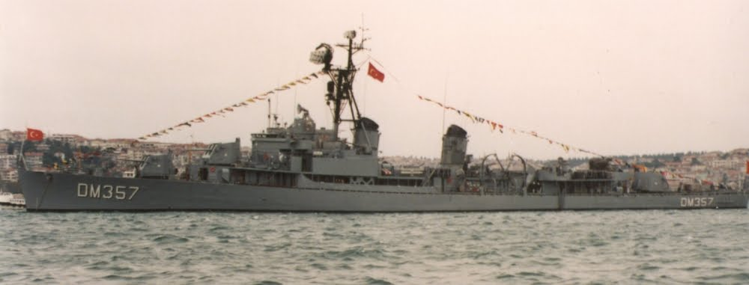

- Oct 01 2005 – Terrorism: Bali, Indonesia » Suicide bombers strike three restaurants in two tourist areas on the Indonesian island of Bali, a popular resort area. The bombings killed 22 people, including the bombers, and injured more than 50 others. This was the second suicide-bombing incident to rock the island in less than three years. (In 2002, a series of three bombs killed 202 people, many of them foreign nationals in Bali on vacation, including 88 Australians.)

The blasts occurred nearly simultaneously, hitting two outdoor restaurants in the Jimbaran beach resort and a third in Kuta, a tourist center about 19 miles away. The attacks, like those in 2002, were thought to be the work of Jemaah Islamiah (JI), an extremist Islamist militant group with links to al-Qaida. JI is also believed to be responsible for the bombing of a Marriott hotel in Jakarta in 2003 that resulted in the deaths of 12 people and of the Australian embassy in Indonesia in 2004, in which 10 people died. Though Indonesia is the most populous Muslim nation in the world, the island of Bali is mainly Hindu.

-o-o-O-o-o-

- Oct 02 1780 – American Revolution: Benedict accomplice hanged » Thirty-one-year-old British Major John Andre is hanged as a spy by U.S. military forces in Tappan, New York, on this day in 1780. Andre, an accomplice of Benedict Arnold, had been captured by Patriots John Paulding, David Williams and Isaac Van Wart on 23 SEP after they found incriminating papers in his boot. The papers revealed that Andre was returning from a secret meeting with U.S. General Benedict Arnold, commander of West Point, who had offered to surrender the strategic Hudson River fort to the British for a bribe of £20,000. Upon hearing of Andre’s capture, Arnold fled to the British warship Vulture and subsequently joined the British in their fight against the Patriots.

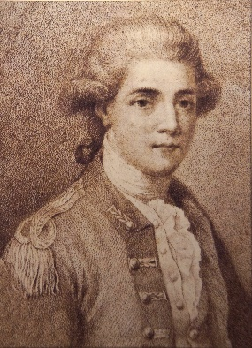

After being sentenced to death by U.S. authorities on 29 SEP, Andre was allowed to write a letter to his commander, General Henry Clinton. Andre also wrote a letter to General George Washington in which he asked, not that his life be spared, but that he be executed by firing squad. Death by firing squad was considered a more “gentlemanly” death than hanging. Members of the Continental Army respected Andre’s bravery, including Washington, who wanted to find a way to spare Andre’s life. Believing that Andre had committed a lesser crime than Benedict Arnold, Washington wrote a letter to Clinton, stating that he would exchange Andre for Arnold, so that Arnold could be hanged instead.

When he did not receive a reply to his offer by 2 OCT, Washington wrote in his “general order” of the day, “That Major Andre General to the British Army ought to be considered as a spy from the Enemy and that agreeable to the law and usage of nations it is their opinion he ought to suffer death…The Commander in Chief directs the execution of the above sentence in the usual way this afternoon at five o’clock precisely.”

- Oct 02 1835 – The Texas Revolution: First shots fired in the Battle of Gonzales » The growing tensions between Mexico and Texas erupt into violence when Mexican soldiers attempt to disarm the people of Gonzales, sparking the Texan war for independence.

Texas–or Tejas as the Mexicans called it–had technically been a part of the Spanish empire since the 17th century. However, even as late as the 1820s, there were only about 3,000 Spanish-Mexican settlers in Texas, and Mexico City’s hold on the territory was tenuous at best. After winning its own independence from Spain in 1821, Mexico welcomed large numbers of Anglo-American immigrants into Texas in the hopes they would become loyal Mexican citizens and keep the territory from falling into the hands of the United States. During the next decade men like Stephen Austin brought more than 25,000 people to Texas, most of them Americans. But while these emigrants legally became Mexican citizens, they continued to speak English, formed their own schools, and had closer trading ties to the United States than to Mexico.

In 1835, the president of Mexico, Antonio Lopez de Santa Anna, overthrew the constitution and appointed himself dictator. Recognizing that the “American” Texans were likely to use his rise to power as an excuse to secede, Santa Anna ordered the Mexican military to begin disarming the Texans whenever possible. This proved more difficult than expected, and on October 2, 1835, Mexican soldiers attempting to take a small cannon from the village of Gonzales encountered stiff resistance from a hastily assembled militia of Texans. After a brief fight, the Mexicans retreated and the Texans kept their cannon. The determined Texans would continue to battle Santa Ana and his army for another year and a half before winning their independence and establishing the Republic of Texas.

- Oct 02 1862 – Civil War: An Army under Union General Joseph Hooker arrives in Bridgeport, Alabama to support the Union forces at Chattanooga. Chattanooga’s Lookout Mountain provides a dramatic setting for the Civil War’s battle above the clouds

- Oct 02 1864 – Civil War: Battle of Saltville » A Union cavalry column of 5,000 men strikes Saltville in southwestern Virginia, but is defeated by a Rebel force of 300 patched together from several reserve units. The Confederacy’s main source of salt, used as a preservative for army rations, was secured as the war entered its final phase. Combined casualties 458

- Oct 02 1879 – Austria*Germany: A dual alliance is formed between Austria and Germany, in which the two countries agree to come to the other’s aid in the event of aggression.

- Oct 02 1912 – U.S.*Nicaraguan: Occupation Aug-Nov » U.S. forces defeat rebels under the command of Benjamín Zeledón at the Battle of Coyotepe Hill. Casualties and losses: US 14 - Rebels 32.

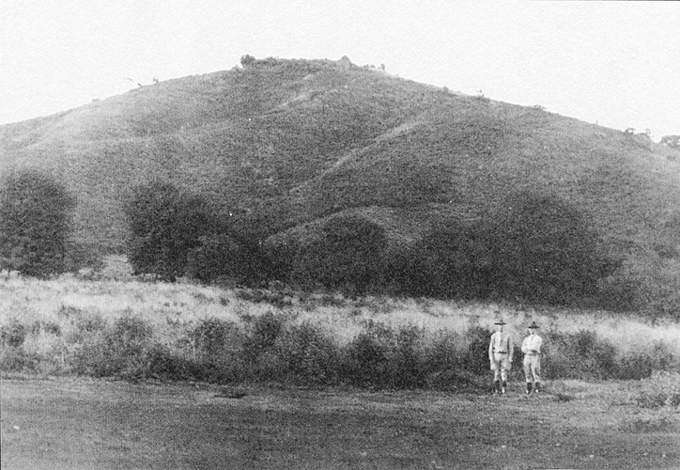

- Oct 02 1941 – WW2: Operation Typhoon is launched » The Germans begin their surge to Moscow, led by the 1st Army Group and Gen. Fedor von Bock. Although some German generals had warned Hitler against launching Operation Typhoon as the harsh Russian winter was just beginning, remembering the fate that befell Napoleon–who got bogged down in horrendous conditions, losing serious numbers of men and horses–Bock urged him on. This encouragement, coupled with the fact that the Germany army had taken the city of Kiev in late September, caused Hitler to declare, “The enemy is broken and will never be in a position to rise again.” So for 10 days, starting October 2, the 1st Army Group drove east, drawing closer to the Soviet capital each day. But the Russians also remembered Napoleon and began destroying everything as they fled their villages, fields, and farms. Harvested crops were burned, livestock were driven away, and buildings were blown up, leaving nothing of value behind to support exhausted troops. Hitler’s army inherited nothing but ruins.

- Oct 02 1944 – WW2: Battle of Aachen Germany begins. Fighting for the city took place between 13–21 OCT.

- Oct 02 1944 – WW2: Warsaw Uprising ends » The Uprising ends with the surrender of the surviving Polish rebels to German forces. Two months earlier, the approach of the Red Army to Warsaw prompted Polish resistance forces to launch a rebellion against the Nazi occupation. The rebels, who supported the democratic Polish government-in-exile in London, hoped to gain control of the city before the Soviets “liberated” it. The Poles feared that if they failed to take the city the Soviet conquerors would forcibly set up a pro-Soviet communist regime in Poland.

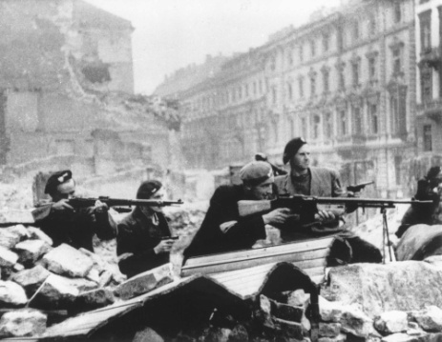

The poorly supplied Poles made early gains against the Germans, but Nazi leader Adolf Hitler sent reinforcements. In brutal street fighting, the Poles were gradually overcome by superior German weaponry. Meanwhile, the Red Army occupied a suburb of Warsaw but made no efforts to aid the Polish rebels. The Soviets also rejected a request by the British to use Soviet air bases to airlift supplies to the beleaguered Poles. After 63 days, the Poles–out of arms, supplies, food, and water–were forced to surrender. In the aftermath, the Nazis deported much of Warsaw’s population and destroyed the city. With protestors in Warsaw out of the way, the Soviets faced little organized opposition in establishing a communist government in Poland.

- Oct 02 1958 – Cold War: Guinea gains its independence » The former French colony of Guinea declares its independence on October 2, 1958, with Sekou Toure as the new nation’s first leader. Guinea was the sole French West African colony to opt for complete independence, rather than membership in the French Community, and soon thereafter France withdrew all aid to the new republic.

It soon became apparent that Toure would pose a problem for the United States. He was fiercely nationalistic and anti-imperialist, and much of his wrath and indignation was aimed at the United States for its alliances with colonial powers such as Great Britain and France and its refusal to openly condemn the white minority government of South Africa. More troubling for U.S. officials, however, was Guinea’s open courting of Soviet aid and money and signing of a military assistance agreement with the Soviet Union. By 1960, nearly half of Guinea’s exports were going to eastern bloc nations and the Soviets had committed millions of dollars of aid to the African republic. Toure was also intrigued by Mao’s communist experiments in China.

Toure played the Soviet Union and the United States against one another to get the aid and trade he desired. While Guinea’s relations with the United States got off to a rocky start (American newspapers routinely referred to the nation as “Red” Guinea), matters improved during the Kennedy administration when Toure refused to accommodate Soviet aircraft wishing to refuel on their way to Cuba during the missile crisis of 1962. In 1975, Toure changed course and allowed Soviet and Cuban aircraft to use Guinea’s airfields during the Angolan civil war, then he again reversed position by revoking the privileges in 1977 and moving closer to France and the United States.

The concerns of U.S. officials over communist influences in Guinea, and the up-and-down relationship with Guinea were but precursors of other difficulties the United States would face in postcolonial Africa. As Guinea and other former colonies achieved independence during the post-World War II period, Africa became another battleground in the U.S.-Soviet conflict.

- Oct 02 1966 – Vietnam: Soviets report that Russian military personnel have come under fire » The Soviet Defense Ministry newspaper, Krasnaya Zuezda, reports that Russian military experts have come under fire during U.S. raids against North Vietnamese missile sites while the Soviets were training North Vietnamese soldiers in the use of Soviet-made anti-aircraft missiles. This was extremely significant because it was the first public acknowledgment that Soviets had trained North Vietnamese missile crews and were observing them in action. Until this point, both the Soviets and Chinese had denied they had personnel in North Vietnam.

- Oct 02 1967 – Vietnam: Aerial offensive against North Vietnam continues » The increased U.S. aerial offensive against North Vietnam that had started August 11 continues. According to U.S. State and Defense officials, the offensive had slowed the flow of war supplies from Communist China to Hanoi. Intelligence overflights revealed that the bombing of bridges had halted the movement of military material on the key rail line from Dong Dang, near the Chinese border, to Hanoi. However, U.S. officials conceded that Communist military equipment was reaching Hanoi by other means. In Congress, dissention continued over the bombing issue. Senator John Sherman Cooper (R-NY) urged the United States to take the “first step” toward negotiations with an “unconditional cessation” of the bombing of North Vietnam. Senator Gale McGee (D-WY) defended the Vietnam policies of the Johnson administration saying the “stake is not only Vietnam but all the nations in Southeast Asia.”

- Oct 02 2001 – 911: NATO backs US military strikes in the wake of the September 11 terrorist attacks.

-o-o-O-o-o-

- Oct 03 1781 – American Revolution: French and Americans cut off British supplies at Gloucester » British Lieutenant Colonel Thomas Dundas of the 80th Foot, leading 1,000 British troops, encounters French Brigadier General Marquis de Choisy, leading French troops and a battalion of the Virginia militia totaling 800 men. The action takes place in Gloucester, Virginia, across the York River from British-occupied Yorktown, which was under Patriot siege. Although the battle between British and Patriot-allied forces was relatively small, it was nonetheless important, because it cut off supplies to General Cornwallis and the British troops across the river in Yorktown. The capture of Gloucester, Virginia, was one of the final steps toward the eventual Patriot victory at Yorktown just 16 days later.

- Oct 03 1862 – Civil War: Battle of Corinth » Confederates under General Earl Van Dorn attempt to recapture Corinth, a vital rail center in Mississippi. The Confederates were initially successful at capturing the outer defenses, driving the 23,000 defenders back nearly two miles. The battle lasted all day, and only nightfall brought relief to the battered Yankees. The next day, the Confederates made a series of desperate assaults on the inner trenches. They suffered heavy losses and began to withdraw from Corinth by early afternoon. The Confederate defeat was devastating. The Union losses included 315 dead, 1,812 wounded, and 232 taken as prisoners, while the Confederate losses included 1,423 dead, 5,692 wounded, and 2,268 prisoners. The Confederate defeat at Corinth allowed the Union to focus attention on capturing Vicksburg, Mississippi, the last major Rebel stronghold on the Mississippi River.

- Oct 03 1873 – Westward Expansion: Modoc War in Oregon » The United States military hung four Indians found guilty of murdering the Civil War hero, General Edward Canby, during the war. Canby was the highest ranking military official–and the only general–ever killed by Indians. As with most of the American military conflicts with Indians, the Modoc war began with a struggle over land. A treaty signed in 1864 had forced a band of Modoc Indians under the leadership of Chief Keintpoos-known to Americans as Captain Jack–to move to a reservation in southeastern Oregon dominated by Klamath Indians, who viewed the Modoc as unwelcome intruders on their traditional lands. Frustrated with the ill–treatment they received at the hands of the Klamath, Captain Jack and his followers abandoned the reservation in 1870 and returned to their former territory and traditional hunter-gatherer life.

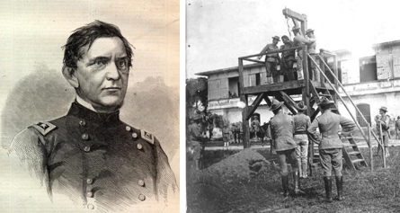

But during their six-year absence, white settlers had flooded into the Modocs' former territory. Despite Captain Jack’s repeated assurances that his people wanted only peace, many feared the Indians. In 1872, bowing to public pressure, the U.S. dispatched military forces to remove the Modoc and force them back onto the reservation. When some of the more hotheaded Modoc resisted, war broke out; and the Modoc fled to a stronghold among the Lava Beds south of Tule Lake, where they succeeded in holding off U.S. forces for almost half a year.

During the early months of the Modoc War, Captain Jack had strongly opposed armed resistance and continuously searched for a peaceful solution. But under pressure from more aggressive Modoc who were challenging his leadership, he made the fatal error of agreeing to a plan to kill the leader of the American forces, General Edward Canby. On April 11, 1873, Canby and two other men entered the Modoc stronghold under a flag of truce, hoping to negotiate a peaceful end to the conflict. Captain Jack murdered Canby, and other Modoc killed one of his companions. The third man escaped to give a detailed report of the Modocs' treachery.

Outraged by the murder of an honored Civil War hero, Americans demanded swift retribution. The Army stepped up its attacks on the Modoc, and by early June Captain Jack and his followers had been captured. After a military trial at Fort Klamath, Oregon, Captain Jack and three other Modoc leaders were found guilty of murder and hanged. As a result of the Modoc War and the murder of Canby, the U.S. began to take a much more aggressive approach to dealing with Indian problems throughout the nation.

- Oct 03 1917 – WWI: War Revenue Act passed in U.S. » Six months after the United States declared war on Germany and began its participation in the First World War, the U.S. Congress passes the War Revenue Act, increasing income taxes to unprecedented levels in order to raise more money for the war effort.

The 16th Amendment, which gave Congress the power to levy an income tax, became part of the Constitution in 1913; in October of that year, a new income tax law introduced a graduated tax system, with rates starting at 1 percent and rising to 7 percent for taxpayers with income above $500,000. Though less than 1 percent of the population paid income tax at the time, the amendment marked an important shift, as before most citizens had carried on their economic affairs without government knowledge. In an attempt to assuage fears of excessive government intervention into private financial affairs, Congress added a clause in 1916 requiring that all information from tax returns be kept confidential.

By then, however, preparation for and entry into World War I had greatly increased the government’s need for revenue. Congress responded to this need by passing an initial Revenue Act in 1916, raising the lowest tax rate from 1 percent to 2 percent; those with incomes above $1.5 million were taxed at 15 percent. The act also imposed new taxes on estates and excess business profits.

By 1917, largely due to the new income tax rate, the annual federal budget was almost equal to the total budget for all the years between 1791 and 1916. Still more was required, however, and in October 1917 Congress passed the War Revenue Act, lowering the number of exemptions and greatly increasing tax rates. Under the 1917 act, a taxpayer with an income of only $40,000 was subject to a 16 percent tax rate, while one who earned $1.5 million faced a rate of 67 percent. While only five percent of the U.S. population was required to pay taxes, U.S. tax revenue increased from $809 million in 1917 to a whopping $3.6 billion the following year. By the time World War I ended in 1918, income tax revenue had funded a full one-third of the cost of the war effort.

- Oct 03 1932 – Britain*Iraq: Iraq wins independence » With the admission of Iraq into the League of Nations, Britain terminates its mandate over the Arab nation, making Iraq independent after 17 years of British rule and centuries of Ottoman rule.

Britain seized Iraq from Ottoman Turkey during World War I and was granted a mandate by the League of Nations to govern the nation in 1920. A Hashemite monarchy was organized under British protection in 1921, and on October 3, 1932, the kingdom of Iraq was granted independence. The Iraqi government maintained close economic and military ties with Britain, leading to several anti-British revolts. A pro-Axis revolt in 1941 led to a British military intervention, and the Iraqi government agreed to support the Allied war effort. In 1958, the monarchy was overthrown, and for the next two decades Iraq was ruled by a series of military and civilian governments. In 1979, General Saddam Hussein became Iraqi dictator; he held onto power with an iron fist, until disappearing in the face of an American-led coalition’s invasion of Iraq in 2003.

- Oct 03 1940 – WW2: The U.S. Army adopts airborne, or parachute, soldiers. Airborne troops are later used in World War II for landing troops in combat and infiltrating agents into enemy territory

- Oct 03 1942 – WW2: Germany conducts first successful V-2 rocket test » German rocket scientist Wernher von Braun’s brainchild, the V-2 missile, is fired successfully from Peenemunde, as island off Germany’s Baltic coast. It traveled 118 miles. It proved extraordinarily deadly in the war and was the precursor to the Intercontinental Ballistic Missiles (ICBMs) of the postwar era.
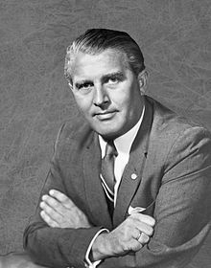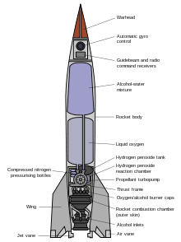

The V-2 was unique in several ways. First, it was virtually impossible to intercept. Upon launching, the missile rises six miles vertically; it then proceeds on an arced course, cutting off its own fuel according to the range desired. The missile then tips over and falls on its target-at a speed of almost 4,000 mph. It hits with such force that the missile burrows itself into the ground several feet before exploding. It had the potential of flying a distance of 200 miles, and the launch pads were portable, making them impossible to detect before firing.

The first launches as part of an offensive did not occur until September 6, 1944 when two missiles were fired at Paris. On 8 SEP, two more were fired at England, which would be followed by more than 1,100 more during the next six months. More than 2,700 Brits died because of the rocket attacks. After the war, both the United States and the Soviet Union captured samples of the rockets for reproduction–they also captured the scientists responsible for their creation. After the war, both the United States and the Soviet Union captured samples of the rockets for reproduction–they also captured the scientists responsible for their creation.

- Oct 03 1944 – WW2: USS Seawolf (SS-197) accidentally sunk by naval aircraft from USS Midway (CVE-63) and USS Richard M. Rowell (DE-403) off Morotai Island. 100 died.

- Oct 03 1944 – WW2: German troops evacuate Athens, Greece.

- Oct 03 1952 – Cold War: Britain successfully tests A-bomb » Britain’s first atomic bomb is tested at the Monte Bello Islands, off the northwest coast of Australia. The test made Britain the world’s third atomic power after the United States and the Soviet Union.

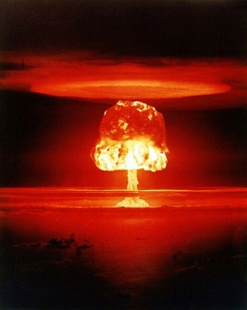

- Oct 03 1961 – Vietnam: Battle of Dak To » In some of the heaviest fighting seen in the Central Highlands area, heavy casualties are sustained by both sides in bloody battles around Dak To, about 280 miles north of Saigon near the Cambodian border. During this battle, the North Vietnamese failed to achieve one of their main objectives, which was the destruction of an American unit. They came close, but the Americans, despite heavy losses, had achieved the true victory: they mauled three enemy regiments so badly that they were unavailable for the Tet Offensive that the Communists launched in late January 1968.

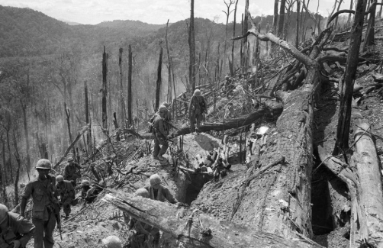

- Oct 03 1967 – Vietnam: Operation Wallowa commences » Elements of the 1st Cavalry Division launch into South Vietnam’s northernmost provinces. As these operations commenced, U.S. planes raided North Vietnamese supply routes and attacked bridges only 10 miles from the Chinese frontier.

- Oct 03 1968 – Vietnam: U.S. planes severed roads in more than 20 places, destroying over 75 supply vehicles in the heaviest raids over North Vietnam since 2 JUL. Meanwhile at Camp Evans, 11 miles north of Hue, 24 U.S. military personnel die when a U.S. Army CH-47 helicopter collides with an American C-7 Caribou transport aircraft. All aboard both aircrafts perished.

- Oct 03 1990 – Cold War: East and West Germany reunite after 45 years » Less than one year after the destruction of the Berlin Wall, East and West Germany come together on what is known as “Unity Day.” Since 1945, when Soviet forces occupied eastern Germany, and the United States and other Allied forces occupied the western half of the nation at the close of World War II, divided Germany had come to serve as one of the most enduring symbols of the Cold War. Some of the most dramatic episodes of the Cold War took place there. The Berlin Blockade (June 1948–May 1949), during which the Soviet Union blocked all ground travel into West Berlin, and the construction of the Berlin Wall in 1961 were perhaps the most famous. With the gradual waning of Soviet power in the late 1980s, the Communist Party in East Germany began to lose its grip on power. Tens of thousands of East Germans began to flee the nation, and by late 1989 the Berlin Wall started to come down. Shortly thereafter, talks between East and West German officials, joined by officials from the United States, Great Britain, France, and the USSR, began to explore the possibility of reunification. Two months following reunification, all-German elections took place and Helmut Kohl became the first chancellor of the reunified Germany. Although this action came more than a year before the dissolution of the Soviet Union, for many observers the reunification of Germany effectively marked the end of the Cold War.

- Oct 03 1993 – Somalia Intervention: Battle of Bakhara Market, Mogadishu » In an attempt to capture officials of warlord Mohamed Farrah Aidid's organization in Mogadishu, Somalia, 18 US soldiers and about 1,000 Somalis are killed in heavy fighting.

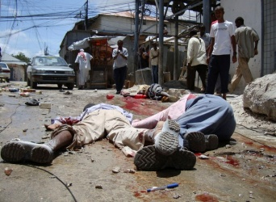

-o-o-O-o-o-

- Oct 04 1777 – American Revolution: Battle of Germantown » 11,000 Patriots under General George Washington attempt an early morning attack on British General William Howe’s 9,000 British troops at Germantown, Pennsylvania, five miles north of the British-occupied capital city of Philadelphia.

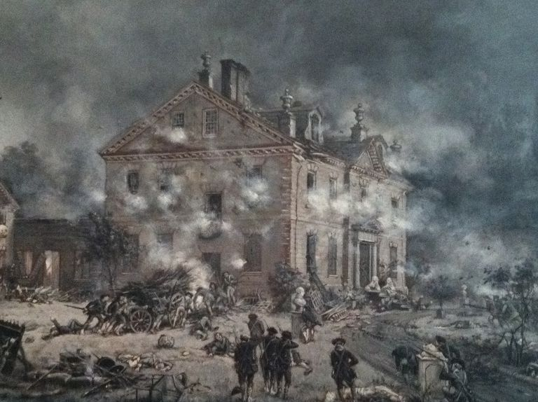

Washington’s Continental forces were poorly trained, poorly fed and poorly clothed. Nonetheless, Washington thought them ready to fight and had planned to send four columns into battle with bits of white paper tucked into their hats to help them identify each other in the darkness of early morning. Washington’s elaborate plan was thrown into disarray, however, when two columns got lost in heavy morning fog. By 10 a.m., the battle was over. Although the Americans were forced into a retreat, both sides suffered heavy losses—152 dead, 521 wounded and 400 captured for the Patriots and 71 dead, 450 wounded and 14 missing for the British–and the battle demonstrated Washington’s strategic abilities.

After Germantown, General Washington led his forces to the nearby hills of what is now Whitemarsh Township, north of Philadelphia, where they engaged in further skirmishes against General Howe’s troops on December 6-8, before continuing on to winter quarters at Valley Forge, Pennsylvania, on 19 DEC.

Friedrich, Freiherr von Steuben, arrived at General Washington’s encampment at Valley Forge on February 23, 1778. The Prussian military officer commenced training soldiers in close-order drill, instilling new confidence and discipline in the demoralized Continental Army. On the merit of his efforts at Valley Forge, Washington recommended that von Steuben be named inspector general of the Continental Army; Congress complied. In this new capacity, von Steuben propagated his methods throughout the Patriot forces by circulating his “Blue Book,” entitled “Regulations for the Order and Discipline of the Troops of the United States.”

- Oct 4 1795 – France: Napoleon Bonaparte rises to national prominence by suppressing armed counter-revolutionary rioters threatening the National Convention. He will change his surname to Bonaparte in 1796 following his first military victories.

- Oct 4 1813 – War of 1812: Jackson Defeats the Creeks » The Creek Indians had continued to be a threat in the South. After the Massacre at FT Mims, a major campaign was planned to eliminate the threat. Leading the campaign was General Andrew Jackson. The plan was to attack from three directions. Like most coordinated attacks during the War of 1812, the plan did not work very well. The campaign stated in November 1813. The initial parts of the campaign did not go as well as planned, but Jackson and the American forces had continuing success against the Creeks.

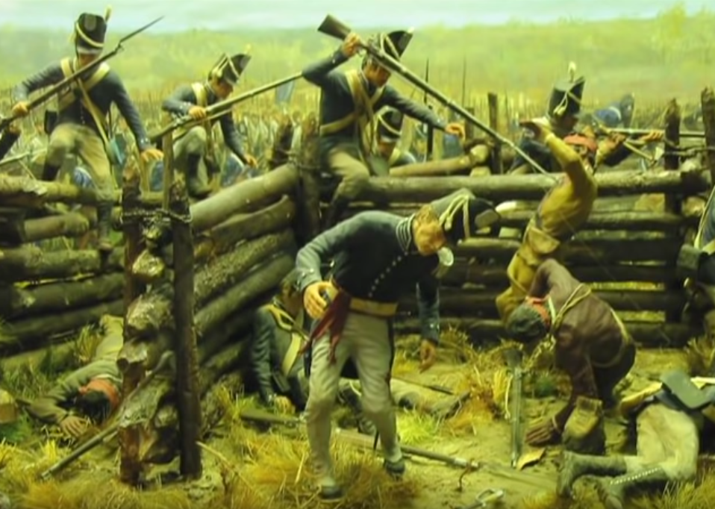

On 14 MAR 1814, Jackson headed south from Fort Strother with 4,000 soldiers and some Indian Allies for what he expected to be a decisive battle with the Creek. Jackson's destination was the Red Stick stronghold called Tohopeka at Horseshoe Bend on the Tallapoosa River. There were 1,000 Indian warriors and three hundred women and children in a fortified settlement at Horseshoe.

On March 27, troops commanded by John Coffee occupied the riverbank opposite the head of the bend. At 10:30 am Jackson gave the order to open cannon fire. The cannon fire had no effect on the Indians. Coffee mounted another diversion, and then Jackson attacked the Indian lines with his main forces. The Indians put up tough resistance but Jackson’s overwhelming force held the opposition at bay. The Indians refused to surrender and by the end of the day nearly 900 were killed. For narratives of Jackson’s campaign against the Creeks refer to https://www.youtube.com/watch?v=-eTPOjEglH0 & https://www.youtube.com/watch?v=QSshJelzNeY,

- Oct 4 1861 – Civil War: Balloon use » President Abraham Lincoln observed a balloon demonstration near Washington, D.C. Both Confederate and Union armies experimented with using balloons to gather military intelligence in the early stages of the war, but the balloons proved to be dangerous and impractical for most situations.

Though balloons were not new, many felt that their military applications had yet to be realized. Even before the firing on Fort Sumter in April 1861, marking the start of the Civil War, several firms approached the U.S. War Department concerning contracts for balloons. The primary figure in the Union’s experiment with balloons was Thaddeus S. C. Lowe, an inventor who had been working with hydrogen balloons for several years before the war. He had built a large craft and hoped to make a transatlantic crossing. In April 1861, he conducted trials around Cincinnati, Ohio, with the support of the Smithsonian Institution. On 19 APR he took off on a flight that floated all the way to Unionville, South Carolina, where he was jailed briefly by Confederates who were convinced he was a Union spy.

Lowe became the head of the Union’s Balloon Corps in 1861and served effectively during the Peninsular campaign of 1862. With the view provided from his balloon, he discovered that the Confederates had evacuated Yorktown, Virginia, and he provided important intelligence during the Battle of Fair Oaks, Virginia. He enjoyed a good working relationship with George McClellan, commander of the Army of the Potomac, but experienced difficulty with McClellan’s successors, generals Ambrose Burnside and Joseph Hooker, who were not convinced that balloon observations provided accurate information. Lowe became increasingly frustrated with the army, particularly after his pay was slashed in 1863. Feeling that army commanders did not take his service seriously, Lowe resigned in the spring of1863. The Balloon Corps was disbanded in August of that same year. Lowe later became involved in a building a railway in California. He died there in 1913 at age 80.

- Oct 4 1861 – Civil War: The Union ship USS South Carolina captures two Confederate blockade runners outside of New Orleans, La.

- Oct 4 1874 – Old West: Kiowa leader Satanta, known as “the Orator of the Plains,” surrenders in Darlington, Texas. He is later sent to the state penitentiary, where he commits suicide on October 11, 1878.

- Oct 4 1914 – WWI: The first German Zeppelin raids London.

- Oct 4 1917 – WWI: The Battle of Broodseinde takes place near Ypres, Flanders, as a part of the larger Battle of Passchendaele, between the British 2nd and 5th armies and the defenders of the German 4th Army; it is the most successful Allied attack of the Passchendaele offensive.

- Oct 04 1918 – WWI: Germany telegraphs President Wilson seeking armistice » German Chancellor Max von Baden, appointed by Kaiser Wilhelm II just three days earlier, sends a telegraph message to the administration of President Woodrow Wilson in Washington, D.C., requesting an armistice between Germany and the Allied powers in World War I.

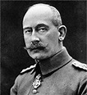
Chancellor Max von Baden

By the end of September 1918, the Allies had made a tremendous resurgence on the Western Front, reversing the gains of the previous spring’s massive German offensive and pushing the German army in eastern France and western Belgium back to its last line of defenses, the so-called Hindenburg Line. Stunned and despondent, German General Erich Ludendorff, chief architect of that final spring offensive, reversed his previous optimism about the German military situation and demanded at a crown council meeting on 29 SEP, that Germany seek an immediate armistice based on the terms President Wilson had laid out in his famous Fourteen Points address in January 1918. Feeling that the army’s leadership had completely usurped the government, Chancellor Georg von Hertling immediately resigned; Kaiser Wilhelm subsequently appointed his second cousin, Prince Max von Baden, to the post.

As soon as von Baden arrived in Berlin to take office on 1 OCT, he made it clear that he had no intention of admitting defeat until Germany had regained at least some ground on the battlefield; in this way he hoped to retain some powers of negotiation with the Allies. On 3 OCT, however, Paul von Hindenburg, the German army’s chief of staff and head of the Third Supreme Command—as Germany’s military leadership was known—reiterated Ludendorff’s advice, stating that “The German army still stands firm and is defending itself against all attacks. The situation, however, is growing more critical daily, and may force the High Command to momentous decisions. In these circumstances it is imperative to stop the fighting in order to spare the German people and their allies unnecessary sacrifices. Every day of delay costs thousands of brave soldiers their lives.”

Von Baden disagreed with Hindenburg, telling him that too early an armistice could mean Germany would lose valuable territory in Alsace-Lorraine and East Prussia, which had been implicit under the terms of the Fourteen Points, despite Wilson’s expressed desire for a “peace without victory.” Deciding to seek his own way apart from the Supreme Command, von Baden brought two 4 OCT, heeding their advice, von Baden telegraphed his request to Washington.

Wilson’s response, in notes of October 14 and 23, made it clear that the Allies would only deal with a democratic Germany, not an imperial state with an effective military dictatorship presided over by the Supreme Command. Neither Wilson nor his even less conciliatory counterparts in Britain and France trusted von Baden’s declaration of 5 OCT that he was taking steps to move Germany towards parliamentary democracy. After Wilson’s second note arrived, Ludendorff’s resolve returned and he announced that the note should be rejected and the war resumed in full force. After peace had come so tantalizingly close, however, it proved even more difficult for Germans—on the battlefield as well as on the home front—to carry on. Within a month, Ludendorff had resigned, as the German position had deteriorated still further and it was determined that the war could not be allowed to continue. On 7 NOV, Hindenburg contacted the Allied Supreme Commander, Ferdinand Foch, to open armistice negotiations; four days later, World War I came to an end.

- Oct 04 1918 – WWI: An explosion kills more than 100 and destroys the T.A. Gillespie Company Shell Loading Plant in Sayreville, New Jersey. Fires and explosions continue for three days forcing massive evacuations and spreading ordnance over a wide area, pieces of which were still being found as of 2007.

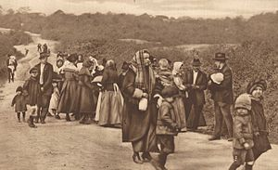
Residents of Morgan, NJ flee from the Morgan Depot explosions to Perth Amboy.

- Oct 4 1940 – WW2: Germany’s Adolf Hitler and Italy’s Benito Mussolini meet at the Brenner Pass.

- Oct 4 1941 – WW2: Willie Gillis Jr., a fictional everyman created by illustrator Norman Rockwell, makes his first appearance, on the cover of The Saturday Evening Post; a series of illustrations on several magazines’ covers would depict young Gillis throughout World War II.

- Oct 04 1943 – WW2: U.S. captures Solomon Islands. Casualties and losses: Allies 10,600 KIA, 40+ Ships, & 800 aircraft - JP 80,000 KIA, 50+ ships & 1500 aircraft.

- Oct 04 1943 – WW2: Heinrich Himmler encourages his SS group leaders » The Reichsfuhrer - SS, Heinrich Himmler, addresses the squad leaders of his Nazi secret police, attempting to fill them with pride for the work they’ve accomplished-the murder of more than 1 million Jews in German-occupied Russia during a one-and-a-half-year period. “Most of you know what it means to see a hundred corpses lying together, five hundred, or a thousand,” claimed Himmler. “To have stuck it out and at the same time… to have remained decent fellows, that is what has made us hard. This is a page of glory in our history which has never been written and shall never be written.”

- Oct 04 1944 – WW2: Ike warns of the risk of "shell shock" » Gen. Dwight D. Eisenhower distributes to his combat units a report by the U.S. Surgeon General that reveals the hazards of prolonged exposure to combat. “[T]he danger of being killed or maimed imposes a strain so great that it causes men to break down. One look at the shrunken, apathetic faces of psychiatric patients…sobbing, trembling, referring shudderingly to ‘them shells’ and to buddies mutilated or dead, is enough to convince most observers of this fact.”

On the basis of this evaluation, as well as firsthand experience, American commanders judged that the average soldier could last about 200 days in combat before suffering serious psychiatric damage. British commanders used a rotation method, pulling soldiers out of combat every 12 days for a four-day rest period. This enabled British soldiers to put in 400 days of combat before being deleteriously affected. The Surgeon General’s report went on to lament the fact that a “wound or injury is regarded, not as a misfortune, but a blessing.” The war was clearly taking a toll on more than just men’s bodies.

- Oct 04 1957 – Cold War: Space Age Inaugurated » The Soviet Union did it with its launch of Sputnik, the world’s first artificial satellite. The spacecraft, named Sputnik after the Russian word for “satellite,” was launched at 10:29 p.m. Moscow time from the Tyuratam launch base in the Kazakh Republic. Sputnik had a diameter of 22 inches and weighed 184 pounds and circled Earth once every hour and 36 minutes. Traveling at 18,000 miles an hour, its elliptical orbit had an apogee (farthest point from Earth) of 584 miles and a perigee (nearest point) of 143 miles. Visible with binoculars before sunrise or after sunset, Sputnik transmitted radio signals back to Earth strong enough to be picked up by amateur radio operators. Those in the United States with access to such equipment tuned in and listened in awe as the beeping Soviet spacecraft passed over America several times a day. In January 1958, Sputnik’s orbit deteriorated, as expected, and the spacecraft burned up in the atmosphere.

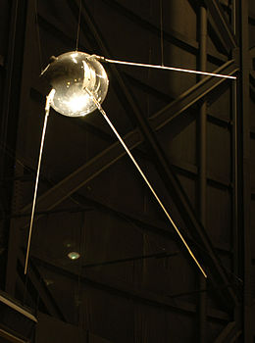

Officially, Sputnik was launched to correspond with the International Geophysical Year, a solar period that the International Council of Scientific Unions declared would be ideal for the launching of artificial satellites to study Earth and the solar system. However, many Americans feared more sinister uses of the Soviets’ new rocket and satellite technology, which was apparently strides ahead of the U.S. space effort. Sputnik was some 10 times the size of the first planned U.S. satellite, which was not scheduled to be launched until the next year. The U.S. government, military, and scientific community were caught off guard by the Soviet technological achievement, and their united efforts to catch up with the Soviets heralded the beginning of the “space race.”

The first U.S. satellite, Explorer, was launched on January 31, 1958. By then, the Soviets had already achieved another ideological victory when they launched a dog into orbit aboard Sputnik 2. The Soviet space program went on to achieve a series of other space firsts in the late 1950s and early 1960s: first man in space, first woman, first three men, first spacewalk, first spacecraft to impact the moon, first to orbit the moon, first to impact Venus, and first craft to soft-land on the moon. However, the United States took a giant leap ahead in the space race in the late ’60s with the Apollo lunar-landing program, which successfully landed two Apollo 11 astronauts on the surface of the moon in July 1969.

- Oct 04 1964 – Vietnam: Johnson orders the commencement of Oplan 34A raids » President Johnson issues the order to reactivate North Vietnamese coastal raids by South Vietnamese boats. These raids had been suspended after the Gulf of Tonkin incident in early August.

- Oct 04 1966 – Vietnam: Pope calls for end to the Vietnam War » Pope Paul VI addresses 150,000 people in St. Peter’s Square in Rome and calls for an end to the war in Vietnam through negotiations. Although the Pope’s address had no impact on the Johnson administration and its policies in Southeast Asia, his comments were indicative of the mounting antiwar sentiment that was growing both at home and overseas.

- Oct 04 1968 – Vietnam: Cambodia admits that the Viet Cong use their country for sanctuary.

-o-o-O-o-o-

- Oct 05 1762 – Seven Years War: The British fleet of 14 ships bombards and captures Manila in the Philippines, a Spanish colony at the time. Their win led to a 20 month occupation of the city. "The humanity and generosity of the British commanders saved Manila from a general and justly merited pillage. A ransom of four millions of dollars only was demanded for this relaxation of the laws of war. Thus the whole archipelago of the Philippines fell with the wealthy city of Manila.

- Oct 05 1775 – American Revolution: Washington informs Congress of espionage » General George Washington writes to the president of the Continental Congress, John Hancock, to inform him that a letter from Dr. Benjamin Church, surgeon general of the Continental Army, to Lieutenant General Sir Thomas Gage, British commander in chief for North America, had been intercepted. Washington wrote, “I have now a painful tho’ a Necessary Duty to perform respecting Doctor Church, Director General of the Hospital.”

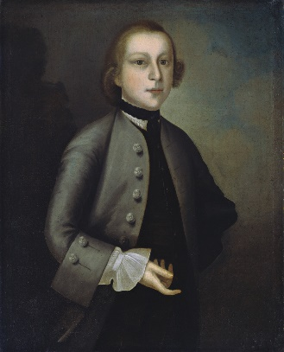
Dr. Benjamin Church

Washington described how a coded letter to a British officer, Major Crane, came into Washington’s possession by a convoluted route from “a Woman who was kept by Doctor Church.” Washington “immediately secured the Woman, but for a long time she was proof against every threat and perswasion[sic] to discover the Author, however at length she was brought to a confession and named Doctor Church. I then immediately secured him and all his papers.” The woman Washington interrogated was the mistress of Dr. Benjamin Church, a renowned Boston physician, who was active in the Massachusetts Committee of Safety and served as a member of the Provincial Congress. In July 1775, Washington had named Church the first surgeon general of the Continental Army, only to find out three months later that he had been spying for the British since 1772. Church faced an army court martial on October 4, 1775.

Despite Church’s plea of innocence, and the inconsequential nature of the information he provided to Crane, the contents of the letter included Church’s statement of allegiance to the British crown. He was charged with treason, convicted and sentenced to life in prison. After becoming ill while incarcerated, Dr. Church was exiled to the West Indies. The ship in which he traveled is believed to have been lost at sea. On November 7, 1775, shortly after the conviction of Dr. Church, the Continental Congress added a mandate for the death penalty as punishment for acts of espionage to the “articles of war.”

- Oct 05 1813 – War of 1812: Tecumseh defeated » A combined British and Indian force is defeated by General William Harrison’s American army at the Battle of the Thames near Ontario, Canada. The leader of the Indian forces was Tecumseh, the Shawnee chief who organized intertribal resistance to the encroachment of white settlers on Indian lands. He was killed in the fighting.

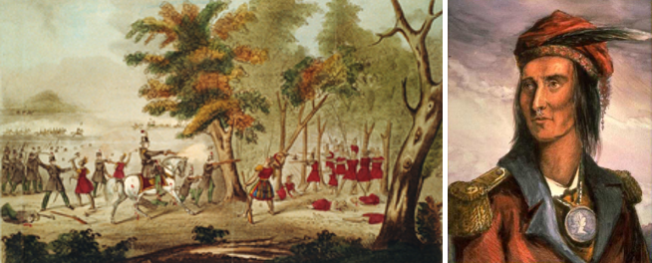
Battle of the Thames in which chief Tecumesh was (right) was killed

Tecumseh was born in an Indian village in present-day Ohio and early on witnessed the devastation wrought on tribal lands by white settlers. He fought against U.S. forces in the American Revolution and later raided white settlements, often in conjunction with other tribes. He became a great orator and a leader of intertribal councils. He traveled widely, attempting to organize a united Indian front against the United States. When the War of 1812 erupted, he joined the British, and with a large Indian force he marched on U.S.-held Fort Detroit with British General Isaac Brock. In August 1812, the fort surrendered without a fight when it saw the British and Indian show of force.

Tecumseh then traveled south to rally other tribes to his cause and in 1813 joined British General Henry Procter in his invasion of Ohio. The British-Indian force besieged Fort Meigs, and Tecumseh intercepted and destroyed a Kentucky brigade sent to relieve the fort. After the U.S. victory at the Battle of Lake Erie in September 1813, Procter and Tecumseh were forced to retreat to Canada. Pursued by an American force led by the future president William Harrison, the British-Indian force was defeated at the Battle of the Thames River on October 5.

The battle gave control of the western theater to the United States in the War of 1812. Tecumseh’s death marked the end of Indian resistance east of the Mississippi River, and soon after most of the depleted tribes were forced we Casualties and losses: US 27 - GB/Indians 616.

- Oct 05 1864 – Civil War: Battle of Allatoona » After losing the city of Atlanta, Confederate General John Bell Hood attacks Union General William T. Sherman’s supply line at Allatoona Pass, Georgia. Hood’s men could not take the Union stronghold, and they were forced to retreat into Alabama. Hood lost 897 men, while the Union lost 706. Realizing that his army was in no shape to fight, he took his force west into Alabama. In November, he would invade Tennessee.

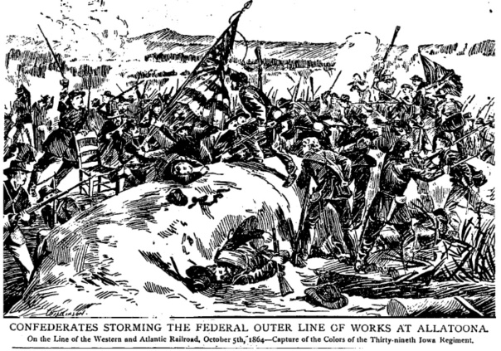

- Oct 05 1877 – Westward Expansion: Chief Joseph surrenders » Chief Joseph of the Nez Perce Indians surrenders to U.S. General Nelson A. Miles in the Bear Paw mountains of Montana, declaring, “Hear me, my chiefs: My heart is sick and sad. From where the sun now stands, I will fight no more forever.” Earlier in the year, the U.S. government broke a land treaty with the Nez Perce, forcing the group out of their homeland in Wallowa Valley in the Northwest for relocation in Idaho. In the midst of their journey, Chief Joseph learned that three young Nez Perce warriors, had killed a band of white settlers. Fearing retaliation by the U.S. Army, the chief began one of the great retreats in American military history.
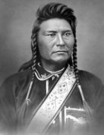

For more than three months, Chief Joseph led fewer than 300 Nez Perce Indians toward the Canadian border, covering a distance of more than 1,000 miles as the Nez Perce outmaneuvered and battled more than 2,000 pursuing U.S. soldiers. During the long retreat, he treated prisoners humanely and won the admiration of whites by purchasing supplies along the way rather than stealing them. Finally, only 40 miles short of his Canadian goal, Chief Joseph was cornered by the U.S. Army, and his people were forcibly relocated to a barren reservation in Indian Territory.

- Oct 05 1892 – Westward Expansion: The Dalton Gang is wiped out in Coffeyville, Kansas » The famous Gang attempts the daring daylight robbery of two Coffeyville, Kansas, banks at the same time. But if the gang members believed the sheer audacity of their plan would bring them success, they were sadly mistaken. Instead, they were nearly all killed by quick-acting townspeople.

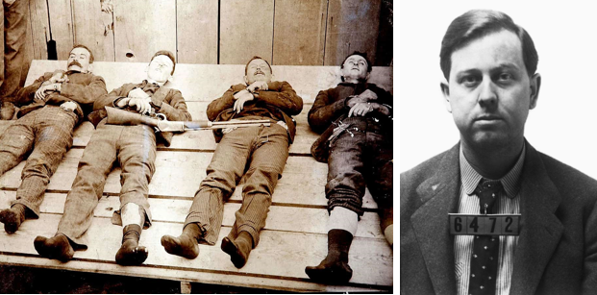
Dalton Gang Members killed in the raid in Kansas and their leader Emmett Dalton’s mug shot

For a year and a half, the Dalton Gang had terrorized the state of Oklahoma, mostly concentrating on train holdups. Though the gang had more murders than loot to their credit, they had managed to successfully evade the best efforts of Oklahoma law officers to bring them to justice. Perhaps success bred overconfidence, but whatever their reasons, the gang members decided to try their hand at robbing not just one bank, but at robbing the First National and Condon Banks in their old hometown of Coffeyville at the same time.

After riding quietly into town, the men tied their horses to a fence in an alley near the two banks and split up. Two of the Dalton brothers-Bob and Emmett-headed for the First National, while Grat Dalton led Dick Broadwell and Bill Powers in to the Condon Bank. Unfortunately for the Daltons, someone recognized one of the gang members and began quietly spreading the word that the town banks were being robbed. Thus, while Bob and Emmett were stuffing money into a grain sack, the townspeople ran for their guns and quickly surrounded the two banks. When the Dalton brothers walked out of the bank, a hail of bullets forced them back into the building. Regrouping, they tried to flee out the back door of the bank, but the townspeople were waiting for them there as well.

Meanwhile, in the Condon Bank a brave cashier had managed to delay Grat Dalton, Powers, and Broadwell with the classic claim that the vault was on a time lock and couldn’t be opened. That gave the townspeople enough time to gather force, and suddenly a bullet smashed through the bank window and hit Broadwell in the arm. Quickly scooping up $1,500 in loose cash, the three men bolted out the door and fled down a back alley. But like their friends next door, they were immediately shot and killed, this time by a local livery stable owner and a barber.

When the gun battle was over, the people of Coffeyville had destroyed the Dalton Gang, killing every member except for Emmett Dalton. But their victory was not without a price: the Dalton’s took four townspeople to their graves with them. After recovering from serious wounds, Emmett was tried and sentenced to life in prison. After 14 years he won parole, and he eventually leveraged his cachet as a former Wild West bandit into a position as a screenwriter in Hollywood. Several years after moving to California, he died at the age of 66 in 1937.

- Oct 05 1914 – WWI: First aerial combat resulting in an intentional fatality.

- Oct 05 1915 – WWI: Britain and France commit troops to operation in Salonika, Greece » At the request of the Greek prime minister, Eleutherios Venizelos, Britain and France agree to land troops at the city of Salonika (now Thessaloniki), in northern Greece.

- Oct 05 1915 – WWI: Germany issues an apology and promises payment for the 128 American passengers killed in the sinking of the British ship Lusitania.

- Oct 05 1915 – WWI: Bulgaria enters World War I on the side of the Central Powers.

- Oct 05 1938 – PreWW2: Germany invalidates Jewish passports.

- Oct 05 1942 – WW2: Stalingrad must not be taken by the enemy » Joseph Stalin, premier and dictator of the Soviet Union, fires off a telegram to the German and Soviet front at Stalingrad, exhorting his forces to victory. “That part of Stalingrad which has been captured must be liberated.” As the Germans reached the Volga, thrust and counterthrust brought the battle to a standstill. Everyone from Russian factory workers to reinforcements of more than 160,000 Soviet soldiers poured into Stalingrad to beat back the German invader. Despite dwindling supplies, such as tanks and troop reserves, Hitler would not relent, convincing himself that the Russians could not hold out for long. But Stalin appealed not only to Russian patriotism but also to Allied armaments. Requests to British Prime Minister Winston Churchill for aid had not gone unheeded, as five British merchant ships arrived in northern Russia, loaded with supplies

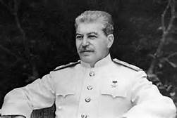

- Oct 05 1943 – WW2: Imperial Japanese forces execute 98 American POWs on Wake Island.

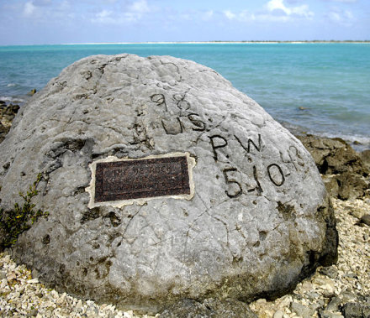
- Oct 05 1963 – Vietnam: Ambassador Henry Cabot Lodge reports to President John F. Kennedy from Saigon that South Vietnamese generals are planning a coup against President Ngo Dinh Diem. There was disagreement among Kennedy’s advisors as to what to do about Diem; some believed that Diem had to go and others were unsure. Ultimately the president decided to do nothing. In this case, that was tantamount to support of the coup plotters. On November 1, rebel forces seized the radio station and police headquarters while laying siege to the presidential palace. In the early morning hours of the next day, Diem and his brother Ngo Dinh Nhu surrendered to representatives from the rebel generals. They were later found murdered in the back of an M-113 armored personnel carrier. What followed was a period of extreme political instability as a series of “revolving door” governments took turns in an attempt to rule and stem the tide of the ongoing insurgency in the countryside.

- Oct 05 1965 – Korea: U.S. forces in Saigon receive permission to use tear gas.

- Oct 05 1966 – Vietnam: Hanoi insists the United States must end its bombings before peace talks can begin.

- Oct 05 1969 – Cold War: Cuban defector lands MiG in Miami » In an embarrassing breach of the United States’ air-defense capability, a Cuban defector enters U.S. air space undetected and lands his Soviet-made MiG-17 at Homestead Air Force Base, south of Miami, Florida. The presidential aircraft Air Force One was at the base at the time, waiting to return President Richard M. Nixon to Washington. The base was subsequently put on continuous alert, and it opened a new radar tracking facility to prevent the repetition of a similar incident in the future.

- Oct 05 1986 – Cold War: Iran-Contra scandal unravels » Eugene Hasenfus is captured by troops of the Sandinista regime in Nicaragua after the plane in which he is flying is shot down; two others on the plane die in the crash. Under questioning, Hasenfus confessed that he was shipping military supplies into Nicaragua for use by the Contras, an anti-Sandinista force that had been created and funded by the United States. Most dramatically, he claimed that operation was really run by the U.S. Central Intelligence Agency (CIA).

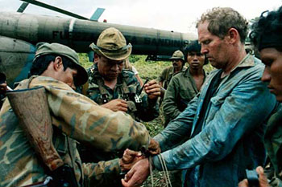

The news of Hasenfus’s revelations caused quite a stir in the United States. Congress, reacting to complaints about corruption and brutality against the Contras, had passed the Boland Amendment in 1984, specifically forbidding the CIA or any other U.S. agency from supporting the Contras. President Ronald Reagan, who saw the Sandinista government in Nicaragua as a puppet of the Soviet Union, had secured U.S. funding for the Contras in 1981 and signed off on the Boland Amendment reluctantly. If Hasenfus’s story was true, then the CIA and Reagan administration had broken the law.

Despite denials from the president, Vice President George Bush, and other Reagan officials that the CIA had nothing to do with the flight, persistent investigations by journalists and Congress began to unravel the so-called Iran-Contra scandal. The scandal involved the secret sale of U.S. weapons to Iran (which was supposed to help in the release of U.S. hostages in the Middle East). Some of the proceeds from these sales were used to covertly fund the Contra war in Nicaragua. A Congressional investigation, begun in December 1986, revealed the scheme to the public. Many figures from the Reagan administration were called to testify. These included Marine Lieutenant Colonel Oliver North, who was the action officer in charge of coordinating both the arms sales and funneling of money to the Contras. His testimony, in particular, demonstrated the cavalier attitude taken by the Reagan administration toward the flaunting of congressional resolutions and acts.

The resulting scandal rocked the Reagan administration and shook the public’s confidence in the U.S. government; 11 members of the President’s administration eventually were convicted of a variety of charges related to the scandal. Hasenfus was tried and sentenced to 30 years imprisonment by a Nicaraguan court, but was released just a few weeks later.

- Oct 05 1986 – Israel: Britain’s The Sunday Times newspaper publishes details of Israel’s secret nuclear weapons development program.

- Oct 05 2001 – Afghanistan: Operation Enduring Freedom begins (GWOT).

-o-o-O-o-o-

- Oct 06 1777 – American Revolution: British capture Forts Montgomery and Clinton » Sailing up the Hudson River to come to the aid of General John Burgoyne and the besieged British army at the Battle of Saratoga, General Henry Clinton and 3,000 British troops stop to launch an attack on Forts Clinton and Montgomery. Despite the loss of both forts and an overwhelming number of troops, though, the Americans were able to delay the British long enough that they were unable to aid Cornwallis at the Battle of Saratoga. The decisive American victory at Saratoga persuaded King Louis XVI of France that the Patriots were worthy of his support—assistance that eventually helped the Americans win the war.

- Oct 06 1780 – American Revolution: Patriots prevail in Carolinas » Patriot militia under Colonel William Campbell defeat Loyalist militia under Major Patrick Ferguson at the Battle of King’s Mountain in North Carolina near the border with Blacksburg, South Carolina. Of the 2,000 men that fought for both sides at the Battle, 1,900 were born on American soil. Only Ferguson and 100 of his personally trained Redcoats were Britons. The Loyalists suffered 157 killed, 163 wounded and 698 captured, while Campbell’s force suffered just 28 killed and 60 wounded. The Patriot success was the first against the British in the South, and convinced General Cornwallis to stop his march through the territory.

- Oct 06 1863 – Civil War: Quantrill attacks Baxter Springs, Kansas » Confederate guerilla leader William Clarke Quantrill continues his bloody rampage through Kansas when he attacks Baxter Springs. Although he failed to capture the Union stronghold, his men massacred a Federal detachment that happened to be traveling nearby. It was General James G. Blunt, commander of the forces in Kansas, who was in the process of moving his headquarters from Fort Scott, Kansas, to Fort Smith, Arkansas. Blunt spotted Quantrill’s men but mistook them for Union troops because many were dressed in captured Yankee uniforms. A large portion of Blunt’s 100 men were clerks and office staffers. Quantrill attacked, and the scene turned into a massacre. The Yankees quickly scattered, and Quantrill’s partisans hunted them down. Seventy Union troops were killed, but Blunt escaped to the safety of Fort Smith. He was removed from command shortly thereafter. Quantrill and his men continued south to Texas, raiding homesteads and attacking Native American communities along the way.

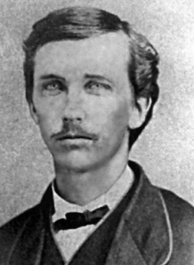

- Oct 6 1866 – Old West: The Reno brothers carry out the first train robbery in U.S. history » The brothers John and Simeon Reno stage the first train robbery in American history, making off with $13,000 from an Ohio and Mississippi railroad train in Jackson County, Indiana. Of course, trains had been robbed before the Reno brothers’ holdup. But these previous crimes had all been burglaries of stationary trains sitting in depots or freight yards. The Reno brothers’ contribution to criminal history was to stop a moving train in a sparsely populated region where they could carry out their crime without risking interference from the law or curious bystanders.

- Oct 6 1908 – Pre WWI: Austria-Hungary annexes Bosnia-Herzegovina » The Dual Monarchy of Austria-Hungary announces its annexation of Bosnia and Herzegovina, dual provinces in the Balkan region of Europe formerly under the control of the Ottoman Empire. Though Bosnia and Herzegovina were still nominally under the control of the Ottoman Sultan in 1908, Austria-Hungary had administered the provinces since the Congress of Berlin in 1878, when the great powers of Europe awarded the Dual Monarchy the right to occupy the two provinces, with the legal title to remain with Turkey. As the provinces were coveted by many—in fact, both Austria and Hungary wanted Bosnia and Herzegovina for themselves—the decision was more or less a stopgap to preserve the delicate balance of power in Europe.

- Oct 06 1945 – WW2: Former French premier and Vichy collaborator Pierre Laval tries to kill himself on the day he is to be executed for treason. He swallows cyanide before they could come for him. A physician saved his life–just in time for Laval to be executed a little less than two weeks later.

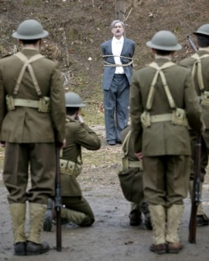

- Oct 06 1961 – Cold War: Kennedy urges Americans to build bomb shelters » Speaking on civil defense, the President advises American families to build bomb shelters to protect them from atomic fallout in the event of a nuclear exchange with the Soviet Union. Kennedy also assured the public that the U.S. civil defense program would soon begin providing such protection for every American. Only one year later, true to Kennedy’s fears, the world hovered on the brink of full-scale nuclear war when the Cuban Missile Crisis erupted over the USSR’s placement of nuclear missiles in Cuba. During the tense 13-day crisis, some Americans prepared for nuclear war by buying up canned goods and completing last-minute work on their backyard bomb shelters.

- Oct 06 1967 – Vietnam: U.S. jets strike targets in North Vietnam » Navy pilots fly 34 missions as they again strike the Chien Chiang and Lang Son bridges near the Chinese border, another bridge 39 miles northeast of Hanoi, a railroad yard near Mo Trang, and two anti-aircraft sites south of Dong Hoi. Other jets attacked the Nam Dinh power plant that lay 45 miles southwest of Haiphong; a railway and highway bridge 24 miles southeast of Hanoi; and eight buildings in the Yen Bac military storage area. These raids were all part of Operation Rolling Thunder, which had been initiated in March 1965 and became the longest bombing campaign ever conducted by the United States Air Force. It was designed to destroy North Vietnam’s industrial base and war-making capability. During the protracted campaign, more than 643,000 tons of bombs fell on North Vietnam, destroying 65 percent of North Vietnam’s petroleum storage capacity and an estimated 60 percent of its power-generating capability. Despite these results, Rolling Thunder has generally assessed as a failure.

- Oct 06 1970 – Vietnam: South Vietnamese forces withdraw from Cambodia » Military officials announce the end of a three-month operation in southeastern Cambodia and the withdrawal of the 12,000-man task force involved. During the operation, which was designed to eliminate Communist base camps and supply areas along the Ho Chi Minh Trail, 453 enemy soldiers were reported killed. South Vietnamese losses were 93 killed and 642 wounded.

- Oct 06 1971 – Vietnam: Operation Jefferson Glenn » The 101st Airborne Division (Airmobile), in coordination with the South Vietnamese (ARVN) 1st Infantry Division, initiates Operation Jefferson Glenn in Thua Thien Province west of Hue. This operation lasted until October 1971, and was one of the last major large-scale military operations in which U.S. ground forces would take part.

- Oct 06 1973 – Cold War: Yom Kippur War » The surprise attack by Egyptian and Syrian forces on Israel throws the Middle East into turmoil and threatens to bring the United States and the Soviet Union into direct conflict for the first time since the Cuban Missile Crisis in 1962. Though actual combat did not break out between the two nations, the events surrounding the Yom Kippur War seriously damaged U.S.-Soviet relations and all but destroyed President Richard Nixon’s much publicized policy of detente.

-o-o-O-o-o-

- Oct 07 1777 – American Revolution: Americans beat British in 2nd Battle of Saratoga aka. Battle of Bemis Heights. The British surrendered 10 days later. Casualties and losses of both battles: US 330 - GB 8,398.
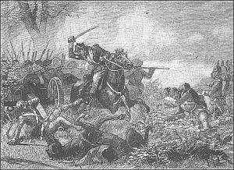

- Oct 07 1780 – American Revolution: Patriots prevail in Carolinas » Patriot irregulars under Colonel William Campbell defeat Tories under Major Patrick Ferguson at the Battle of King’s Mountain in South Carolina. Major Ferguson’s Tory force, made up mostly of American Loyalists from South Carolina and elsewhere, was the western wing of General Lord Cornwallis’ North Carolina invasion force. One thousand American frontiersmen under Colonel Campbell of Virginia gathered in the backcountry to resist Ferguson’s advance. Pursued by the Patriots, Ferguson positioned his Tory force in defense of a rocky, treeless ridge named King’s Mountain. The Patriots charged the hillside multiple times, demonstrating lethal marksmanship against the surrounded Loyalists.

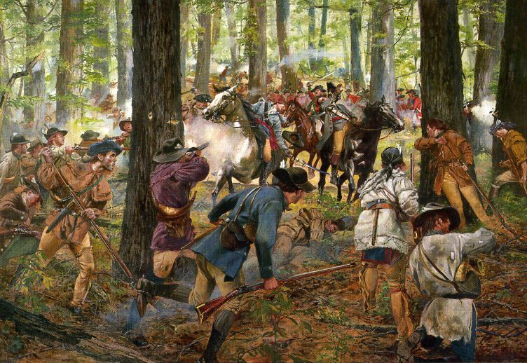

Unwilling to surrender to a “band of banditti,” Ferguson led a suicidal charge down the mountain and was cut down in a hail of bullets. After his death, some of his men tried to surrender, but they were slaughtered in cold blood by the frontiersmen, who were bitter over British excesses in the Carolinas. The Tories suffered 157 killed, 163 wounded, and 698 captured. Colonel Campbell’s force suffered just 28 killed and 60 wounded.

- Oct 07 1864– Civil War: Battle of Darbytown Road (Johnson's Farm) » A Confederate attempt to regain ground that had been lost around Richmond, Virginia, is thwarted when Union troops turn back General Robert E. Lee’s assault at the Battle of Darbytown.

In the summer of 1864, the campaign between Lee and Union General Ulysses S. Grant ground to a halt at Petersburg, 25 miles south of Richmond. The two great armies settled into trenches for a siege, and the lines soon extended all the way back to Richmond. Grant periodically attacked portions of the Rebel defenses but was not successful. On 29 SEP, Union forces captured part of Richmond’s outer defense at the Battle of New Market Heights. Although Richmond was still safely in Confederate hands, Lee was concerned about the new position of the Yankee troops.

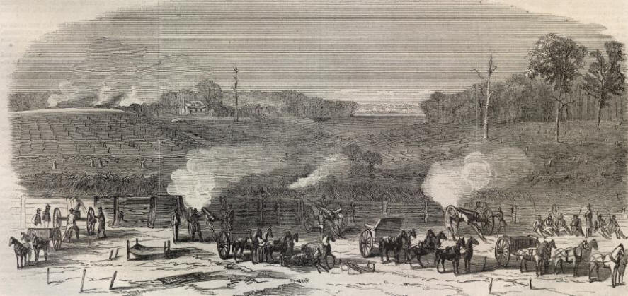

Lee sent two divisions under generals Charles Field and Robert Hoke to move around the end of the Union line. Lee hoped that the Federal flank could be turned and the Confederates could regain the defensive works lost the week before. On the morning of 7 OCT, the Confederates moved down Darbytown Road and around the Union right flank and attacked 1,700 cavalrymen. The assault sent the Yankees into a quick retreat. The Confederates captured eight cannons and drove the Union troops into the breastworks of General Alfred Terry.

Alerted to the advancing Confederates, Terry summoned reinforcements to his position. By the time the Confederates worked their way through the thick foliage, they faced a strong Union force. Lee ordered an attack anyway. Brigades advanced one at a time, and the Yankee artillery tore the lines apart. By the afternoon, the Confederates withdrew to their original position. They lost 700 men while the Yankees lost only 400, and no ground was gained. Lee did not make another attempt to regain the ground and focused instead on setting up defenses closer to Richmond.

- Oct 07 1864 – Civil War: USS Wachusett captures the Confederate raider ship CSS Florida while in port in Bahia, Brazil.

- Oct 07 1914 – WWI: Antwerp under siege » Advancing German forces bombard the Belgian city as Belgian troops and their British allies struggle to resist the onslaught. On October 8, Antwerp was evacuated; its military governor, General Victor Deguise, formally surrendered to the Germans on October 10. German forces would occupy Antwerp for the duration of the war; it was finally liberated in late 1918.

- Oct 07 1940 – WW2: The McCollum memo proposes bringing the United States into the war in Europe by provoking the Japanese to attack the United States.

- Oct 07 1940 – WW2: German troops enter Romania » Hitler occupies Romania as part of his strategy of creating an unbroken Eastern front to menace the Soviet Union.

- Oct 07 1943 – WW2: USS S–44 (SS–155) lost to Japanese escort destroyer Ishigaki, northeast Araito Island off Kamchatka. 56 killed.

- Oct 07 1943 – WW2: Japanese execute nearly 100 American prisoners on Wake Island » In late December 1941, the Japanese reinforced existing forces on Wake Island, part of a coral atoll west of Hawaii, in massive numbers after being unable to wrest the island from a small number of Americans troops earlier in the month. The Japanese strength was now overwhelming, and most of those Americans left alive after the battle were taken by the Japanese off the island to POW camps elsewhere. Ninety-six remained behind to be used as forced labor. The Allied response was periodic bombing of the island–but no more land invasions, as part of a larger Allied strategy to leave certain Japanese-occupied islands in the South Pacific to basically starve in isolation.

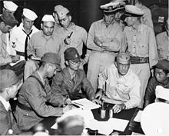
Admiral Shigematsu Sakaibara (seated second from left) signing the surrender of Wake Island
aboard USS Levy on September 4, 1945

Rear Adm. Shigematsu Sakaibara, commander of the Japanese garrison on the island, pm 7 OCT ordered the execution of 96 Americans POWs, claiming they were trying to make radio contact with U.S. forces. The execution of those remaining American POWs, who were blindfolded and shot in cold blood, remains one of the more brutal episodes of the war in the Pacific.

- Oct 07 1944 – WW2: Auschwitz mini-revolt » As several hundred Jewish prisoners were being forced to carry corpses from the gas chambers to the furnace to dispose of the bodies, they blew up one of the gas chambers and set fire to another, using explosives smuggled to them from Jewish women who worked in a nearby armaments factory. Of the roughly 450 prisoners involved in the sabotage, about 250 managed to escape the camp during the ensuing chaos. They were all found and shot. Those co-conspirators who never made it out of the camp were also executed, as were five women from the armaments factory-but not before being tortured for detailed information on the smuggling operation. None of the women talked.

- Oct 07 1949 – Cold War: East Germany created » Less than five months after Great Britain, the United States, and France established the Federal Republic of Germany in West Germany, the Democratic Republic of Germany is proclaimed within the Soviet occupation zone. Criticized by the West as an un-autonomous Soviet creation, Wilhelm Pieck was named East Germany’s first president, with Otto Grotewohl as prime minister. Approximately half the size of West Germany, East Germany consisted of the German states of Mecklenburg, Brandenburg, Lusatia, Saxony, and Thuringia. Berlin, the former German capital, remained divided between West and East German authorities, even though it was situated deep within the communist Democratic Republic of Germany. East Germany ceased to exist in 1990, when its land and people were absorbed into the democratic Federal Republic of Germany.

- Oct 07 1960 – Cold War: Kennedy and Nixon debate Cold War foreign policy » In the second of four televised debates, Democratic presidential nominee John F. Kennedy and Vice President Richard Nixon turn their attention to foreign policy issues. Three Cold War episodes, in particular, engendered spirited confrontations between Kennedy and Nixon. The first involved Cuba, which had recently come under the control of Fidel Castro. Nixon argued that the island was not “lost” to the United States, and that the course of action followed by the Eisenhower administration had been the best one to allow the Cuban people to “realize their aspirations of progress through freedom.” Kennedy fired back that it was clear that Castro was a communist, and that the Republican administration failed to use U.S. resources effectively to prevent his rise to power. He concluded that, “Today Cuba is lost for freedom.”

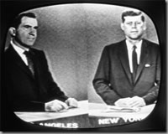

The second point of contention revolved around the downing of an American U-2 spy plane over the Soviet Union and the subsequent canceling of the U.S.-Soviet summit set for May 1960. Kennedy argued that the United States was “not in accordance with international law” in the case, and should have expressed its regrets to the Soviet Union in an attempt to keep the summit on track. Nixon fired back that Kennedy was simply wrong: the Soviets never really wanted the summit to take place and simply used the incident as an excuse.

The two candidates continued their discussions of foreign policy in the next two debates, but the lines had clearly been drawn. Kennedy’s strategy was to paint the Republican administration in which Nixon served as timid, indecisive, and given to poor strategizing in terms of the Cold War. Nixon, on the other hand, wanted to portray Kennedy as naive and much too willing to compromise with the Soviets and communist Chinese. Whether the debates really changed any voters’ minds is uncertain. While many speech experts argue that Nixon really won the debates, media analysts claim that Kennedy’s telegenic presence swayed enough voters for him to win the extremely close 1960 election. To view the debate go to https://youtu.be/jznAJySwkmM.

- Oct 07 1969 – Vietnam: General Wheeler announces progress in the Vietnamization effort » At his departure from Saigon following a four-day inspection of South Vietnam, General Earle Wheeler, Chairman of the Joint Chiefs of Staff, reports that “progress in Vietnamization is being steadily and realistically achieved,” but that U.S. forces will have to assist the South Vietnamese “for some time to come.”

- Oct 07 1970 – Vietnam: Nixon announces a new peace proposal » In a televised speech, President Richard Nixon announces a five-point proposal to end the war, based on a “standstill” cease-fire in place in South Vietnam, Laos, and Cambodia. He proposed eventual withdrawal of U.S. forces, unconditional release of prisoners of war, and political solutions reflecting the will of the South Vietnamese people. Nixon said that the Communist proposals for the ouster of Nguyen Van Thieu, Nguyen Cao Ky, and Tran Thiem Van Thieu were “totally unacceptable” and rejected them. These proposals were well received at home, but were rejected by the Communists a few days later.

- Oct 07 2001 – Afghanistan: Operation Enduring Freedom » On this day in 2001, a U.S.-led coalition begins attacks on Taliban-controlled Afghanistan with an intense bombing campaign by American and British forces. Logistical support was provided by other nations including France, Germany, Australia and Canada and, later, troops were provided by the anti-Taliban Northern Alliance rebels. The invasion of Afghanistan was the opening salvo in the United States “war on terrorism” and a response to the September 11, 2001, terrorist attacks on New York and Washington, D.C.

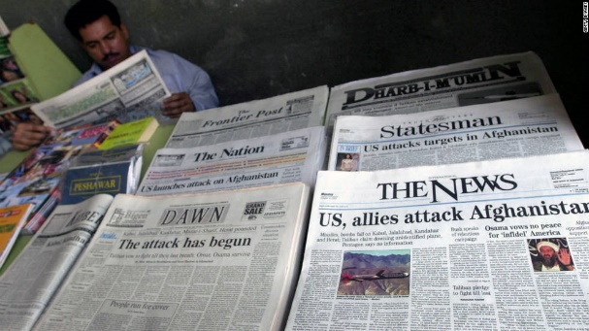

Dubbed “Operation Enduring Freedom” in U.S. military parlance, the invasion of Afghanistan was intended to target terrorist mastermind Osama bin Laden’s al-Qaida organization, which was based in the country, as well as the extreme fundamentalist Taliban government that had ruled most of the country since 1996 and supported and protected al-Qaida. The Taliban, which had imposed its extremist version of Islam on the entire country, also perpetrated countless human rights abuses against its people, especially women, girls and ethnic Hazaras. During their rule, large numbers of Afghans lived in utter poverty, and as many as 4 million Afghans are thought to have suffered from starvation.

In the weeks prior to the invasion, both the United States and the U.N. Security Council had demanded that the Taliban turn over Osama bin Laden for prosecution. After deeming the Taliban’s counteroffers unsatisfactory—among them to try bin Laden in an Islamic court—the invasion began with an aerial bombardment of Taliban and al-Qaida installations in Kabul, Kandahar, Jalalabad, Konduz and Mazar-e-Sharif. Other coalition planes flew in airdrops of humanitarian supplies for Afghan civilians. The Taliban called the actions “an attack on Islam.” In a taped statement released to the Arabic al-Jazeera television network, Osama bin Laden called for a war against the entire non-Muslim world.

After the air campaign softened Taliban defenses, the coalition began a ground invasion, with Northern Alliance forces providing most of the troops and the U.S. and other nations giving air and ground support. On 12 NOV, a little over a month after the military action began, Taliban officials and their forces retreated from the capital of Kabul. By early December, Kandahar, the last Taliban stronghold, had fallen and Taliban leader Mullah Mohammed Omar went into hiding rather than surrender. Al-Qaida fighters continued to hide out in Afghanistan’s mountainous Tora Bora region, where they were engaged by anti-Taliban Afghan forces, backed by U.S. Special Forces troops. Al-Qaida soon initiated a truce, which is now believed to have been a ploy to allow Osama bin Laden and other key al-Qaida members time to escape into neighboring Pakistan. By mid-December, the bunker and cave complex used by al-Qaida at Tora Bora had been captured, but there was no sign of bin Laden.

After Tora Bora, a grand council of Afghan tribal leaders and former exiles was convened under the leadership of Hamid Karzai, who first served as interim leader before becoming the first democratically elected president of Afghanistan on December 7, 2004. Even as Afghanistan began to take the first steps toward democracy, however, with more than 10,000 U.S. troops in country, al-Qaida and Taliban forces began to regroup in the mountainous border region between Afghanistan and Pakistan. They continue to engage U.S. and Afghan troops in guerilla-style warfare and have also been responsible for the deaths of elected government officials and aid workers and the kidnapping of foreigners. Hundreds of American and coalition soldiers and thousands of Afghans have been killed and wounded in the fighting.

Afghans continue to make up the largest refugee population in the world, though nearly 3 million have returned to Afghanistan since the fall of the Taliban, further straining the country’s war-ravaged economy.

-o-o-O-o-o-

- Oct 08 1778 – American Revolution: Continentals raid Unadilla » A group of Continental Army soldiers under the command of Colonel William Butler launch an evening attack on Mohawk Chief Joseph Brant’s home village of Unadilla on the Susquehanna River in what is now Otsego County, New York. The assault was retaliation for Brant’s September 17 raid on the town of German Flats, New York. The Continentals were prepared for a full-scale assault, but as they approached Unadilla, about 50 miles west of German Flats, they realized that Chief Brant and the entire encampment of Mohawk Indians had recently deserted the village. Without opposition, the Continental soldiers took Unadilla and set fire to every house, sawmill and barn, reducing the entire village to ashes.

- Oct 08 1862 – Civil War: Battle of Perryville » The Confederate invasion of Kentucky stalls when Union General Don Carlos Buell stops General Braxton Bragg at the Battle of Perryville, the largest Civil War combat to take place in Kentucky. The losses were heavy. Of 23,000 Yankees engaged in the battle, 4,200 were killed, wounded, or missing; of 15,000 Confederates involved, 3,400 were lost. Bragg retreated south to rejoin Smith, and the Confederates slipped back to Tennessee through the Cumberland Gap. Buell did not pursue, and as a result he was replaced by General William Rosecrans. The Confederates abandoned the invasion of Kentucky and it remained firmly in Federal hands for the rest of the war.

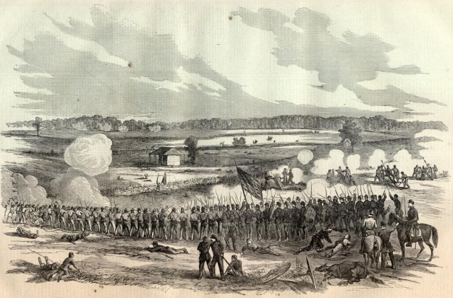

- Oct 08 1871 - Old West: The Great Fire destroys much of Chicago » Fire breaks out in a barn behind the Chicago cottage of Patrick O’Leary. Winds blowing off the prairie fed the flames, and the fire spread rapidly, eventually consuming a four-mile-long and two-third-mile-wide swath of Chicago. When the Great Fire was finally over two days later, nearly 300 people were dead, one hundred thousand were homeless, and Chicago’s booming downtown was in ashes. Despite the devastation, Chicago would rise again and continue to be the economic center of the American West for decades to come.

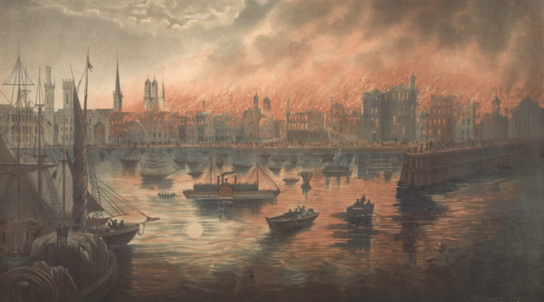
- OCT 08 1906 – U.S.*Cuba: Cuban Pacification Campaign – A U.S. Marine expeditionary force land on Cuba to establish and maintain law and order. The Cuban republic was established after the 1898 Spanish-American War. In 1901 the Platt Amendment, a rider attached to the Army Appropriations Bill of 1901, stipulated the conditions for U.S. intervention in Cuba that virtually made the island an U.S. protectorate. Under the terms of this bill the United States established - and retains to this day - a naval base at Guantanamo Bay. In mid-1906 Cuban internal strife (revolution) caused the United States to invoke the Platt Amendment and send troops to the island nation in an attempt to restore order. William Howard Taft, now Secretary-of-War, sent his Philippine Insurrection veterans, the experienced 11 Cavalry Regiment. Order was soon restored upon the arrival 8 OCT of United States Army troops as occupation forces. Peacekeeping operations continued during the Regiment's two-year stay, demonstrating to the natives that the US Army's Cavalry was ready for any and all eventualities. By 1909 the political situation in Cuba was stable and the regiment was recalled.

- Oct 08 1918 – WWI: U.S. soldier Alvin York displays heroics at Argonne » Corporal Alvin C. York reportedly kills over 20 German soldiers and captures an additional 132 at the head of a small detachment in the Argonne Forest near the Meuse River in France. The exploits later earned York the Congressional Medal of Honor.

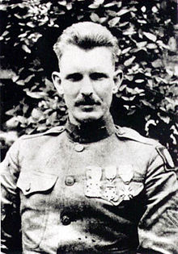

Born in 1887 in a log cabin near the Tennessee-Kentucky border, York was the third of 11 children in a family supported by subsistence farming and hunting. After experiencing a religious conversion, he became a fundamentalist Christian around 1915. Two years later, when the United States entered World War I, York was drafted into the U.S. Army. After being denied conscientious-objector status, York enlisted in the 82nd Infantry Division and in May 1918 arrived in France for active duty on the Western Front. He served in the successful Saint-Mihiel offensive in September of that year, was promoted to corporal and given command of his own squad.

The events of October 8, 1918, took place as part of the Meuse-Argonne offensive—what was to be the final Allied push against German forces on the Western Front during World War I. York and his battalion were given the task of seizing German-held positions across a valley; after encountering difficulties, the small group of soldiers—numbering some 17 men—were fired upon by a German machine-gun nest at the top of a nearby hill. The gunners cut down nine men, including a superior officer, leaving York in charge of the squad.

As York wrote in his diary of his subsequent actions: “[T]hose machine guns were spitting fire and cutting down the undergrowth all around me something awful…. I didn’t have time to dodge behind a tree or dive into the brush, I didn’t even have time to kneel or lie down…. As soon as the machine guns opened fire on me, I began to exchange shots with them. In order to sight me or to swing their machine guns on me, the Germans had to show their heads above the trench, and every time I saw a head I just touched it off. All the time I kept yelling at them to come down. I didn’t want to kill any more than I had to. But it was they or I. And I was giving them the best I had.”

Several other American soldiers followed York’s lead and began firing; as they drew closer to the machine-gun nest, the German commander—thinking he had underestimated the size of the enemy squadron—surrendered his garrison of some 90 men. On the way back to the Allied lines, York and his squad took more prisoners, for a total of 132. Though Alvin York consistently played down his accomplishments of that day, he was given credit for killing more than 20 German soldiers. Promoted to the rank of sergeant, he remained on the front lines until November 1, 10 days before the armistice. In April 1919, York was awarded the highest American military decoration, the Medal of Honor.

Lauded by The New York Times as “the war’s biggest hero” and by General John J. Pershing, commander of the American Expeditionary Force (AEF), as “the greatest civilian soldier” of World War I, York went on to found a school for underprivileged children, the York Industrial Institute (now Alvin C. York Institute), in rural Tennessee. In 1941, his heroism became the basis for a movie, Sergeant York, starring Gary Cooper. Upon York’s death in 1964, U.S. President Lyndon Johnson called him “a symbol of American courage and sacrifice” who epitomized “the gallantry of American fighting men and their sacrifices on behalf of freedom.”

- Oct 08 1941 – WW2: Germans overrun Mariupol, in southern Russia » The German invasion of the Soviet Union begins a new stage, with Hitler’s forces capturing Mariupol. The Axis power reached the Sea of Azov. The capture at the sea’s edge, signaled the beginning of the end of Russia-as least as far as Hitler’s propaganda machine was concerned. “Soviet Russia has been vanquished!” Otto Dietrich, Hitler’s press chief, announced to foreign journalists the very next day.

- Oct 08 1944 – WW2: The Battle of Crucifix Hill – Capt. Bobbie Brown receives a Medal of Honor for his heroics in this battle just outside Aachen on Crucifix Hill.

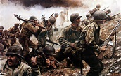

- Oct 08 1950 – Korea: Chinese Communist Forces begin to infiltrate the North Korean Army.

- Oct 08 1968 – Vietnam: U.S. and South Vietnamese navies commence Operation Sealords » This operation was launched in the Mekong Delta. It was ordered by newly appointed Commander Naval Forces Vietnam, Vice-Admiral Elmo R. Zumwalt, Jr., who established Task Force 194 to operate along the canals and less-traveled waterways of the Mekong Delta to interdict Viet Cong infiltration routes from Cambodia. Additionally, TF 194 was to harass Communist forces in the area and, with the assistance of ground and air forces, pacify the Delta region. Under Zumwalt’s direction, U.S. and South Vietnamese naval forces worked together to secure the waterways of the Mekong Delta.

- Oct 08 1970 – Vietnam: Communists reject Nixon's peace proposal » In Paris, a Communist delegation rejects US President Richard Nixon's 7 OCT peace proposal as "a maneuver to deceive world opinion". The North Vietnamese and Viet Cong negotiators refused to even consider Nixon’s proposal, reiterating their previous and long-standing demand for an unconditional and total withdrawal of U.S. forces from Indochina and the overthrow of the “puppet” leaders in Saigon. U.S. officials publicly urged the Soviet Union to use its “considerable influence” with the Communists to persuade them to accept President Nixon’s new proposals, but the North Vietnamese stood their ground.

- Oct 08 1972 – Vietnam: Possible breakthrough at Paris peace talks » Rumors arise that there is a breakthrough in the secret talks that had been going on in a villa outside Paris since August 1969. Henry Kissinger, President Richard Nixon’s national security advisor, and North Vietnamese negotiators conducted the peace talks. Le Duc Tho, who had taken over as chief negotiator for Hanoi from Xuan Thuy, presented a draft peace agreement proposing that two separate administrations remain in South Vietnam to negotiate general elections. This proposal accepted in substance earlier U.S. terms, and by doing so dropped previous Communist demands for a political solution to accompany a military one.

- Oct 08 2001 – Cold War: Office of Homeland Security is founded » Less than one month after the September 11 terrorist attacks Homeland Security is now one of the largest organs of the federal government, charged with preventing terror attacks, border security, immigrations and customs, disaster relief and prevention and other related tasks.

President George W. Bush announced the creation of a new office to “develop and coordinate the implementation of a comprehensive national strategy to secure the United States from terrorist threats or attacks” a mere ten days after September 11. On 8 OCT, former Pennsylvania governor Tom Ridge assumed his role as director and the office opened. Despite concerns about adding to the federal bureaucracy and dramatically re-organizing the security state, Congress officially voted to make the office a cabinet-level department in November of 2002. The Department of Homeland Security eventually absorbed no fewer than 22 agencies into its fold. Entities absorbed by DHS included the Secret Service, Customs and Border Protection and even Coast Guard.

DHS has faced criticism for much of its brief history. Many condemned its response to Hurricane Katrina in 2005—despite having been founded, in part, to coordinate a government-wide disaster response, DHS reportedly did not develop such a plan until two days after Katrina made landfall.

Since the election of Donald Trump, DHS’ border enforcement and immigration duties have come under scrutiny. In particular, many Americans are critical of one DHS office, Immigration and Customs Enforcement (ICE), which was founded in 2003. In recent years, ICE has stepped up its raids on undocumented immigrant communities, leading to a rising number of deportations. ICE is responsible for detaining migrants at America’s southern border, where the conditions of its facilities and its practice of separating detained children from their families have led to widespread condemnation and the rise of an “Abolish ICE” movement.

-o-o-O-o-o-

- Oct 09 1775 – American Revolution: Lord Dartmouth orders British officers to North Carolina » Just a few short months after commanding British soldiers during the Battle of Bunker Hill, General Sir William Howe writes to the British-appointed secretary of state for the American colonies, Lord Dartmouth, to inform him of his belief that the British army should be evacuated from Boston to Rhode Island. From there, British forces could move expeditiously to the southern colonies, without having to go around Cape Cod. As Lord Dartmouth had previously received reports that men were needed in the southern colonies from the likes of Josiah Martin, the royal governor of North Carolina, and John Murray, the royal governor of South Carolina, he ordered General Howe to send officers stationed in Boston to North Carolina to assist Martin in the southern campaign.

- Oct 09 1781 – American Revolution: Americans begin shelling the British surrounded at Yorktown.

- Oct 09 1812 – War of 1812: In a naval engagement on Lake Erie, American forces capture two British ships: HMS Detroit and HMS Caledonia.

- Oct 09 1861 – Civil War: Battle of Santa Rosa Island » Union troops repel a Confederate attempt to capture Fort Pickens. Casualties and losses: US 67 - CSA 87.

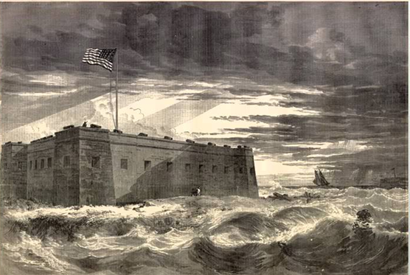

- Oct 09 1863 – Civil War: Confederate cavalry raiders return to Chattanooga after attacking Union General William Rosecrans‘ supply and communication lines all around east Tennessee.

- Oct 09 1864 – Civil War: Battle of Tom's Brook » Union cavalry in the Shenandoah Valley deal a humiliating defeat to their Confederate counterparts at Tom’s Brook, Virginia. At dawn Generals Custer and Merritt and their respective forces attacked the two wings of the Confederate cavalry. Merritt’s 3,500 Yankees overwhelmed General Lunsford Lomax’s 1,500 troopers, but Custer had more difficulty. His 2,500 men faced 3,000 men under the command of Rosser, who was, coincidentally, a close friend of Custer’s at West Point before the war. Custer observed that the Rebels were protected by the high bank of Tom’s Creek, so he sent three of his regiments around Rosser’s flank. Both groups of Confederates broke in retreat. The Yankees pursued the defeated Confederates for over 20 miles, a flight called the Woodstock Races. The chase ended only when the Confederates reached the safety of confederate General Jubal Early’s infantry. Casualties and losses: US 57 - CSA 350.

- Oct 09 1914 – WWI: Siege of Antwerp » Antwerp, Belgium falls to German troops after 12 days. Casualties and losses: Ger Unk – GB 2437, Netherlands 33,000 interned & 30,000 Captured.

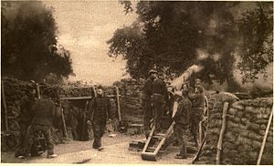
Belgian artillery position around Antwerp

- Oct 09 1915 – WWI: Belgrade falls to Austria-Hungary » Austro-Hungarian forces capture the Serbian capital of Belgrade, assisted in their defeat of Serbian forces by German troops under the command of General August von Mackensen. Of all the belligerent nations during World War I, Serbia suffered the greatest number of casualties in relation to the size of its population. Its losses were staggering: Of some 420,000 soldiers in September 1915, 94,000 were killed in action and another 174,000 were captured or missing, while undoubtedly great numbers of civilian casualties remained uncalculated.

- Oct 09 1934 – Hungary: In Marseilles, a Macedonian revolutionary associated with Croat terrorists in Hungary assassinates King Alexander of Yugoslavia and French Foreign Minister Louis Barthou. The two had been on a tour of European capitals in quest of an alliance against Nazi Germany. The assassinations bring the threat of war between Yugoslavia and Hungary, but confrontation is prevented by the League of Nations.

- Oct 09 1940 – WW2: St. Paul's Cathedral bombed » During the Battle of Britain, the German Luftwaffe launches a heavy nighttime air raid on London. The dome of St. Paul’s Cathedral was pierced by a Nazi bomb, leaving the high altar in ruin. It was one of the few occasions that the 17th-century cathedral suffered significant damage during Germany’s nearly ceaseless bombing raids on London in the fall of 1940.

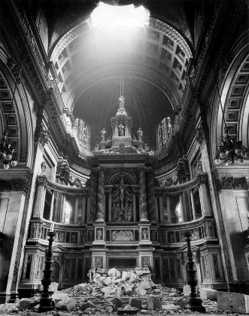

According to tradition, a Roman temple to the goddess Diana once stood on Ludgate Hill at the site of St. Paul’s Cathedral. In 604 A.D., King Aethelberht I dedicated the first Christian cathedral there to St. Paul. That cathedral burned, and its replacement was destroyed by Vikings in 962. A third cathedral was destroyed by fire in 1087 and was replaced by a grand Norman structure that was completed in the 13th century. In the 16th century, the fourth cathedral fell into disrepair and was damaged by fire, and further harm was done during the English civil wars of the 17th century. In the 1660s, the English architect Sir Christopher Wren was enlisted to repair the cathedral, but the Great Fire of London intervened, destroying Old St. Paul’s Cathedral in 1666.

In the aftermath of the fire, Wren designed a new St. Paul’s Cathedral, with dozens of smaller new churches ranged around it like satellites. The cathedral was Wren’s masterpiece, featuring a baroque design and a prominent, stately dome. Wren himself set down the foundation block in 1675 and in 1710 put the final stone in place. When the architect died in 1723, he was buried with great ceremony in St. Paul’s. An inscription near his tomb reads, Lector, si monumentum requiris, circumspice–Latin for “Reader, if you seek a monument, look about you.” Many other notable British citizens later joined him in St. Paul’s crypts, including the military heroes Lord Nelson and the Duke of Wellington.

St. Paul’s Cathedral became an inspiration to the British people during World War II. In the Battle of Britain, the Luftwaffe attempted to bomb Britain into submission by pounding London and other major cities, but St. Paul’s miraculously escaped major bomb damage, even as historic buildings nearby were reduced to rubble. Images of St. Paul’s framed by smoke and fire became a symbol of Britain’s indomitable spirit. Civilian defense brigades, including the St. Paul’s Fire Watch, protected the structure from fire, and at one point an unexploded bomb was removed at great risk from the roof of the cathedral. Despite the damage caused on the night of October 9, 1940, the cathedral survived the Blitz largely intact. In 1944, St. Paul’s bells rang out to celebrate the liberation of Paris, and in 1945 services marking the end of the war in Europe were attended by 35,000 people.

- Oct 09 1941 – WW2: President Franklin D. Roosevelt requests congressional approval for arming U.S. merchant ships.

- Oct 09 1942 – WW2: The last day of the October Matanikau action on Guadalcanal as United States Marine Corps forces withdraw back across the Matanikau River after destroying most of the Imperial Japanese Army's 4th Infantry Regiment.

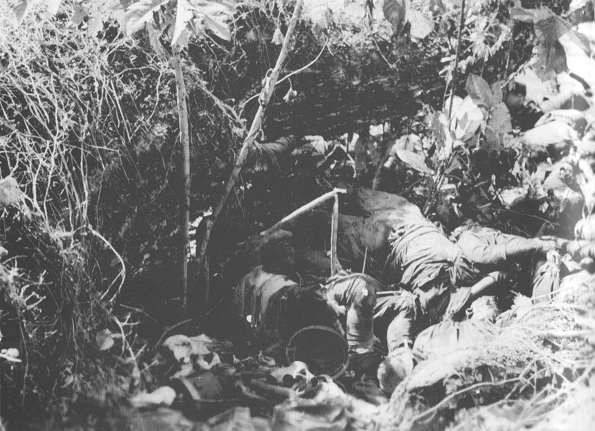
Dead soldiers from the Japanese 2nd Battalion, 4th Infantry Regiment lie piled in a ravine after being killed by mortar and small arms fire from U.S. Marines on 9 October 1942

- Oct 09 1944 – WW2: Churchill and Stalin confer » British Prime Minister Winston Churchill and Soviet Premier Joseph Stalin begin a nine-day conference in Moscow, during which the war with Germany and the future of Europe are discussed. Germany’s defeat now seemed inevitable, and Stalin was prepared to commit the USSR to intervening in the war against Japan once Germany had formally surrendered. This optimistic outlook enabled a significant portion of the talks to center on the relative spheres of influence of the two superpowers in a postwar European environment. Churchill ceded the disposition of Romania, which Stalin’s troops were liberating from German control even as the conference commenced, to the Soviet Union. But the British prime minister was keen on keeping the Red Army away from Greece. “Britain must be the leading Mediterranean power.” They made a deal: Romania for Greece.

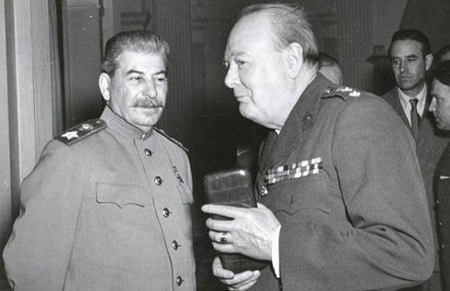

- Oct 09 1950 – Korea: U.N. forces, led by the First Cavalry Division, cross the 38th parallel in South Korea and begin attacking northward towards the North Korean capital of Pyongyang.

- Oct 09 1952 – Korea: Total Dead » The US Defense department has released the latest figures on those killed so far in the Korean War, it now stands at 120,269. The Army draft call for the upcoming month of December has been announced and it will be 47,000.

- Oct 09 1966 – Vietnam: Dien Nien–Phuoc Binh massacre » Over 2 days South Korean forces massacre 280 unarmed citizens in Tịnh Sơn village. Most of the victims were children, elderly and women. Troops also set fire to the Binh Tai villagers’ homes and shoot 68 of its villagers who fled the burning buildings.

- Oct 09 1967 – Bolivia: Che Guevara is assasinated » Socialist revolutionary and guerilla leader Che Guevara, age 39, is killed by the Bolivian army. The U.S.-military-backed Bolivian forces captured Guevara on 8 OCT while battling his band of guerillas in Bolivia and assassinated him the following day. His hands were cut off as proof of death and his body was buried in an unmarked grave. In 1997, Guevara’s remains were found and sent back to Cuba, where they were reburied in a ceremony attended by President Fidel Castro and thousands of Cubans.

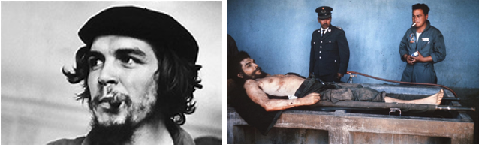

Ernesto Rafael Guevara de la Serna was born to a well-off family in Argentina in 1928. While studying medicine at the University of Buenos Aires, he took time off to travel around South America on a motorcycle; during this time, he witnessed the poverty and oppression of the lower classes. He received a medical degree in 1953 and continued his travels around Latin America, becoming involved with left-wing organizations. In the mid-1950s, Guevara met up with Fidel Castro and his group of exiled revolutionaries in Mexico. Guevara played a key role in Castro’s seizure of power from Cuban dictator Fulgencio Batista in 1959 and later served as Castro’s right-hand man and minister of industry. Guevara strongly opposed U.S. domination in Latin America and advocated peasant-based revolutions to combat social injustice in Third World countries. Castro later described him as “an artist of revolutionary warfare.”

Guevara resigned—some say he was dismissed—from his Cuban government post in April 1965, possibly over differences with Castro about the nation’s economic and foreign policies. Guevara then disappeared from Cuba, traveled to Africa and eventually resurfaced in Bolivia, where he was killed. Following his death, Guevara achieved hero status among people around the world as a symbol of anti-imperialism and revolution. A 1960 photo taken by Alberto Korda of Guevara in a beret became iconic and has since appeared on countless posters and T-shirts. However, not everyone considers Guevara a hero: He is accused, among other things, of ordering the deaths of hundreds of people in Cuban prisons during the revolution. Since his death, Guevara has been idolized as a hero of leftist Third World revolution.

- Oct 09 1969 – Vietnam: The National Guard breaks up protests at home » In the United States, the National Guard is called in as demonstrations continue in Chicago protesting the trial of the “Chicago Eight.” The trial had begun on September 24 and involved charges against David Dellinger, Rennie Davis, Thomas Hayden, Abbie Hoffman, Jerry Rubin, Lee Weiner, John Froines, and Bobby Seale for conspiracy to cross state lines with intent to cause a riot. These charges stemmed from the violent antiwar demonstrations in Chicago during the 1968 Democratic National Convention.

- Oct 09 1969 – Vietnam: Laird describes new orders to U.S. commanders in Vietnam » U.S. Secretary of Defense Melvin Laird, reporting on Chairman of the Joint Chiefs of Staff General Earle Wheeler’s trip to Vietnam at a news conference in Washington, announces that U.S. commanders in Vietnam have been given new orders aimed at placing the “highest priority” on shifting the burden of the fighting to the South Vietnamese forces. Laird described the new tactics as “protective reaction,” but said that the new orders did not forbid U.S. commanders from seeking out and attacking enemy troops that posed threats.

- Oct 09 1970 – Cambodia: Khmer Republic proclaimed in Cambodia » In March, a coup led by Cambodian General Lon Nol had overthrown the government of Prince Norodom Sihanouk in Phnom Penh. Between 1970 and 1975, Lon Nol and his army, the Forces Armees Nationale Khmer (FANK), with U.S. support and military aid, fought the Communist Khmer Rouge for control of Cambodia. During those five years of bitter fighting, approximately 10 percent of Cambodia’s 7 million people died. When the U.S. forces departed South Vietnam in 1973, both the Cambodians and South Vietnamese found themselves fighting the Communists alone. Without U.S. support, Lon Nol’s forces succumbed to the Khmer Rouge in April 1975. The Khmer Rouge promptly evacuated Phnom Penh and set about to reorder Cambodian society, which resulted in a killing spree and the notorious “killing fields.” Under the brutal rule of the Khmer Rouge, hundreds of thousands of Cambodians were murdered or died from exhaustion, hunger, and disease.

- Oct 09 1983 – Korea: The president of South Korea, Doo Hwan Chun, with his cabinet and other top officials are scheduled to lay a wreath on a monument in Rangoon, Burma, when a bomb explodes. Hwan had not yet arrived and so escaped injury, but 17 Koreans–including the deputy prime minister and two other cabinet members–and two Burmese are killed. North Korea is blamed.

- Oct 09 1991 – USA: Defense secretary Dick Cheney defended the Pentagon policy of a ban on homosexuals in the military stating we shouldn't take any step that undermines the overall fighting effectiveness of our military forces.

- Oct 09 2006 – North Korea: Announces it has carried out its first test of a nuclear weapon, becoming the world’s 9th Nuclear Power. Israel is believed to have nuclear warheads but has never been confirmed.

- Oct 09 2007 – Iraq: Blackwater - Iraq has demanded that the US ends its use of private security firm Blackwater within six months in Iraq and demanded Blackwater pay $8m compensation to each family bereaved by last month's shootings by Blackwater staff of 17 Iraq Iraqi civilians.

-o-o-O-o-o-

- Oct 10 1775 – American Revolution: Howe named commander in chief of British army » General William Howe is named the interim commander in chief of the British army in America replacing Lieutenant General Thomas Gage. He was permanently appointed to the post in April 1776.

General Howe’s first major battles against his American counterpart, General George Washington, including the Battle of Bunker Hill, came during the Patriot siege of Boston. They proved to be disappointing failures that resulted in a British retreat from Boston in March 1776. Howe and the British army redeemed themselves, however, with a victory over Washington and the Continental Army at the Battle of Long Island in August. Just one month later, Howe led a British invasion of New York City. While successful during the fall of 1776, many believe General Howe missed an opportunity to crush General Washington and the Continental Army by not pursuing the Patriots as they retreated from New York.

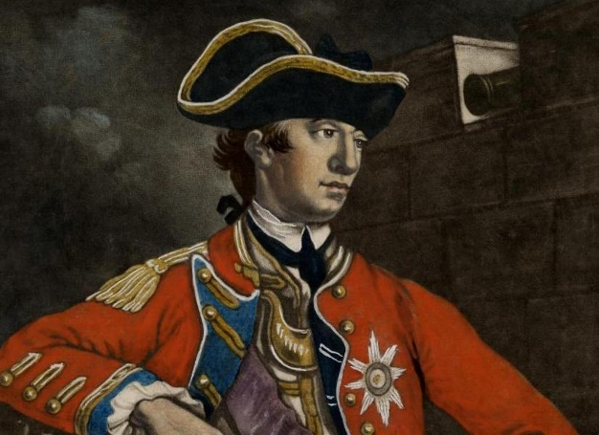

Howe again defeated Washington and the Continental Army at the Battle of Brandywine in September 1777, but decided to then launch an attack against Philadelphia instead of coming to the aid of British General John Burgoyne at the Battle of Saratoga as planned. Without the support of Howe and his men, the British army at Saratoga was overwhelmed and forced to surrender to American General Horatio Gates on October 17, 1777. The American victory at the Battle of Saratoga was one of the turning points of the Revolutionary War and General Howe’s decision not to support it proved a major failure in judgment.

Burgoyne placed the blame for the British loss at the Battle of Saratoga squarely on Howe’s shoulders. Within a month, Howe requested that he be relieved of his duty as commander in chief of the British army, and, in the spring of 1778, he was replaced by General Henry Clinton. Upon his return to England, Howe received so much criticism that, in 1779, Parliament was forced to open an investigation into his military conduct in America.

Howe was cleared of any wrongdoing by the investigation and went on to become the governor of Berwick. Upon his brother’s death in 1799, Howe inherited his Irish title and was named a viscount. He also became governor of Plymouth and a privy councilor (advisor to the king) prior to his death on July 12, 1814, at the age of 84.

- Oct 10 1812 – War of 1812: In a naval engagement on Lake Erie, American forces capture two British ships: HMS Detroit and HMS Caledonia.

- Oct 10 1845 – U.S. Navy: Birth of the U.S. Naval Academy » The Naval School, now known as the Naval Academy, opens in Annapolis, Md. with 50 midshipmen and seven professors. The first superintendent, Cmdr. Franklin Buchanan, later becomes an admiral in the Confederate Navy and commands the Confederate forces at Mobile Bay, Ala.

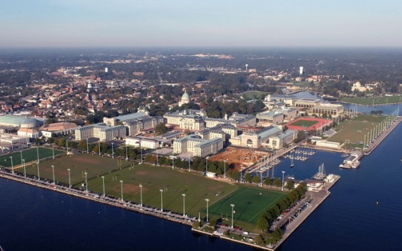

- Oct 10 1860 – U.S. Navy: USS San Jacinto, commanded by Capt. T.A. Dorwin, captures the slave ship Bonito in the South Atlantic with about 622 slaves onboard. Bonito is then taken into naval service.

- Oct 10 1861 – Civil War: Battle of Santa Rosa Island – Union troops repel a Confederate attempt to capture Fort Pickens.

- Oct 10 1862 – Civil War: John Magruder sent to Texas » Confederate General John Bankhead Magruder is given command of the Trans-Mississippi Department.

- Oct 10 1862 – Civil War: In the aftermath of the Battle of Antietam, Confederate General J.E.B. Stuart and his men loot Chambersburg, Pennsylvania, during a raid into the north.

- Oct 10 1864 – Civil War: Battle of Tom's Brook – Union cavalrymen in the Shenandoah Valley defeat Confederate forces at Tom's Brook, Virginia.

- Oct 10 1877 – U.S. Army: Custer's funeral is held at West Point » The U.S. Army holds a West Point funeral with full military honors for Lieutenant-Colonel George Armstrong Custer. Killed the previous year in Montana by Sioux and Cheyenne Indians at the Battle of the Little Big Horn, Custer’s body had been returned to the East for burial on the grounds of the U.S. Military Academy at West Point, New York, where Custer had graduated in 1861-at the bottom of his class.

Even before the Battle of the Little Big Horn, Custer had won national fame as a bold-and some said foolhardy-Civil War commander who eventually became the youngest major general in the U.S. Army. A handsome man, famous for his long blond hair (though he cut it short while in the field), Custer, even after the Civil War, continued to attract the appreciative attention of newspapers and the nation as a lieutenant colonel in the 7th Cavalry, a unit recently created to fight in the western Indian wars. Reports that Custer treated deserters of the 7th with unnecessary cruelty and overworked his soldiers led to a court-martial and conviction in 1867. But Custer redeemed himself, at least in the eyes of some, with his subsequent attack on a winter camp of Cheyenne in on the Washita River. Others, though, faulted Custer for attacking a peaceful band of Cheyenne and leaving behind some of his men when he withdrew from the battle under cover of night.

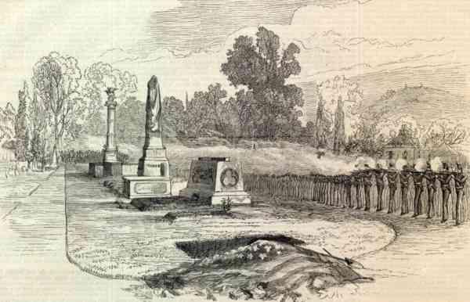

Though Custer was controversial in his day, his spectacular death at the Little Big Horn transformed him into a beloved martyr in the eyes of many Americans, especially those who were calling for wholesale war against the Indians. Some newspapers began to refer to Custer as the “American Murat,” a reference to a famous martyr of the French Revolution, and they called for decisive retaliation against the “treacherous Indians” who had murdered the golden-haired general. Others refused to believe that Custer’s own tactical mistakes could alone explain the disaster at Little Big Horn, and they instead sought to place the blame on the shoulders of other commanders who had been at the battle. (Tellingly, no one suggested that clever tactics and leadership by the Indians might have been the cause for Custer’s defeat.) Custer’s widow, Elizabeth, also worked to transform her husband into a legend by writing several adulatory books chronicling his career. Hundreds of other books and movies, many of them more fiction than history, helped cement the image of Custer as the great fallen leader of the Indian wars in many American minds.

Custer’s status as a national hero and martyr only began to be seriously questioned in the 1960s, and since then he has often been portrayed as a vain and glory-seeking man whose own ineptitude was all the explanation needed for the massacre at Little Big Horn. The truth about George Custer is probably somewhere in between these two extremes.

- Oct 10 1916 – WWI: Eighth Battle of the Isonzo » Italian forces during World War I initiate the Eighth Battle of the Isonzo, essentially continuing a previous assault on Austrian positions near the Isonzo River and attempting to increase gains made during previous battles in the same region. The The battle fought from October 10-12, 1916, was a continuation of these Italian attempts to extend their positions at Gorizia. As in the previous month, the short, concentrated burst of fighting resulted in heavy Italian casualties, prompting Cadorna to call the offensive off pending his army’s recuperation. Although the Italians made a fifth and final attack of the year, the Ninth Battle of the Isonzo, on November 1, stalemate in the region continued until the following October, when Austria-Hungary called on its ally, Germany, for reinforcements in the region. The resulting offensive, the Twelfth Battle of the Isonzo, or the Battle of Caporetto, was a decisive victory for the Central Powers, and a crushing blow for the Italian forces—one that resulted in Cadorna’s dismissal and a comprehensive change in strategy. By war’s end, Italy had suffered some 600,000 casualties—fully half of those came in the Isonzo region.

- Oct 10 1923 – U.S. Navy: The first American-built rigid airship USS Shenandoah (ZR 1), powered by helium gas instead of hydrogen, is christened at Naval Air Station Lakehurst, N.J. On Sept. 3, 1925, USS Shenandoah encountered violent weather over southern Ohio and broke up. Fourteen of her crew lost their lives in this tragedy.

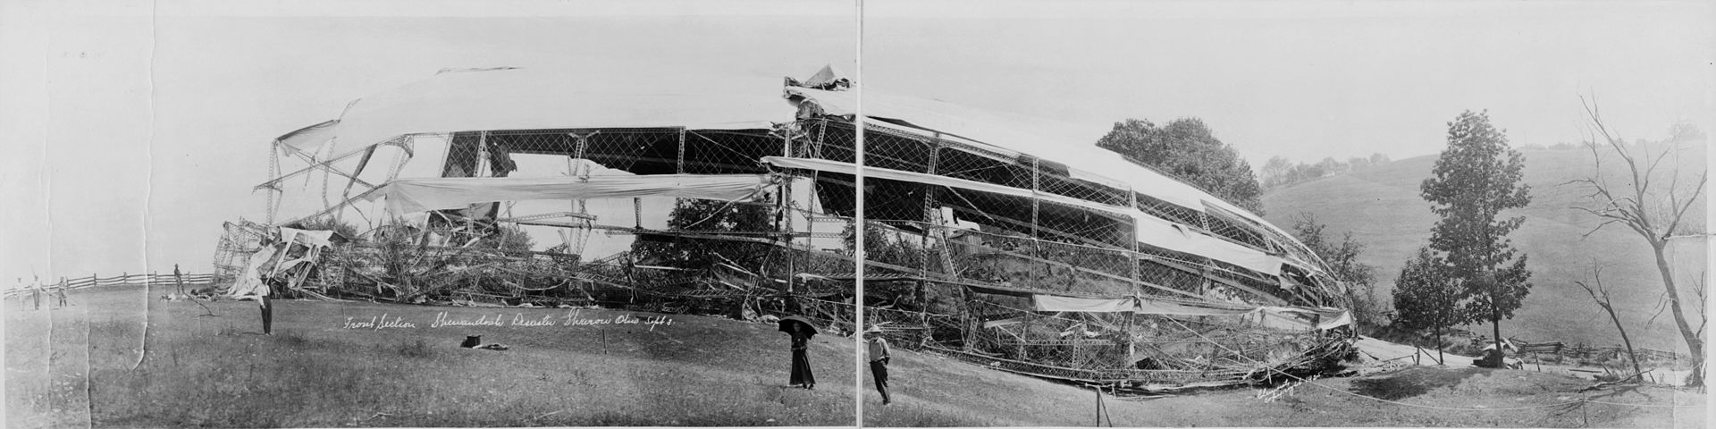
The wreck of the Shenandoah

- Oct 10 1933 – Latin America: At Rio de Janeiro, nations of the Western Hemisphere sign a non-aggression and conciliation treaty. President Roosevelt adopts a “good neighbor” policy toward Latin America and announces a policy of nonintervention in Latin American affairs at the December 7th International American Conference at Montevideo, Uruguay.

- Oct 10 1941 – WW2: Soviet troops halt the German advance on Moscow.

- Oct 10 1942 – WW2: Battle of Cape Esperance – On the northwest coast of Guadalcanal, United States Navy ships intercept and defeat a Japanese fleet on their way to reinforce troops on the island.

- Oct 10 1943 – WW2: USS Bonefish (SS 223) sinks the Japanese army cargo ship Isuzugawa Maru and merchant transport Teibi Maru off Cam Ranh Bay, French Indochina.

- Oct 10 1944 – WW2: US. Forces take Okinawa.

- Oct 10 1944 – WW2: Children gassed to death at Auschwitz » On this day 800 Gypsy children, including more than a hundred boys between 9 and 14 years old are systematically murdered.

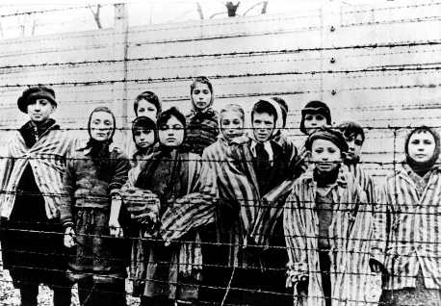

Auschwitz was really a group of camps, designated I, II, and III. There were also 40 smaller “satellite” camps. It was at Auschwitz II, at Birkenau, established in October 1941, that the SS created a complex, monstrously orchestrated killing ground: 300 prison barracks; four “bathhouses,” in which prisoners were gassed; corpse cellars; and cremating ovens. Thousands of prisoners were also used as fodder for medical experiments, overseen and performed by the camp doctor, Josef Mengele (“the Angel of Death”).

A mini-revolt took place on 7 OCT. As several hundred Jewish prisoners were being forced to carry corpses from the gas chambers to the furnace to dispose of the bodies, they blew up one of the gas chambers and set fire to another, using explosives smuggled to them from Jewish women who worked in a nearby armaments factory. Of the roughly 450 prisoners involved in the sabotage, about 250 managed to escape the camp during the ensuing chaos. They were all found and shot. Those co-conspirators who never made it out of the camp were also executed, as were five women from the armaments factory-but not before being tortured for detailed information on the smuggling operation. None of the women talked.

Gypsies, too, had been singled out for brutal treatment by Hitler’s regime early on. Deemed “carriers of disease” and “unreliable elements who cannot be put to useful work,” they were marked for extermination along with the Jews of Europe from the earliest years of the war. Approximately 1.5 million Gypsies were murdered by the Nazis. In 1950, as Gypsies attempted to gain compensation for their suffering, as were other victims of the Holocaust, the German government denied them anything, saying, “Gypsies have been persecuted under the Nazis not for any racial reason but because of an asocial and criminal record.” They were stigmatized even in light of the atrocities committed against them.

- Oct 10 1953 – U.S.*South Korea: The Mutual Defense Treaty between the US and South Korea is signed.

- Oct 10 1957 – Cold War: President Dwight D. Eisenhower apologizes to African diplomat » In the conclusion to an extremely embarrassing situation, President Dwight D. Eisenhower offers his apologies to Ghanian Finance Minister, Komla Agbeli Gbdemah, who had been refused service at a restaurant in Dover, Delaware. It was one of the first of many such incidents in which African diplomats were confronted with racial segregation in the United States. While the matter might appear rather small relative to other events in the Cold War, the continued racial slights to African (and Asian) diplomats during the 1950s and 1960s were of utmost concern to U.S. officials. During those decades the United States and the Soviet Union were competing for the “hearts and minds” of hundreds of millions of people of color in Asia and Africa.

- Oct 10 1965 – Vietnam: 1st Cavalry Division commences operations » In the first major operation since arriving the previous month, the U.S. 1st Cavalry Division (Airmobile) joins with South Vietnamese Marines to strike at 2,000 North Vietnamese troops 25 miles from An Khe in the Central Highlands. Faulty U.S.-South Vietnamese coordination prevented their forces from entrapping the North Vietnamese Army 325th Infantry Division, but they managed to reopen Route 19, between Pleiku and An Khe, the main east-west supply route in the region.

- Oct 10 1966 – Vietnam: Operation Robin – U.S. Forces launch operation in Hoa Province south of Saigon to provide road security between villages.

- Oct 10 1969 – Vietnam: U.S. Navy transfers vessels to South Vietnamese » The U.S. Navy transfers 80 river-patrol boats to the South Vietnamese Navy in the largest single transfer of naval equipment since the war began. This was part of the ongoing Vietnamization program, which had been announced by President Richard Nixon at Midway in June. Under this program, the United States sought to turn over responsibility for the fighting to the South Vietnamese so that U.S. troops could be withdrawn from Vietnam.

- Oct 10 1972 – Vietnam: A race riot involving 100 to 200 Afro American sailors occurs on the United States Navy aircraft carrier Kitty Hawk off the coast of Vietnam during Operation Linebacker.

- Oct 10 1985 – U.S. Navy: Navy F-14's launch from USS Saratoga (CV 60), intercept an Egyptian 737 airliner over international waters, and direct it to Sigonella, Sicily. The airliner was carrying four Middle Eastern terrorists who hijacked the Italian cruise ship Achille Lauro on 7 OCT and murdered a U.S. citizen. The hijackers are taken into custody.

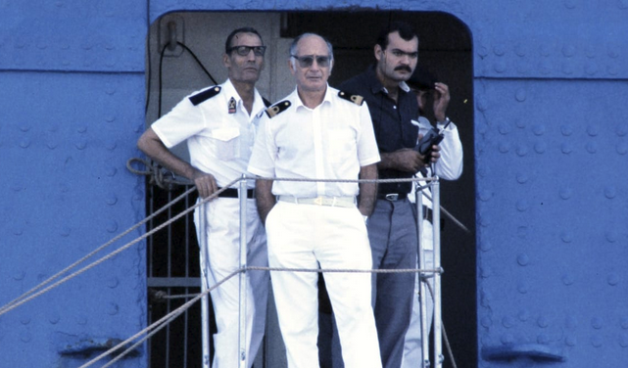

- Oct 10 2008 – Afghanistan: Orakzai bombing takes place in Afghanistan: members of the Taliban drive an explosive-laden truck into a meeting of 600 people discussing ways to rid their area of the Taliban; the bomb kills 110.

-o-o-O-o-o-
Stop
- Oct 11 1776 – American Revolution: Battle of Valcour Island » A British fleet under Sir Guy Carleton defeats 15 American gunboats under the command of Brigadier General Benedict Arnold at the Battle of Valcour Island on Lake Champlain. Although nearly all of Arnold’s ships were destroyed, it took more than two days for the British to subdue the Patriot naval force, delaying Carleton’s campaign and giving the Patriot ground forces adequate time to prepare a crucial defense of New York.

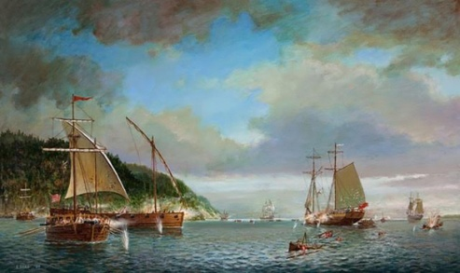

- Oct 11 1845 – U.S. Navy: In Annapolis, Maryland, the Naval School (later renamed the United States Naval Academy) opens with 50 midshipman students and seven professors.

- Oct 11 1862 – Civil War: Stuart hits Pennsylvania » Confederate cavalry leader General J.E.B. Stuart loots Chambersburg, Pennsylvania, on a daring raid in the aftermath of the bloody Battle of Antietam in Maryland.

- Oct 11 1862 – Civil War: The Confederate Congress in Richmond passes a draft law allowing anyone owning 20 or more slaves to be exempt from military service. This law confirms many southerners opinion that they are in a ‘rich man’s war and a poor man’s fight.’

- Oct 11 1915 – WWI: Bulgaria enters World War I » Prime Minister Vasil Radoslavov issues a statement announcing his country’s entrance into the First World War on the side of the Central Powers.

- Oct 11 1942 – WW2: United States defeats Japanese in the Battle of Cape Esperance » On the northwest coast of Guadalcanal, United States Navy ships intercept and defeat a Japanese fleet on their way to reinforce troops on the island. The American Navy continued to harass Japanese ships trying to reinforce the Japanese position on the island; relatively few Japanese troops made it ashore. By the end of 1942, the Japanese were ready to evacuate the island–in defeat.

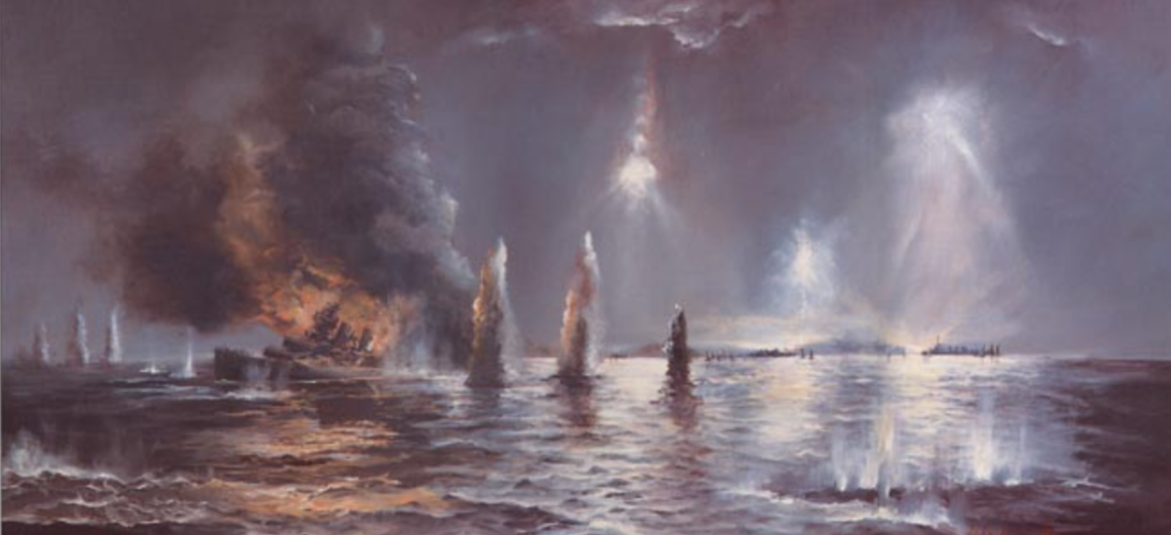

- Oct 11 1943 – WW2: USS Wahoo (SS-238) – Sunk by Japanese naval aircraft, submarine chasers Ch 15 and Ch 43, and minesweeper W.18 in La Perouse Strait off Japan. 80 killed.

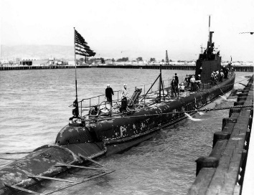

- Oct 11 1954 – Vietnam: Viet Minh take control in the north » The Viet Minh formally take over Hanoi and control of North Vietnam. The Vietnam Doc Lap Dong Minh (Vietnam Independence League), or Viet Minh as it would become known to the world, was a Communist front organization founded by Ho Chi Minh in 1941 to organize resistance against French colonial rule and occupying Japanese forces.

With the end of the Japanese occupation in 1945, the French attempted to reimpose colonial rule. The Viet Minh launched a long and bloody guerrilla war against French colonial forces in what came to be known as the First Indochina War. Ultimately, the Viet Minh, under the leadership of General Vo Nguyen Giap, decisively defeated the French at the Battle of Dien Bien Phu in May 1954. On 1 AUG, the armistice ending the war went into effect. The triumphant Viet Minh marched into Hanoi as the French prepared to withdraw their forces.

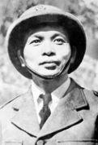
Vo Nguyen Giap

Under the provisions of the agreement signed at the Geneva Conference in July, Vietnam was to be temporarily split into approximately equal halves. The two halves were to be separated by a Demilitarized Zone (DMZ) running along the 17th parallel. The northern half was to be governed by the Democratic Republic of Vietnam, which had been proclaimed by Ho Chi Minh, and the southern half would be governed by the noncommunist State of Vietnam until 1956, at which time the two zones were to be reunified following internationally supervised elections. Ngo Dinh Diem, who had become premier of the State of Vietnam in June, was a Catholic and staunchly anticommunist. Diem disliked the Geneva Accords and set about to consolidate his power in the south. By the middle of 1955, Diem had effectively gained control of most of South Vietnam, and in July of that year, he declared his refusal to permit the elections called for at Geneva. This announcement led to a stepped-up insurgency in the south and ultimately to the Second Indochina War, when North Vietnamese regular units were committed in the south and U.S. forces arrived. Vietnam was not reunited until April 1975, when North Vietnamese troops captured Saigon.

- Oct 11 1972 – Vietnam: A French mission in Vietnam is destroyed by a U.S. bombing raid.

- Oct 11 1972 – Vietnam: A race riot breaks out on the U.S. Navy aircraft carrier Kitty Hawk off the coast of Vietnam during Operation Linebacker. Kitty Hawk will eventually be forced to retire to San Diego and will be removed from the Vietnam War.

- Oct 11 1972 – Vietnam: Last U.S. ground combat unit departs South Vietnam » The last U.S. ground combat unit in South Vietnam, the Third Battalion, Twenty-First Infantry, departs for the United States. The unit had been guarding the U.S. air base at Da Nang. This left only 43,500 advisors, airmen, and support troops left in-country. This number did not include the sailors of the Seventh Fleet on station in the South China Sea or the air force personnel in Thailand and Guam.

- Oct 11 1976 – Post Revolutionary War: George Washington's appointment, posthumously, to the grade of General of the Armies of the United States by congressional joint resolution Public Law 94-479 is approved by President Gerald R. Ford.

- Oct 11 1976 – Cold War: The so-called “Gang of Four,” Chairman Mao Tse-tung’s widow and three associates, are arrested in Peking, setting in motion an extended period of turmoil in the Chinese Communist Party.

- Oct 11 1986 – Cold War: Reagan and Gorbachev meet in Reykjavik » Following up on their successful November 1985 summit meeting in Geneva, President Ronald Reagan and Soviet leader Mikhail Gorbachev meet in Reykjavik, Iceland, to continue discussions about curbing their intermediate missile arsenals in Europe. Just when it appeared that agreement might be reached, the talks fell apart amid accusations and recriminations, and U.S.-Soviet relations took a giant step backwards.

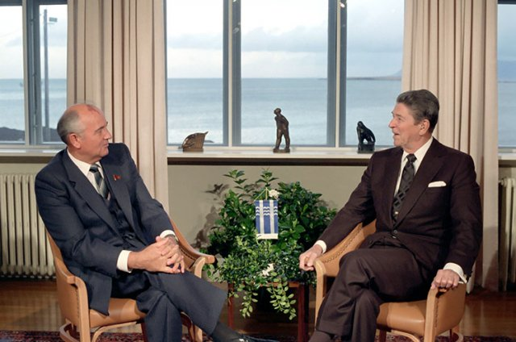

The sticking point arose when Gorbachev requested that the talks concerning the missiles be expanded to include limitations on America’s Strategic Defense Initiative (SDI). Referred to as the “Star Wars” initiative by opponents, SDI was one of Reagan’s pet projects. A multi-billion-dollar program, SDI was supposed to use space technology to provide a “shield” from nuclear attacks. Not surprisingly, Reagan refused to consider Gorbachev’s suggestion, and the talks ended the next day, 12 OCT, with no agreement in hand. Reagan charged the Soviet leader with bad faith in trying to expand the parameters of the talks; back in the Soviet Union, Gorbachev reported that Reagan seemed to be lying about his desire for serious negotiations concerning arms limitations. Talks on the missile issue did not resume until December 1987, when the two leaders met for a third summit in Washington, and Gorbachev dropped his insistence on including SDI in the negotiations.

-o-o-O-o-o-

- Oct 12 1776 – American Revolution: British troops head up East River » British Generals Henry Clinton and William Howe lead a force of 4,000 troops aboard some 90 flat-boats up New York’s East River toward Throg’s Neck, a peninsula in Westchester County, in an effort to encircle General George Washington and the Patriot force stationed at Harlem Heights. After hearing of the British landing at Throg’s Neck, Washington ordered a contingent of troops from the Pennsylvania regiment to destroy the bridge leading from the peninsula to the Westchester mainland. The destruction of the bridge stranded Clinton and his men at Throg’s Neck for six days before they were loaded back onto their vessels and continued up the East River toward Pell Point. With the British stranded at Throg’s Neck, General Washington decided to withdraw all but 2,000 of his troops north to White Plains, before the British could use Redcoats stationed on Long Island and in Westchester County to surround them on Manhattan Island. After stopping at Pell Point, the British continued north up the East River, engaging in daily skirmishes with Washington’s Continental Army, until the two armies—both 13,000 strong—confronted each other at the inconclusive Battle of White Plains, beginning on October 28, 1776. On October 31, after a bad storm, Washington chose to withdraw to New Jersey before Howe could orchestrate another attack with newly arrived reinforcements.

- Oct 12 1861 – Civil War: Confederate ironclad Manassas attacks and rams Union's ironclad Richmond. Manassas suffered the loss of her iron prow and smokestack(s) and had one of her two engines unseated from its mounts, temporarily putting it out of commission. She managed to retire under heavy fire.

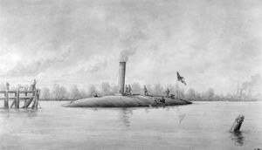

- Oct 12 1870 – Post Civil War: Robert E. Lee dies » General Robert Edward Lee, the commander of the Confederate Army of Northern Virginia, dies peacefully at his home in Lexington, Virginia. He was 63 years old.

Lee was born to Henry Lee and Ann Carter Lee at Stratford Hall, Virginia, in 1807. His father served in the American Revolution under George Washington and was later a governor of Virginia. Robert Lee attended the U.S. Military Academy at West Point and graduated second in his class in 1829. He did not earn a single demerit during his four years at the academy. Afterward, Lee embarked on a military career, eventually fighting in the Mexican War (1846-48) and later serving as the superintendent of West Point.

When the Civil War broke out in 1861, Lee sided with the Confederacy and spent the first year of the war as an advisor to Confederate President Jefferson Davis. He assumed command of the Army of Northern Virginia when Joseph Johnston was wounded in battle in May 1862. Over the next three years, Lee earned a reputation for his brilliant tactics and battlefield leadership. However, his invasions of the North, at Antietam in Maryland and Gettysburg, Pennsylvania, ended in defeat.

After Lee surrendered his army at Appomattox Court House, Virginia, in 1865, he returned to Richmond, Virginia, and an uncertain future. With his military career over, he accepted the presidency of Washington College in Lexington, Virginia. Under his leadership, the struggling institution’s enrollment increased from a few dozen to more than 300 students. He contributed to faculty stability, revamped the curriculum, and improved the physical condition of the campus. He also became a symbol of the defeated South, a dignified and stoic figure who was lionized by North and South alike. Lee suffered a stroke on September 28, 1870, and lingered for two weeks before passing. The school changed its name to Washington and Lee College soon after he died.

- Oct 12 1915 – WWI: British nurse executed in WWI » The 49-year-old British nurse Edith Cavell is executed by a German firing squad in Brussels, Belgium. Before World War I began in 1914, Cavell served for a number of years as the matron of a nurse’s training school in Brussels. After the city was captured and occupied by the Germans in the first month of war, Cavell chose to remain at her post, tending to German soldiers and Belgians alike. In August 1915, German authorities arrested her and accused her of helping British and French prisoners-of-war, as well as Belgians hoping to serve with the Allied armies, to escape Belgium for neutral Holland.

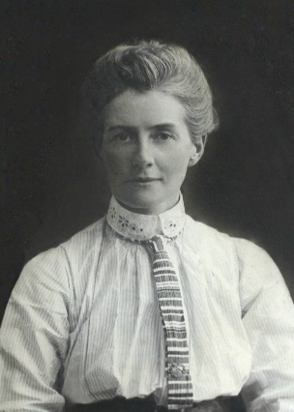

During her trial, Cavell admitted that she was guilty of the offenses with which she had been charged. She was sentenced to death. Though diplomats from the neutral governments of the United States and Spain fought to commute her sentence, their efforts were ultimately in vain. The night before her execution on October 12, 1915, Cavell confided in Reverend Horace Graham, a chaplain from the American Legation, that “They have all been very kind to me here. But this I would say, standing as I do in view of God and eternity: I realize that patriotism is not enough. I must have no hatred or bitterness towards anyone.”

Cavell’s execution led to a rise in anti-German feeling in the United States as well as in Britain, where she was idealized as a heroic martyr to the cause and was honored with a statue in St. Martin’s Place, just off London’s Trafalagar Square. “What Jeanne d’Arc has been for centuries to France,” wrote one Allied journalist, “that will Edith Cavell become to the future generations of Britons.”

- Oct 12 1933 – U.S. Army: The United States Army Disciplinary Barracks on Alcatraz Island, is acquired by the United States Department of Justice

- Oct 12 1942 – WW2: Battle of Cape Esperance (Guadalcanal) ends » The battle, also known as the Second Battle of Savo Island and, in Japanese sources, as the Sea Battle of Savo Island, took place on 11–12 OCT in the Pacific campaign between the Imperial Japanese Navy and United States Navy. The naval battle was the second of four major surface engagements during the Guadalcanal campaign and took place at the entrance to the strait between Savo Island and Guadalcanal in the Solomon Islands. Cape Esperance is the northernmost point on Guadalcanal, and the battle took its name from this point.

On the night of 11 OCT, Japanese naval forces in the Solomon Islands area—under the command of Vice Admiral Gunichi Mikawa—sent a major supply and reinforcement convoy to their forces on Guadalcanal. The convoy consisted of two seaplane tenders and six destroyers and was commanded by Rear Admiral Takatsugu Jojima. At the same time, but in a separate operation, three heavy cruisers and two destroyers—under the command of Rear Admiral Aritomo Gotō—were to bombard the Allied airfield on Guadalcanal (called Henderson Field by the Allies) with the object of destroying Allied aircraft and the airfield's facilities.

Shortly before midnight on 11 OCT, a U.S. force of four cruisers and five destroyers—under the command of Rear Admiral Norman Scott—intercepted Gotō's force as it approached Savo Island near Guadalcanal. Taking the Japanese by surprise, Scott's warships sank one of Gotō's cruisers and one of his destroyers, heavily damaged another cruiser, mortally wounded Gotō, and forced the rest of Gotō's warships to abandon the bombardment mission and retreat. During the exchange of gunfire, one of Scott's destroyers was sunk and one cruiser and another destroyer were heavily damaged. In the meantime, the Japanese supply convoy successfully completed unloading at Guadalcanal and began its return journey without being discovered by Scott's force. Later on the morning of 12 OCT, four Japanese destroyers from the supply convoy turned back to assist Gotō's retreating, damaged warships. Air attacks by U.S. aircraft from Henderson Field sank two of these destroyers later that day.

As with the preceding naval engagements around Guadalcanal, the strategic outcome was inconclusive because neither the Japanese nor United States navies secured operational control of the waters around Guadalcanal as a result of this action. However, the Battle of Cape Esperance provided a significant morale boost to the U.S. Navy after the failure at Savo Island.

- Oct 12 1943 – WW2: The U.S. Fifth Army begins an assault crossing of the Volturno River in Italy.

- Oct 12 1944 – WW2: The Axis occupation of Athens comes to an end. The occupation has ruined the Greek economy and brought about terrible hardships for the Greek civilians.

- Oct 12 1945 - WW2: Conscientious objector wins Medal of Honor » Private First Class Desmond T. Doss of Lynchburg, Virginia, is presented the Congressional Medal of Honor for outstanding bravery as a medical corpsman, the first conscientious objector in American history to receive the nation’s highest military award. When called on by his country to fight in World War II, Doss, a dedicated pacifist, registered as a conscientious objector. Eventually sent to the Pacific theater of war as a medical corpsman, Doss voluntarily put his life in the utmost peril during the bloody battle for Okinawa, saving dozens of lives well beyond the call of duty.

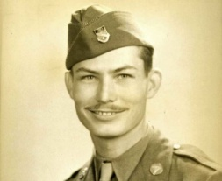

- Oct 12 1960 – Cold War: Nikita Khrushchev throws a tantrum at the United Nations » In one of the most surreal moments in the history of the Cold War, the Russian leader removes his shoe and pounds a table with it in protest against a speech critical of Soviet policy in Eastern Europe. During a debate over a Russian resolution decrying colonialism, a representative of the government of the Philippines charged the Soviets with employing a double standard, pointing to their domination of Eastern Europe as an example of the colonialism they were criticizing in their resolution. In response, Khrushchev took off one of his shoes and began to furiously pound the table. The chaotic scene finally ended when General Assembly President Frederick Boland (Ireland) broke his gavel calling the meeting to order, but not before the image of Khrushchev as a hotheaded buffoon was indelibly etched into America’s collective memory.
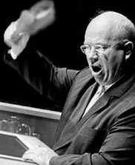

- Oct 12 1964 – Cold War: USSR leads the space race » The Soviet Union launches Voskhod 1 into orbit around Earth, with cosmonauts Vladamir Komarov, Konstantin Feoktistov, and Boris Yegorov aboard. Voskhod 1 was the first spacecraft to carry a multi-person crew, and the two-day mission was also the first flight performed without space suits. In the late 1950s and early 1960s, the U.S. space program consistently trailed the Soviet program in space firsts, a pattern that drastically shifted with the triumph of the U.S. lunar program in the late 1960s and early 1970s.

- Oct 12 1967 – Vietnam: Dean Rusk criticizes Congress while fighting continues in South Vietnam » US Secretary of State states during a news conference that proposals by the U.S. Congress for peace initiatives are futile because of North Vietnam's opposition.

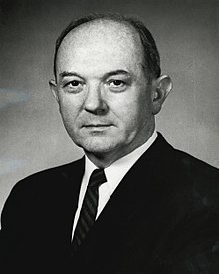

- Oct 12 1970 – Vietnam: Nixon announces another round of troop withdrawals » The President announces the pullout of 40,000 more American troops in Vietnam by Christmas.

- Oct 12 1972 – U.S. Navy: Racial violence flares aboard U.S. Navy ships » Forty six sailors are injured in a race riot involving more than 100 sailors on the aircraft carrier USS Kitty Hawk enroute to her station in the Gulf of Tonkin off Vietnam. The incident broke out when a black sailor was summoned for questioning regarding an altercation that took place during the crew’s liberty in Subic Bay (in the Philippines). The sailor refused to make a statement and he and his friends started a brawl that resulted in sixty sailors being injured during the fighting. Eventually 26 men, all black, were charged with assault and rioting and were ordered to appear before a court-martial in San Diego.

Four days later, a group of about 12 black sailors aboard the USS Hassayampa, a fleet oiler docked at Subic Bay, told ship’s officers that they would not sail with the ship when the ship put to sea. The group demanded the return of money that allegedly had been stolen from the wallet of one of the group. The ship’s leadership failed to act quickly enough to defuse the situation and later that day, a group of seven white sailors were set upon by the group and beaten. It took the arrival of a Marine detachment to restore order. Six black sailors were charged with assault and rioting.

These incidents indicated the depth of the racial problems in the Navy. All of the services had experienced similar problems earlier, but the Navy had lagged behind the others in addressing the issues that contributed to the racial tensions that erupted on the Kitty Hawk and the Hassayampa. Admiral Elmo R. Zumwalt, Jr., Chief of Naval Operations, instituted new race relations programs and made significant changes to Naval Regulations to address many of the very real issues raised by the black sailors regarding racial injustice in the Navy.

- Oct 12 2000 – Yemen: USS Cole attacked by terrorists » At 12:15 p.m. local time, a motorized rubber dinghy loaded with explosives blows a 40-by-40-foot hole in the port side of the USS Cole, a U.S. Navy destroyer that was refueling at Aden, Yemen. Seventeen sailors were killed and 38 wounded in the attack, which was carried out by two suicide terrorists alleged to be members of Saudi exile Osama bin Laden’s al Qaeda terrorist network.

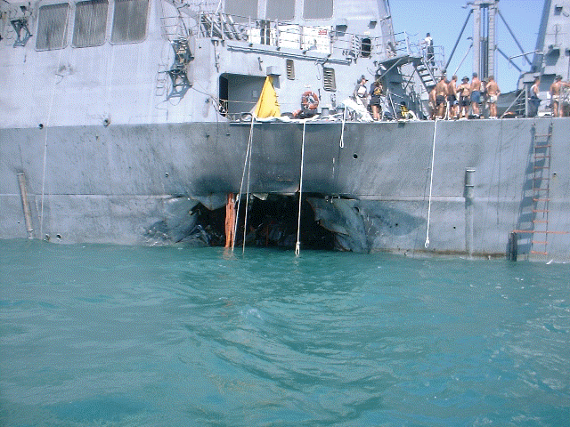

The Cole had come to Aden at the southern tip of the Arabian Peninsula to refuel on its way to join U.S. warships that were enforcing the trade sanctions against Iraq. It was scheduled to remain in the port for just four hours, indicating that the terrorists had precise information about the destroyer’s unannounced visit to the Aden fueling station. The terrorists’ small boat joined a group of harbor ships aiding the Cole moor at a refueling, and they succeeded in reaching the U.S. warship unchallenged. Their dinghy then exploded in a massive explosion that ripped through the Cole’s port side, badly damaging the engine room and adjoining mess and living quarters. Witnesses on the Cole said both terrorists stood up in the moment before the blast.

The explosion caused extensive flooding in the warship, causing the ship to list slightly, but by the evening crew members had managed to stop the flooding and keep the Cole afloat. In the aftermath of the attack, President Bill Clinton ordered American ships in the Persian Gulf to leave port and head to open waters. A large team of U.S. investigators was immediately sent to Aden to investigate the incident, including a group of FBI agents who were focused exclusively on possible links to Osama bin Laden. Bin Laden had been formally charged in the U.S. with masterminding the 1998 bombings of U.S. embassies in Kenya and Tanzania that killed 224 people, including 12 Americans.

Six men believed to be involved in the Cole attack were soon arrested in Yemen. Lacking cooperation by Yemeni authorities, the FBI has failed to conclusively link the attack to bin Laden.

- Oct 12 2000 – Russia: Nuclear submarine “Kursk,” sinks » A Russian nuclear submarine sinks to the bottom of the Barents Sea on this day in 2000; all 118 crew members are later found dead. The exact cause of the disaster remains unknown. The Kursk left port on 10 AUG to take part in war games with the Russian military. Russian ships, planes and submarines met up in the Barents Sea, which is above the Arctic Circle, to practice military maneuvers. On 12 AUG, the Kursk was scheduled to fire a practice torpedo; at 11:29 a.m., before doing so, two explosions spaced shortly apart occurred in the front hull of the submarine and it plunged toward the bottom of the sea.

The Kursk was 500 feet long and weighed 24,000 tons. It had two nuclear reactors and could reach speeds of 28 knots. It was the largest attack submarine in the world, approximately three times the size of the largest subs in the United States Navy.

With the fate of the 118 Russian soldiers onboard the Kursk unknown, several nations offered to contribute to the rescue effort, but the Russian government refused any assistance. When divers finally reached the Kursk a week later, they found no signs of life. Under a great deal of pressure, Russian President Vladimir Putin agreed to raise the submarine from the sea bottom for an investigation, although no ship or object that size had ever before been recovered from the ocean floor. Furthermore, given that the Barents Sea is frozen for most of the year, the operation had only a small window in which to work.

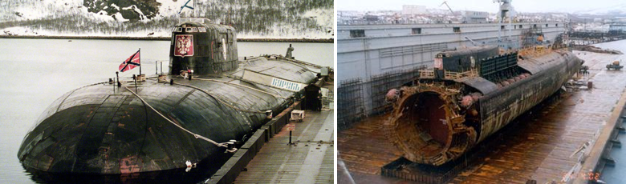

Using $100 million, the best available technology and an international team of experts, the Kursk was raised on September 26, 2001, about a year after the accident. Unfortunately, however, the team was forced to cut off the front hull from the rest of the sub in order to bring it to the surface, leaving the best evidence of what caused the explosions at the bottom of the sea.

- Oct 12 2002 – Indonesia: Terrorists kill 202 in Bali » three bombings shatter the peace in the town of Kuta on the Indonesian island of Bali. Indonesia is the world’s most populous Muslim nation.The blasts, the work of militant Islamist terrorists, left 202 people dead and more than 200 others injured, many with severe burns. The attacks shocked residents and those familiar with the mostly Hindu island, long known as a tranquil and friendly island paradise.

The most deadly of the three blasts occurred when a large bomb, estimated to be about 1,200 kilograms, was detonated in a van outside the town s Sari Club nightclub. The explosion left a large crater in the ground and was said to have blown the windows out of buildings throughout the town. Many of those killed and injured in the blast were young visitors vacationing on the island, most from Australia. Thirty-eight Indonesians, mainly Balinese, were killed.

Two other bombs were also detonated that day: one, packed in a backpack, was detonated in a bar and another was exploded in the street in front of the American consulate. All three were thought to be the work of the regional militant Islamist group Jemaah Islamiah, which is believed to have links to al-Qaida. Jemaah Islamiah is also alleged to be responsible for the bombing of a Marriott hotel in Jakarta in 2003 and the Australian embassy to Indonesia in 2004, as well as the suicide bombing of three restaurants in Bali on October 1, 2005. The second attack on Bali killed 22 people, including the bombers, and injured more than 100 others.

-o-o-O-o-o-

- Oct 13 1775 – American Revolution: Continental Congress authorizes first naval force » The Continental Congress authorizes construction and administration of the first American naval force—the precursor to the United States Navy.

Since the outbreak of open hostilities with the British in April, little consideration had been given to protection by sea until Congress received news that a British naval fleet was on its way. In November, the Continental Navy was formally organized, and on 22 DEC, Esek Hopkins was appointed the first commander in chief of the Continental Navy. Congress also named four captains to the new service: Dudley Saltonstall, Abraham Whipple, Nicholas Biddle and John Burrows Hopkins. Their respective vessels, the 24-gun frigates Alfred and Columbus, the 14-gun brigs Andrew Doria and Cabot, as well as three schooners, the Hornet, the Wasp and the Fly, became the first ships of the Navy’s fleet. Five first lieutenants, including future American hero John Paul Jones, five second lieutenants and three third lieutenants also received their commissions.

Admiral Hopkins, as he was dubbed by George Washington, was first tasked with assessing the feasibility of an attack on British naval forces in the Chesapeake Bay. After sailing south with his meager force of eight ships, Hopkins decided that victory in such an encounter was impossible. He sailed to the Bahamas instead, where he attacked the British port of Nassau, a decision for which he was relieved of his command upon returning to the continent.

During the American Revolution, the Continental Navy successfully preyed on British merchant shipping and won several victories over British warships. This first naval force was disbanded after the war. What is now known as the United States Navy was formally established with the creation of the federal Department of the Navy in April 1798.

- Oct 13 1812 – War of 1812: Battle of Queenston Heights Canada » US forces defeated at a battle near Niagara Falls, on Queenston Heights. To lead the attack on Canada, De Witt Clinton, the governor of New York, appointed a political appointee General Stephen Van Ressler of the New York militia. However, Van Ressler had no previous military experience. By Early October, he amassed a force of 3,500 along the Niagara River to fight 2,000 British and Indian fighters.

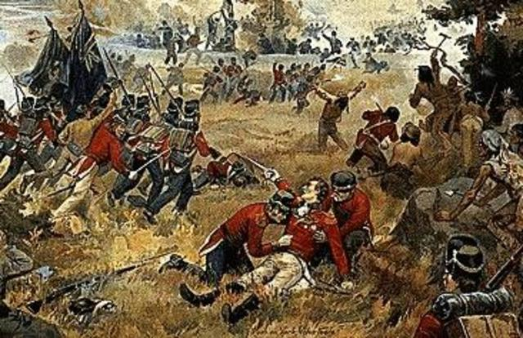

On 13 OCT, General Ressler led a group of 200 men across the River at Queenstown. While crossing the river, Ressler was severely wounded as the British attacked his men. Captain John Wool took command and led a group of experienced soldiers up an unguarded trail leading up to the Heights. British General Brock led a surprise attack against Ressler but his troops were forced to retreat. More of US troops arrived and Brock ordered a counterattack. However, Brock was killed in the assault his troops were pushed off by the Americans. Reinforcements led by Lieutenant Colonel Winfield Scott were sent to help Ressler and it appeared as if victory was on the side of the Americans. Van Ressler ordered the New York Militia to reinforce Scott, but they refused to cross over into Canada.

With more British forces on the way, Ressler feared that Scott would not be able to hold the Heights and ordered him to withdraw promising that there would be boats on the beach waiting to take his men back across. When Scott’s men reached the river there were no boats to be seen. Before long, the British were pouring gunfire down on the Americans from the newly recaptured Heights. The stranded Americans had no choice but to surrender. Three hundred Americans were killed and 938 men, including Scott, were taken prisoner.

- Oct 13 1863 – Civil War: Ohio voters reject Vallandigham » The voters of Ohio send Clement Vallandigham to a resounding defeat in the fall gubernatorial election. As leader of the Copperheads, or anti-war Democrats, Vallandigham was an important and highly visible critic of the Republicans’ war policy, particularly the emancipation of slaves.

- Oct 13 1915 – WWI: The Battle for the Hohenzollern Redoubt marks the end of the Battle of Loos in northern France.

- Oct 13 1942 – WW2: In the first of four attacks two Japanese battleships sail down the slot and shell Henderson field on Guadalcanal in an unsuccessful effort to destroy the American Cactus Air Force.

- Oct 13 1943 – WW2: Italy declares war on Germany » The government of Italy declares war on its former Axis partner Germany and joins the battle on the side of the Allies.

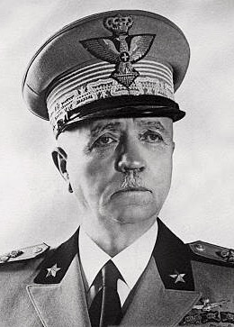
Pietro Badoglio

With Mussolini deposed from power and the collapse of the fascist government in July, Gen. Pietro Badoglio, Mussolini’s former chief of staff and the man who had assumed power in the Duce’s stead by request of King Victor Emanuel, began negotiating with General Eisenhower regarding a conditional surrender of Italy to the Allies. It became a fact on 8 SEP, with the new Italian government allowing the Allies to land in Salerno, in southern Italy, in its quest to beat the Germans back up the peninsula.

The Germans too snapped into action. Ever since Mussolini began to falter, Hitler had been making plans to invade Italy to keep the Allies from gaining a foothold that would situate them within easy reach of the German-occupied Balkans. On the day of Italy’s surrender, Hitler launched Operation Axis, the occupation of Italy. As German troops entered Rome, General Badoglio and the royal family fled to Brindisi, in southeastern Italy, to set up a new antifascist government.

On 13 OCT, Badoglio set into motion the next stage of his agreement with Eisenhower, the full cooperation of Italian troops in the Allied operation to capture Rome from the Germans. It was extremely slow going, described by one British general as “slogging up Italy.” Bad weather, the miscalculation of starting the operation from so far south in the peninsula, and the practice of “consolidation,” establishing a firm base of operations and conjoining divisions every time a new region was captured, made the race for Rome more of a crawl. But when it was over, and Rome was once again free, General Badoglio would take yet one more step in freeing Italy from its fascist past-he would step down from office.

- Oct 13 1966 – Vietnam: McNamara claims that war is progressing satisfactorily » The Defense Secretary declares at a news conference in Saigon that he found that military operations have “progressed very satisfactorily since 1965.” McNamara had arrived in Saigon on October 11 for his eighth fact-finding visit to South Vietnam. He conferred with General William Westmoreland, the senior U.S. military commander; Ambassador Henry Cabot Lodge; various military leaders; and South Vietnam’s Premier Nguyen Cao Ky and President Nguyen Van Thieu.

- Oct 13 1970 – Vietnam: Sir Robert Thompson advises President Nixon » In a report prepared at the request of the President, counterinsurgency expert Sir Robert Thompson explains that smashing the Viet Cong is a prerequisite for solving the political troubles of South Vietnam. After a five-week secret mission to Saigon in September and early October at the request of the president, Thompson reported that U.S. and Allied intelligence and police efforts had failed to destroy the Communist subversive apparatus in South Vietnam. His report concluded that success in other areas of pacification could not solve the basic political problems of South Vietnam after the withdrawal of the bulk of U.S. forces as long as the Viet Cong apparatus remained virtually intact.

- Oct 13 1977 – Germany: Palestinians hijack German airliner » Four Palestinians hijack a Lufthansa airliner and demand the release of 11 imprisoned members of Germany’s Baader-Meinhof terrorist group, also known as the Red Army Faction. The Red Army Faction was a group of ultra-left revolutionaries who terrorized Germany for three decades, assassinating more than 30 corporate, military, and government leaders in an effort to topple capitalism in their homeland.

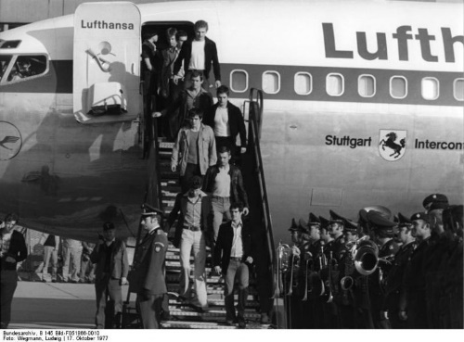

The Palestinian hijackers took the plane on a six-country odyssey, eventually landing at Mogadishu, Somalia, on October 17, after shooting one of the plane’s pilots. Early the next morning, a German Special Forces team stormed the aircraft, releasing 86 hostages and killing three of the four hijackers. Only one of the German commandos was wounded. The Red Army Faction’s imprisoned leaders responded to the news later that day by committing suicide in their jail cell, in Stammheim, Germany.

-o-o-O-o-o-

- Oct 14 1780 – American Revolution: Patriots sting Loyalists at Shallow Ford, North Carolina » In the early morning hours a contingent of approximately 350 Patriot troops from the North Carolina and Virginia militias engages a group of British Loyalists, numbering between 400 and 900, at the Shallow Ford crossing of the Yadkin River in North Carolina. The Patriot militia lost one soldier killed and four wounded while it is believed that the Loyalists lost 14 killed. The Battle of Shallow Ford is considered one of the most important battles for the Patriot cause to take place in North Carolina during the Revolutionary War. It lasted just under 90 minutes.

- Oct 14 1863 – Civil War: Battle of Bristoe Station » Confederate General Robert E. Lee attempts to drive the Union army out of Virginia but fails when an outnumbered Union force repels the attacking Rebels. In a very short engagement, the Confederates suffered 1,400 men killed, wounded, or captured, while the Union lost only 546. “Bury these poor men,” Lee somberly told Hill, “and let us say no more about it.” The Union army was driven back 40 miles from its original positions, and the Confederates destroyed a large section of the Orange and Alexandria Railroad, a key Union supply line.

- Oct 14 1918 – WWI: Adolf Hitler wounded in British gas attack » Among the German wounded in the Belgium Ypres Salient is Corporal Adolf Hitler, temporarily blinded by a British gas shell and evacuated to a German military hospital at Pasewalk, in Pomerania.

- Oct 14 1943 – WW2: U.S. 8th Air Force loses 60 B-17 Flying Fortresses during an assault on Schweinfurt Germany.
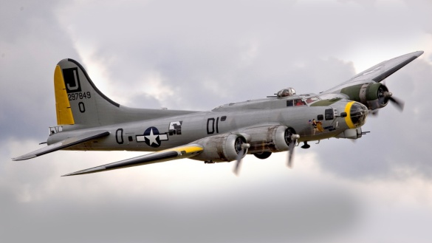

- Oct 14 1944 – WW2: "The Desert Fox" commits suicide » German Gen. Erwin Rommel, nicknamed “the Desert Fox,” is given the option of facing a public trial for treason, as a co-conspirator in the plot to assassinate Adolf Hitler, or taking cyanide. He chooses the latter.

Rommel was born in 1891 in Wurttenberg, Germany, the son of a teacher. Although not descended from military men, the newly unified German empire made it fashionable to choose a military career, which young Rommel did, becoming an officer cadet. During World War I, he showed himself to be a natural leader with unnatural courage, fighting in France, Romania, and Italy. Following the war, he pursued a teaching career in German military academies, writing a textbook, Infantry Attacks, that was well regarded.

At the outbreak of World War II, Rommel was given command of the troops that guarded Hitler’s headquarters, a disappointment for a man used to fighting on the front lines with the infantry. But in early 1940, he was given his chance to put to use his gifts, when he was given command of the 7th Panzer Division. Although a novice as far as mechanized forces were concerned, he soon mastered the advantages and proved his leadership abilities again in the German offensive against the French channel coast in May.

In early 1941, Rommel was given control of the troops sent to North Africa to aid Germany’s ailing ally, Italy, in maintaining its position in Libya. It is here, in the deserts of North Africa, that Rommel earned his vaunted reputation, as well as his nickname (he became known for his “fox-like” sneak attacks). Winning significant victories against the British, whom he begrudgingly admired, Rommel nevertheless became weary of this theater of operations; he wanted to go back to Europe. It wasn’t until a second battle to take el-Alamein in Egypt went against him that the “invincible” general was finally called home back to Europe.

Hitler put Rommel back in northern France, to guard against an Allied invasion. Rommel’s suggestions for the precautions necessary to repel an enemy invasion were not heeded, and he began to lose confidence in Hitler and Germany’s ability to win the war. When Rommel was approached by friends to agree to head the German government in the event of Hitler’s overthrow, he agreed-although there was no explicit talk of assassination, which he found abhorrent.

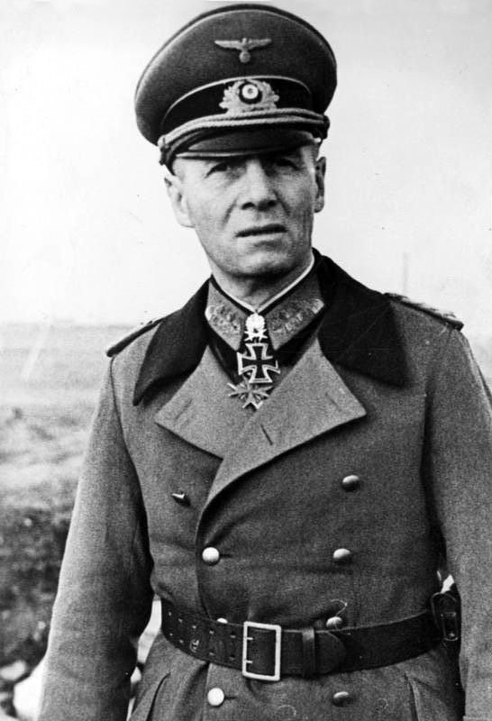

D-Day was launched, and Rommel’s prediction of disaster for Germany’s position played itself out. Still, Hitler would not consider negotiations with the Allies. Rommel ended up in the hospital after his car was attacked by British bombers and he was forced off the road. Meanwhile, details of the failed assassination plot had come to Hitler’s attention, including Rommel’s contact with the conspirators. As Rommel was convalescing in his home at Herrlingen, two generals visited and offered him his choice-trial or suicide. Rommel told his wife and son what had transpired, and that he had chosen to take the cyanide capsules the generals had provided. The German government gave Rommel a state funeral. His death was attributed to war wounds.

- Oct 14 1947 – U.S. Air Force: Yeager breaks the sound barrier » U.S. Air Force Captain Chuck Yeager becomes the first person to fly faster than the speed of sound.

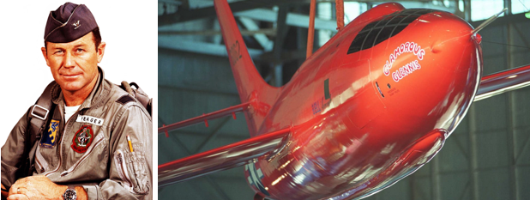

Yeager, born in Myra, West Virginia, in 1923, was a combat fighter during World War II and flew 64 missions over Europe. He shot down 13 German planes and was himself shot down over France, but he escaped capture with the assistance of the French Underground. After the war, he was among several volunteers chosen to test-fly the experimental X-1 rocket plane, built by the Bell Aircraft Company to explore the possibility of supersonic flight.

For years, many aviators believed that man was not meant to fly faster than the speed of sound, theorizing that transonic drag rise would tear any aircraft apart. All that changed on October 14, 1947, when Yeager flew the X-1 over Rogers Dry Lake in Southern California. The X-1 was lifted to an altitude of 25,000 feet by a B-29 aircraft and then released through the bomb bay, rocketing to 40,000 feet and exceeding 662 miles per hour (the sound barrier at that altitude). The rocket plane, nicknamed “Glamorous Glennis,” was designed with thin, unswept wings and a streamlined fuselage modeled after a .50-caliber bullet.

Because of the secrecy of the project, Bell and Yeager’s achievement was not announced until June 1948. Yeager continued to serve as a test pilot, and in 1953 he flew 1,650 miles per hour in an X-1A rocket plane. He retired from the U.S. Air Force in 1975 with the rank of brigadier general.

- Oct 14 1952 – Korea: Battle of Hill 598 (Sniper Ridge) – 7th Infantry Division battles the Chinese near Kumhwa, the right leg of the Iron Triangle. The operation is a failure and the UNC never allowed Eighth Army to undertake a similar sized offensive for the remainder of the war.

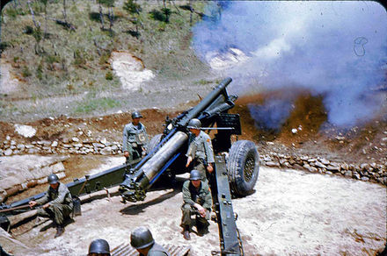

- Oct 14 1962 – Cold War: The Cuban Missile Crisis » The Crisis bringing the United States and the Soviet Union to the brink of nuclear conflict begins. Photographs taken by a high-altitude U-2 spy plane offered incontrovertible evidence that Soviet-made medium-range missiles in Cuba—capable of carrying nuclear warheads—were now stationed 90 miles off the American coastline.

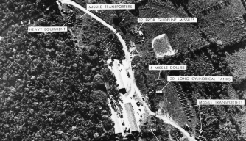

Tensions between the United States and the Soviet Union over Cuba had been steadily increasing since the failed April 1961 Bay of Pigs invasion, in which Cuban refugees, armed and trained by the United States, landed in Cuba and attempted to overthrow the government of Fidel Castro. Though the invasion did not succeed, Castro was convinced that the United States would try again, and set out to get more military assistance from the Soviet Union. During the next year, the number of Soviet advisors in Cuba rose to more than 20,000. Rumors began that Russia was also moving missiles and strategic bombers onto the island.

Russian leader Nikita Khrushchev may have decided to so dramatically up the stakes in the Cold War for several reasons. He may have believed that the United States was indeed going to invade Cuba and provided the weapons as a deterrent. Facing criticism at home from more hard-line members of the Soviet communist hierarchy, he may have thought a tough stand might win him support. Khrushchev also had always resented that U.S. nuclear missiles were stationed near the Soviet Union (in Turkey, for example), and putting missiles in Cuba might have been his way of redressing the imbalance. Two days after the pictures were taken, after being developed and analyzed by intelligence officers, they were presented to President Kennedy. During the next two weeks, the United States and the Soviet Union would come as close to nuclear war as they ever had, and a fearful world awaited the outcome.

- Oct 14 1964 – Vietnam: Khrushchev ousted as premier of Soviet Union » Nikita Khrushchev is ousted as both premier of the Soviet Union and chief of the Communist Party after 10 years in power. He was succeeded as head of the Communist Party by his former protégé Leonid Brezhnev, who would eventually become the chief of state as well. The new Soviet leadership increased military aid to the North Vietnamese without trying to persuade them to attempt a negotiated end to hostilities. With this support and no external pressure to negotiate, the North Vietnamese leadership was free to carry on the war as they saw fit.

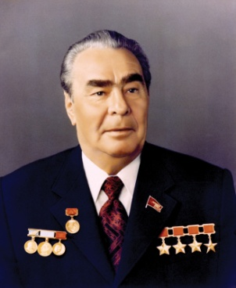

- Oct 14 1964 – Vietnam: U.S. aircraft are permitted to fly with Laotian planes on operations against Communist movements along the Ho Chi Minh Trail in Laos. After considerable pressure from both Laos and the U.S. Air Force, the Pentagon authorized the Yankee Team jets to fly cover with the Laotian Air Force T-28s that were bombing the trails and installations used by the Viet Cong and North Vietnamese troops making their way into Laos. The U.S. jets protected the Laotian planes from North Vietnamese MiGs attacks.

- Oct 14 1968 – Vietnam: U.S. servicemen sent to Vietnam for second tours » U.S. Defense Department officials announce that the Army and Marines will be sending about 24,000 men back to Vietnam for involuntary second tours because of the length of the war, high turnover of personnel resulting from the one year of duty, and the tight supply of experienced soldiers. This decision had an extremely negative impact on troop morale and the combat readiness of U.S. forces elsewhere in the world as troops were transferred to meet the increased personnel requirements in Vietnam.

-o-o-O-o-o-

- Oct 15 1780 – American Revolution: British retreat from Middleburgh » A combined force of 1,000 British regulars, Hessians, Loyalists and Indians, led by Loyalist Sir John Johnson and Mohawk Chief Joseph Brant, attempts an unsuccessful attack upon Middleburgh (or Middle Fort), New York. Only 200 Continental soldiers under Major Melanchthon Woolsey were defending the fort, and unknown to the British, the Continentals were low on ammunition. In their ignorance of the Patriots’ weakness, the Loyalist forces retreated in the direction of the Schoharie Valley, contenting themselves with destroying everything in their path and continuing the civil war raging in upstate New York.

- Oct 15 1813 – War of 1812: During the land defeat of the British on the Thames River in Canada, the Indian chief Tecumseh, now a brigadier general with the British Army, is killed.

- Oct 15 1863 – Civil War: C.S.S. Hunley sinks during tests » The C.S.S. Hunley, the world’s first successful combat submarine, sinks during a test run, killing its inventor and seven crewmembers.

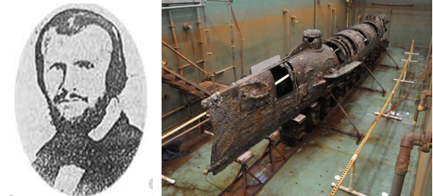

Horace Lawson Hunley developed the 40-foot submarine from a cylinder boiler. It was operated by a crew of eight—one person steered while the other seven turned a crank that drove the ship’s propeller. The Hunley could dive, but it required calm seas for safe operations. It was tested successfully in Alabama’s Mobile Bay in the summer of 1863, and Confederate commander General Pierre G.T. Beauregard recognized that the vessel might be useful to ram Union ships and break the blockade of Charleston Harbor. The Hunley was placed on a railcar and shipped to South Carolina.

The submarine experienced problems upon its arrival. During a test run, a crewmember became tangled in part of the craft’s machinery and the craft dove with its hatch open; only two men survived the accident. The ship was raised and repaired, but it was difficult to find another crew that was willing to assume the risk of operating the submarine. Its inventor and namesake stepped forward to restore confidence in his creation. On 15 OCT, he took the submarine into Charleston Harbor for another test. In front of a crowd of spectators, the Hunley slipped below the surface and did not reappear. Horace Hunley and his entire crew perished.

Another willing crew was assembled and the Hunley went back into the water. On February 17, 1864, the ship headed out of Charleston Harbor and approached the U.S.S. Housatanic. The Hunley struck a torpedo into the Yankee ship and then backed away before the explosion. The Housatanic sank in shallow water, and the Hunley became the first submarine to sink a ship in battle. However, its first successful mission was also its last—the Hunley sank before it returned to Charleston, taking yet another crew down with it. The vessel was raised in 2000, and is now on exhibit in Charleston.

- Oct 15 1864 – Civil War: Battle of Glasgow ends with the surrender of Glasgow, Missouri and its Union garrison, to the Confederacy. Casualties and losses: US 400 - CSA 50.

- Oct 15 1880 – Westward Expansion: Chiricahua Apache leader Victorio is killed » The warrior Victorio, one of the greatest Apache military strategists of all time, dies in the Tres Castillos Mountains south of El Paso, Texas. Born in New Mexico around 1809, Victorio grew up during a period of intense hostility between the native Apache Indians of the southwest and encroaching Mexican and American settlers. Determined to resist the loss of his homeland, Victorio began leading his small band of warriors on a long series of devastating raids against Mexican and American settlers and their communities in the 1850s.

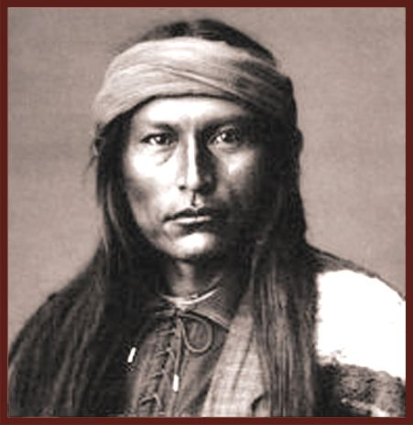

After more than a decade of evading the best efforts of the Mexican and American armies to capture him, the U.S. Army managed to convince Victorio to accept resettlement of his people on an inhospitable patch of sunburnt land near San Carlos, Arizona, in 1869. But with summer temperatures reaching 110 degrees on the San Carlos reservation (an area also known as Hell’s Forty Acres) and farming nearly impossible, Victorio decided the new reservation was unacceptable and moved his followers to more pleasant grounds at Ojo Caliente (Warm Springs), thus again becoming an outlaw in the eyes of the United States. In 1878, the U.S. Army attempted to force the Apaches back to the San Carlos reservation, but Victorio eluded capture, disappearing into the desert with 150 braves. Surviving by raiding the towns and farms of Chihuahua, Mexico, Victorio and his men began to take bloody revenge against their enemies, ambushing U.S. troops with devastating effect and killing any Mexican or American sheepherder unfortunate enough to cross their path.

In 1880, a combined force of U.S. and Mexican troops finally succeeded in tracking down the wily Apache and his warriors, surrounding them in the Tres Castillos Mountains of Mexico, just south of El Paso, Texas. Having sent the American troops away, the Mexican soldiers proceeded to kill all but 17 of the trapped Apaches, though the exact manner of Victorio’s death remains unclear. Some claimed an Indian scout employed by the Mexican army killed the famous warrior. But according to the Apache, Victorio took his own life rather than surrender to the hated Mexicans. Regardless of how it happened, Victorio’s death made him a martyr to the Apache people and strengthened the resolve of other warriors to continue the fight. The last of the great Apache warriors, Geronimo, would not surrender until 1886.

- Oct 15 1894 – U.S. Army: Captain Alfred Dreyfus, a Jewish army officer, is arrested for betraying military secrets to Germany.

- Oct 15 1917– WWI: Mata Hari is executed » Mata Hari, the archetype of the seductive female spy, is executed for espionage by a French firing squad at Vincennes outside of Paris.

She first came to Paris in 1905 and found fame as a performer of exotic Asian-inspired dances. She soon began touring all over Europe, telling the story of how she was born in a sacred Indian temple and taught ancient dances by a priestess who gave her the name Mata Hari, meaning “eye of the day” in Malay. In reality, Mata Hari was born in a small town in northern Holland in 1876, and her real name was Margaretha Geertruida Zelle. She acquired her superficial knowledge of Indian and Javanese dances when she lived for several years in Malaysia with her former husband, who was a Scot in the Dutch colonial army. Regardless of her authenticity, she packed dance halls and opera houses from Russia to France, mostly because her show consisted of her slowly stripping nude.

She became a famous courtesan, and with the outbreak of World War I her catalog of lovers began to include high-ranking military officers of various nationalities. In February 1917, French authorities arrested her for espionage and imprisoned her at St. Lazare Prison in Paris. In a military trial conducted in July, she was accused of revealing details of the Allies’ new weapon, the tank, resulting in the deaths of thousands of soldiers. She was convicted and sentenced to death, and on October 15 she refused a blindfold and was shot to death by a firing squad at Vincennes.

There is some evidence that Mata Hari acted as a German spy, and for a time as a double agent for the French, but the Germans had written her off as an ineffective agent whose pillow talk had produced little intelligence of value. Her military trial was riddled with bias and circumstantial evidence, and it is probable that French authorities trumped her up as “the greatest woman spy of the century” as a distraction for the huge losses the French army was suffering on the western front. Her only real crimes may have been an elaborate stage fallacy and a weakness for men in uniform.

- Oct 15 1924 – Germany: A German ZR-3 flies 5000 miles, the furthest Zeppelin flight to date.

- Oct 15 1941 –WW2: Odessa, a Russian port on the Black Sea which has been surrounded by German troops for several weeks, is evacuated by Russian troops.

- Oct 15 1945 –WW2: Vichy leader executed for treason » Pierre Laval, the puppet leader of Nazi-occupied Vichy France, is executed by firing squad for treason against France.

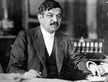

Laval, originally a deputy and senator of pacifist tendencies, shifted to the right in the 1930s while serving as minister of foreign affairs and twice as the French premier. A staunch anti-communist, he delayed the Soviet-Franco pact of 1935 and sought to align France with Fascist Italy. Hostile to the declaration of war against Germany in 1939, Laval encouraged the antiwar faction in the French government, and with the German invasion in 1940 he used his political influence to force an armistice with Germany. Henri Pétain took over the new Vichy state, and Laval served as minister of state. Laval was dismissed by PÉtain in December 1940 for negotiating privately with Germany.

By 1942, Laval had won the trust of Nazi leader Adolf Hitler, and the elderly Pétain became merely a figurehead in the Vichy regime. As the premier of Vichy France, Laval collaborated with the Nazi programs of oppression and genocide, and increasingly became a puppet of Hitler. After the Allied liberation of France, he was forced to flee east for German protection. With the defeat of Germany in May 1945, he escaped to Spain but was expelled and went into hiding in Austria, where he finally surrendered to American authorities in late July. Extradited to France, Laval was convicted of treason by the High Court of Justice in a sensational trial. Condemned to death, he attempted suicide by poison but was nursed back to health in time for his execution, on October 15, 1945.

- Oct 15 1946 – Post WW2: Herman Goering dies » Hermann Göring, commander in chief of the Luftwaffe, president of the Reichstag, head of the Gestapo, prime minister of Prussia, chief forester of the Reich, chief liquidator of sequestered estates, supreme head of the National Weather Bureau, and Hitler’s designated successor dies by his own hand.

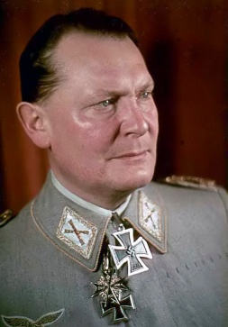

Göring was an early member of the Nazi Party and was wounded in the failed Munich Beer Hall Putsch in 1923. That wound would have long-term effects, as Göring became increasingly addicted to painkillers. Not long after Hitler’s accession to power, Göring was instrumental in creating concentration camps for political enemies. Ostentatious and self-indulgent, he changed his uniform five times a day and was notorious for flaunting his decorations, jewelry, and stolen artwork. It was Göring who ordered the purging of German Jews from the economy following the Kristallnacht pogrom in 1938, initiating an “Aryanization” policy that confiscated Jewish property and businesses.

Göring's failure to win the Battle of Britain and prevent the Allied bombing of Germany led to his loss of stature within the Party, aggravated by the low esteem with which he was always held by fellow officers because of his egocentrism and position as Hitler’s right-hand man. As the war progressed, he dropped into depressions and continued to battle drug addiction.

When Göring fell into U.S. hands after Germany’s surrender, he had in his possession a rich stash of paracodin pills, a morphine derivative. He was tried at Nuremberg and charged with various crimes against humanity. Despite a vigorous attempt at self-acquittal, he was found guilty and sentenced to be hanged, but before he could be executed, he died by suicide by swallowing a cyanide tablet he had hidden from his guards.

- Oct 15 1950 – Korean War: President Harry Truman meets with General Douglas MacArthur at Wake Island to discuss U.N. progress in the Korean War.

- Oct 15 1964 – Cold War: Nikita Khrushchev is replaced by Leonid Brezhnev as leader of the Soviet Union.

- Oct 15 1965 – Vietnam: First draft card burned » In a demonstration staged by the student-run National Coordinating Committee to End the War in Vietnam, the first public burning of a draft card in the United States takes place. These demonstrations drew 100,000 people in 40 cities across the country. In New York, David Miller, a young Catholic pacifist, became the first U.S. war protestor to burn his draft card in direct violation of a recently passed law forbidding such acts. Agents from the Federal Bureau of Investigation later arrested him; he was tried, found guilty, and sentenced to two years imprisonment.

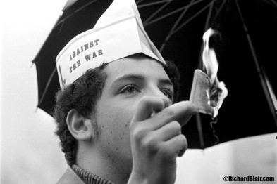
David J. Miller, 24, first person arrested and convicted under P.L. 89-152 served 22 months for burning his card

- Oct 15 1966 – Vietnam: Operation Attleboro continues in Tay Ninh Province » U.S. troops move into Tay Ninh Province near the Cambodian border, about 50 miles north of Saigon, and sweep the area in search of Viet Cong as part of Operation Attleboro, which had begun in September. The purpose of this operation was to find and eliminate all enemy troops west of the Michelin rubber plantation. It was the largest U.S. operation to date

- Oct 15 1969 – Vietnam: National Moratorium demonstrations held across the United States » Rallies for The Moratorium to End the War in Vietnam draw over 2 million demonstrators across the US, a quarter million of them in the nation’s capital. The National Moratorium was an effort by David Hawk and Sam Brown, two antiwar activists, to forge a broad-based movement against the Vietnam War. The organization initially focused its effort on 300 college campuses, but the idea soon grew and spread beyond the colleges and universities. Hawk and Brown were assisted by the New Mobilization Committee to End the War in Vietnam, which was instrumental in organizing the nation-wide protest.

- Oct 15 1990 – Cold War: Mikhail Gorbachev wins Nobel Peace Prize » Soviet leader Mikhail Gorbachev wins the Nobel Peace Prize for his work in ending Cold War tensions. Since coming to power in 1988, Gorbachev had undertaken to concentrate more effort and funds on his domestic reform plans by going to extraordinary lengths to reach foreign policy understandings with the noncommunist world.

Some of his accomplishments include four summits with President Ronald Reagan, including a 1987 meeting at which an agreement was reached to dismantle the U.S. and USSR intermediate-range missiles in Europe. He also began to remove Soviet troops from Afghanistan in 1988 and exerted diplomatic pressure on Cuba and Vietnam to remove their forces from Angola and Kampuchea (Cambodia), respectively. In a 1989 meeting with President George Bush, Gorbachev declared that the Cold War was over.

Gorbachev also earned the respect of many in the West through his policy of non-intervention in the political upheavals that shook the Eastern European “satellite” nations during the late-1980s and early-1990s. When Czechoslovakia, East Germany, Poland, and other Iron Curtain countries began to move toward more democratic political systems and free market economies, Gorbachev kept Soviet intervention in check. (This policy did not extend to the Soviet republics; similar efforts by Lithuania and other republics were met with stern warnings and force to keep the Soviet Socialist Republics together.)

[Source: http://www.history.com/this-day-in-history & https://www.historycentral.com | September 2019 ++]

