Windows 10 (64-bit) installation for ABI 3130xl

Microsoft has rolled-out the final support of Windows 7 with free security updates. As such, facilities with networked instruments running on Windows 7 must upgrade to Windows 10, isolate the instruments within their organization’s network, or pay Microsoft for continued security support. Here, we considered isolating our three ABI 3130xl platforms to a private network; however, this would have greatly complicated supporting our clients. Thus, in close coordination with our IT manager, I experimented with installing the vendor software in a Windows 10 (64-bit) environment. After about a month of trial-&-error, with far more hair lost than I could afford, we were successful! May this document blaze a path through the cyber-wilderness for anyone else needing to convert an ABI 3130xl to Windows 10.

CAVEATS:
- Upgrade path to Windows 10 for 3130xl:
  - Unlike the 3730xl, there is no official path planned for upgrading the 3130xl to a Windows 10 environment (32-bit or 64-bit).
  - Data Collection 4.0 (and associated ABI software) has been validated by the vendor solely for a Windows 7 (32-bit) environment.
- Installation options:
  - 32-bit vs. 64-bit: I did not test the 32-bit version of Windows 10 because I wanted the full 16 GB of RAM to be available to the computer.
  - Enterprise vs. Professional: Both formats worked for me.
  - Clean install vs. Migrate Oracle Database: I chose to simplify the process by not carrying over any Oracle data; I do not know whether the ‘migration software’ will work when converting to Windows 10 (64-bit).
- System Stability:
  - Data Collection 4.0 (with UDC patch) and SequenceAnalysis 6.0 (patched to 6.2) have functioned flawlessly for >10 weeks in this configuration.
  - GeneMapper 5.0 (patched to 5.1) installed successfully, but it has been used only twice so far, aside from setting up FA Plate records in Data Collection.
  - I installed Variant Reporter 2.0, SeqScape 3.0, and PrimerExpress 3.0.1 on a separate computer (Dell Precision T1500; 2.8 GHz; 8 GB RAM) running Windows 10 (64-bit).
- 31xx Family Service Tools: used by an FSE to perform PM and diagnose instrument issues.
  - The software installed in the Windows 10 (64-bit) environment without any error messages, but I cannot verify whether it is fully functional because only an FSE actually knows how to use the software.
  - Nevertheless, the software accessed the 3130xl’s information and everything that I did with the software gave the same results as seen with the same software running on a Windows 7 (32-bit) computer that had been set up by the FSE.
- Technical support: Assistance with 3130xl software or hardware might not be provided under a Win10 configuration.
- PMs and Repairs: I don’t know if an FSE will service a 3130xl if the computer’s OS is Windows 10.

Install notes (read and re-read these 10 notes before plunging forward!):
- Please, please, please.... review this procedure with your IT folks BEFORE starting it.
- It takes ~1 full workday to complete the process to the point where Spectrals can be run.
- Computer: We tested the protocol first on a non-ABI computer.
  - Lenovo computer specifications: Intel i5-4590 CPU @ 3.30 GHz, 8 GB RAM, with a single NIC (used a Linksys dongle for wireless internet access).
  - Required transferring the Data Collection license from the ABI computer to the Lenovo; to get the license transferred back the ABI computer, I needed assistance from Tech Support as the online License portal was not working properly for me.
  - ABI computer specifications: Dell Optiplex XE2; Intel(R) Core(TM) i7-477OS CPU @3.10 GHz; 16 GB RAM; 500 GB hard drive in a RAID configuration.
- During all software installs, I used a regular account with Administrative privileges, but always ‘right-clicked’ and selected “Run as Administrator”. Theoretically, you ought to be able to skip this step by first logging into the built-in ‘Administrator’ account (which is disabled by default in Windows 10).
  - To enable the built-in Admin account, Open ‘Computer Management’, drill down to ‘Administrator’ account, click Local Users & Groups, click Users, click ‘Properties’, uncheck ‘Account is disabled’ box, & click ‘Ok’. Reboot the computer, and log on with the Administrator account.
  - After the computer has been completely set up and you have created another account with “admin” privileges, consider disabling the built-in ‘Administrator’ account. The built-in account has the “highest” admin privileges of all and IT folks often recommend that it not be accessible in the event that malware or viruses infect your computer.
- Verify that your proposed computer name meets the requirements of your IT group... name changes later will create a problem with Data Collection.
- Partitions: Partition sizes can be adjusted after installation of the ABI software (using Disk Management or software such as MiniTool Partition Magic); however, it is best to get sizes correct initially as later adjustments involve some risk of rendering the PC ‘non-functional’ after having put in all the effort to set up the various software.
- Software install order: Do NOT install any software other than Windows 10 and Java (i.e., JRE 8 – Java SE Runtime Environment 8) until the ABI Data Collection software is fully installed.
  - Java JRE8 must be present on the C-drive BEFORE installation of Data Collection:
    - Otherwise, the DC install will hang at Oracle-11g step.
    - Whenever DC software failed to fully install, the only solution I found was to format the E:\drive and re-install Windows 10 (using format option).
  - For JRE8, Log-in to the Oracle website, click the license box, and select the appropriate jre8 version for your Windows 10 installation; if needed, first create a free Oracle account.
  - Do NOT install the ‘regular’ Java (java.com/en/download/):
    - Initially, I mistakenly installed Java SE and DC setup aborted due to presence of an existing Oracle installation.
    - Uninstalling Java SE did not resolve the issue; thus, I had to re-install Windows and reformat all other partitions.
  - I have no idea if any other software might cause a similar problem; thus, I recommend installing all the ABI software first.
- Antivirus (etc.): For all ABI software installs, ensure that Windows Defender (WD) is completely turned off (especially Real-Time protection) and all Firewalls (FW) are turned off. If you have any other virus or malware protection, ensure that those programs are off too. (See Antivirus & Firewall notes at end of document for potential alternative to these instructions.)
  - As described later, turn WD off through Group Policy; if you simply turn off WD in the Security Center, Real-Time Pro will reactivate upon a PC restart & the DC install will fail.
  - When WD and FWs are off, disconnect from the internet whenever possible.
- Testing Caveats: During the testing phase for converting our 3130xl computers to Windows 10, I frequently encountered ‘errors’ which ultimately prevented a full installation of the DC software.
  - Sometimes, after the required re-installation of Windows 10, I resolved the DC installation problem with a single change to my protocol; in those cases, I am confident that the change was critical... albeit, perhaps not the only path forward.
  - On the other hand, not every aspect of my protocol is necessarily crucial because I often implemented multiple changes simultaneously and did not always investigate which changes were actually required to allow the DC installation to proceed.
  - In generating this protocol, I have endeavored to make it as complete and as clear as possible; however, in the interest of ‘brevity’ (oops! too late!), I have sometimes omitted ‘click-by-click’ descriptions.
  - Please remember that converting your 3130xl Windows 7 (32-bit) system to Windows 10 (64-bit) is completely unsupported by the vendor.
- Short-Cuts: If multiple 3130xl computers (same configurations) need upgrading to Windows 10, consider shortening the setup time by getting one computer fully updated to Windows 10 and Java JRE8 installed, imaging the C:drive & using that image to get the other computers to the same state.
  - However, an image from a finished Data Collection installation probably could not be used to upgrade any other computer:
    - Each installation uses a separate Data Collection license; and,
    - Computer’s name is “baked” into Data Collection software during the install process.
    - I know of potential solutions for these issues, but I have not tested them.
  - On the other hand, if you have lots of ancillary software to install, consider installing (configuring & updating) anything that doesn’t clearly use Oracle on the first machine and see if DC will install correctly in that configuration.
    - If successful, you could get Windows 10, Java JRE8, & ancillary software installed on one computer, and image that C:drive for transfer to other computers.
    - If not, you could attempt to first isolate what programs are causing the ‘Oracle’ detection issue, eliminate them from the pre-DC install, and proceed.

INSTRUCTIONS:
- Prepare PC for full deletion (->>Image ->>Backup ->>update ->>cleanup ->>defragment ->>image):
  - On an external drive, BEFORE making any changes to your FUNCTIONAL system, make images of all 5 partitions (C, D, E, F, S).
    - Why?:
    - ensures existence of functional backup image no matter what.
    - can revert system in case ThermoFisher ever refuses to provide service support due to installation of Data Collection in Windows 10.
    - How?:
      - Have IT set up a bootable WinPE external drive; ours had two partitions:
        - WinPE: 2 GB Fat32 partition.
        - Captured Images: NTFS partition of remaining space of external drive.
      - Connect WinPE external drive to PC; restart PC, booting to WinPE drive (for Dell desktops, tap F12 repeatedly during startup to select WinPE).
      - After WinPE environment loads, type commands in order (omit quotation marks):
        - “diskpart” (enters program)
        - “list disk” (verify which disk is the pc vs. WinPE)
        - “select disk 0” (if ‘0’ is the pc)
        - “list partition” (shows partitions)
        - “list volume”
          - shows volume letters, vs. ‘drive’ letters assigned in Windows.
          - take photo of volume info as reference for image capture steps.
- “exit”
      - To capture images of each partition, type (^ = space): dism^/capture-image^/
imagefile:J:\filename.wim^/capturedir:I:\^/Name:filename
        - ‘filename’ is what you want to call the partition;
        - ‘J’ is destination for image; and,
        - ‘I’ is volume letter of partition to be imaged (see ‘3e’ above).
      - Exit the DOS prompt, and reboot to the PC.
  - On an external drive, back up all necessary files and instrument information.
    - Capture ‘snip’ images of anything you might want to refer to later (much of the listed suggestions can be obtained through the Computer Management app):
      - # of runs on Capillary array.
      - Partition information; Computer system info.
      - ftp service info ( Default & UDC site, authentication, & authorization settings).
      - User account information (Users, properties, members of).
    - Open 3130xl Data Collection software and export non-default *.xml files (must do 1 file at a time... no batch mode available):
      - Analysis protocols.
      - Instrument protocols.
      - Module Manager.
      - Protocol Manager.
      - Results Groups (for Fragment Analysis, save just examples… a new install of GeneMapper will require recreating these FSA Results Groups).
    - Save copies of: 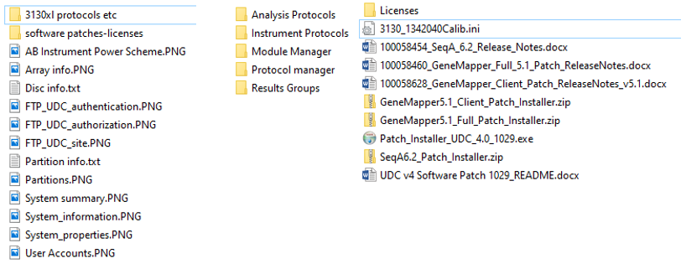
      - 3130xl License (E:\AppliedBiosystems\UDC\DataCollection\bin\config\licenses).
        - It may be necessary to download a current license from the ABI Licensing Portal.
        - If you have never used this License portal before, you will need to register for it (your existing ThermoFisher account doesn’t apply here).
        - See ABI Licensing Portal Manual.
        - The portal can be finicky; if you run into problems, contact Tech Support and ask for help in getting the licenses corrected. With screenshots of your pc’s MAC address (type ‘getmac’ in Cmd prompt), Tech Support can manually correct the license server and have new files emailed to you.
      - 3130xl Calib.ini file (located in C:\AppliedBiosystems\Firmware).
      - Save (or Download) patches for:
        - Data Collection (Patch_Installer_UDC_4.0_1029)
        - SequenceAnalysis (SeqA6.2_Patch_Installer)
        - GeneMapper (GeneMapper5.1_Full_Patch_Installer).
      - Other relevant files (e.g., Excel templates used for creating plate records).
    - Back up Data: necessary only if planning to store or migrate user data.
    - Oracle Database: For a clean install as described below, skip this step. However, there is an ABI protocol for migrating an Oracle database to a new PC installation in Windows 7. As long as Windows 10 is not mentioned, ThermoFisher tech support might provide guidance on the ‘backup’ process, but you will have to figure out how to incorporate migration of the Oracle database into the procedure outlined below.
  - Create a Restore point (might need to enable process), and then perform whatever final updates you deemed to be needed (e.g., Windows, Java, any other ancillary software).
    - Despite ABI’s repeated warnings over the years against updating Windows or Java, in over a decade of running the 3130xl (Windows XP or 7), I have never seen either type of update cause a problem with ABI software.

    - By contrast, failing to update Windows & Java sometimes created problems with ancillary software (e.g., Malwarebytes)… and left pc more vulnerable to attacks.
    - HOWEVER, Windows updates can sometimes cause a problem with Windows itself. Indeed, in the January 2020 final rollout for Windows 7 security updates, it appears that SSU KB4531786 may have been faulty as Microsoft rapidly replaced it with SSU KB4536952. Further, with the original “prepare pc for full deletion” process on 1 of our 3 ABI computers, we had a problem which rendered Windows 7 unstable. The full “prepare” process involves a lot of activity, so we don’t know the cause of the problem... but it might have been the Windows update. Regardless, it emphasizes the need to create 2 sets of images: (1) the functional system before ‘touching it’; and, (2) after installing all updates & cleaning up the system.
  - Reboot computer; verify that DC still opens properly and appears to function correctly.
  - Clean up computer of unneeded files (including emptying Recycle bin).
  - Defragment C-drive (preferably with software such as PerfectDisk).
  - Database Manager: Cleanup processed plates (saves space on external drive for PC images), unless you are planning to transfer your Oracle database.
    - If desired for space considerations, defragment both Oracle partitions (D & F).
    - Typically, defragmenting these partitions takes a long time (>30 minutes).
    - When defragmenting D & F, Data Collection MUST be OFF; otherwise, the process will corrupt the Oracle database.
  - Image updated & cleaned Windows 7 (32-bit) configuration, following ‘imaging instructions’ above; remember to name files differently (e.g., Data_updated vs. Data).
- Destroy existing RAID and rebuild partitions in desired sizes with the correct names.
  - Notes:
    - Based on disk statistics from running DC software in Windows 7, we chose the following partition sizes: C=110 GB; D=150 GB; E=100 GB; F=100 GB; S=5.12 GB.
    - To generate these exact partition sizes, you must do the proper conversion to MB (not just multiply by 1000); further, you must add 1 MB to MB conversion value for C: to keep C: from showing as 109.99 GB (Windows doesn’t count 1st block).
    - Giving 110 GB to C: ensures subsequent Windows updates do not fill the partition.
    - Giving extra space to D: ensures that it will have enough free space to move the very large files and thus minimize the chance of any ‘crashes’.
    - The S: partition can be very small because its sole purpose is to give your FSE (and your facility) a specific place to store any files deemed useful from a repair or PM... generally speaking, this partition is left nearly empty.
  - Instructions:
    - Restart PC, booting (tap F12 repeatedly) to the WinPE drive.
    - Type (omit quotes in ii[1-5]):
      - “diskpart”
      - “list disk”
      - “select disk 0” (if ‘0’ is the pc)
      - “clean”
      - “convert gpt” (needed for modern UEFI, see step 3.a.i below)

      - For the first 4 partitions (OS, ORACLE1, DATA, ORACLE2), type:
        - create partition efi size=X (where ‘X’ is the size of the proposed partition as calculated in Mb)
        - format quick fs=NTFS label=”PartitionName” (where PartitionName is what you want to call the partition; the quotes in the command are required here)
- For the ABService partition:
        - create primary partition
        - format quick fs=ntfs label=”ABService” (this will put remaining Mb into ABService; again, the quotes are required here)
    - Exit
- Obtain from IT a flashdrive for installing Windows 10 (we used 64-bit).
  - Reboot PC, tapping F12 repeatedly until given options.
    - Enter BIOS, change boot options to UEFI instead of Legacy.
    - Boot from the Windows-Install flashdrive.
  - Choose Windows 10 version (Enterprise or Pro).
    - When screen shows the partitions, select the partition for the OS.
    - Click ‘delete’ and select Windows to install on this unallocated space.
  - Choose setup method: Ultimately, I chose to set up for an Organization and Domain Join; however, I was also successful using the other setup configurations.
  - Input security questions/answers; decline optional ‘stuff’ since this is a PC for 3130xl.
  - After Windows 10 installation (takes ~30 min), remove Windows 10 installation key.
- Windows update and management:
  - Run Windows update: Restart PC when prompted; Repeat Windows update (restarting PC as needed) until no more updates are available... and re-start Windows.
  - While updating Windows, perform the following tasks:
    - Activate Windows 10 as directed by your IT.
    - Reassign drive letters as per original through Disk Management.
    - Adjust Time/Date of PC, if needed.
- Install Java.
  - Do NOT proceed to installing DC until you have successfully installed Java JRE8.
  - Navigate to the Java download site (see link, or type “jre8” in Internet Explorer):
    - Download software from jre8-downloads.
    - Accept license and download the appropriate version for your Win10 installation (as of 21Jan20, for Win10-64bit, it was file jre-8u241-windows-x64.exe).
    - Close Internet Explorer, install Java (Run as Administrator), and restart PC.
  - Note: I did not test a more recent version of jre (e.g., jre10).
- Disconnect PC from Internet.
- Turn off Windows Defender ‘permanently’ by editing the group policy (will restore later).
  - Open WD to turn off Tamper Protection (>Settings; >Updates & Security; >Windows Security; >Virus & Threat Protection; >Manage Settings; Tamper Protection).
  - Exit Settings, open Admin Cmd Prompt (should get C:\Windows\system32 if account has admin privileges).
    - Type: gpedit.msc
    - In the Group Policy Edit screen, navigate to:
      - ->>Administrative Templates ->>Windows Components ->>WD Antivirus
        - Select “Turn off WD Antivirus”, edit, ‘Enable’, Apply, OK.
        - Open“Real-Time protection” folder:
          - Select “Turn off Real-Time Protection”, Edit, ‘Enable’, Apply, OK.
          - Select “Turn on Behavior Monitoring”, Edit, ‘DISable’, Apply, OK.
      - Exit GP Edit screen; exit Cmd prompt.
- Restart PC; turn off all three Firewalls from Settings.
- Verify that all WD settings remain off; then exit Windows Security:
  - It might take a few minutes for the ‘protection info’ to appear; and,
  - it is especially critical that Real-Time Protection be inactive.
- Rename PC to whatever you want it called for the 3130xl Software.
  - >Settings; >System; >About.
  - Note: If you ever need to change the computer’s name (e.g., per IT requirements), the name in Data Collection must also be changed. This is very difficult, but not impossible, to do without actually re-installing Data Collection (see Rename computer without re-installing 3130xl Data Collection software); thus, ensure that your computer’s name satisfies your IT requirements now.
  - Note: The 3130xl software will capitalize all letters in the name; having lower-case letters in your computer name and upper-case letters in the same name within the 3130xl software does not seem to matter.
- All partitions, except “C:”, should be blank at this point; however, I performed a ‘Quick format’ on D, E, F, & S just to be completely certain.
- Restart PC and double-check that all Defender components (esp. RT Pro) and Firewalls are “OFF”.
  - Don’t skip this step, even though it seems pointless.
  - If you skip it and it turns out that not all of the features were off, your installation is highly likely to fail and you will have to start over with installing Windows 10 again.
- Close Settings (as well as all running applications, if there are any others).
- Insert DC installation disc (installation takes ~10 minutes):
  - Open CD, right-click ‘setup.exe’, and choose ‘Run as Administrator’.
  - Close File Explorer when prompted.
  - Select ‘Yes” when notified that a Windows 10 installation is not officially supported.
  - For clean install, do not choose to migrate oracle data.
  - Verify PC name is correct:
    - DC software will convert name to all Uppercase; ignore it as final result will still be ‘all caps’ even if you change it back to lowercase here.
    - If name is otherwise not correct, exit DC setup & rename PC as directed above.
  - Input instrument Serial number (format: XXXX-YYY).
  - Click ‘Next’; software will notify you that setup is ready… click ‘Next’.
  - Popup will warn that setup cannot be cancelled or interrupted; if satisfied, click ‘Yes’.
  - When install is ~45% complete, it will ask for .NET Framework 3.5:
    - reconnect PC to internet to download & install the update (takes several minutes).
    - After Windows declares that .NET Framework 3.5 (includes .NET 2.0 and 3.0) was ‘successfully installed’, close the window.
    - DC installation software will again ask for this update (repeatedly, if you install each time); thus, skip it the 2nd time (takes ~7 clicks on skip to move forward).
  - Disconnect PC from internet for the duration of the remainder of DC software install.
- When popup window requests it, provide the path to install the instrument’s Calibi.ini file.
  - Click ‘Next’; if correct file is displayed, click ‘Next’.
  - A cmd prompt window will open, but nothing will seem to happen for a few minutes.
  - Popup window appears, asking if you want to restart the PC now or later:
    - Leave the DC installation disk in the CD drive.
    - Leave default setting of ‘Restart now’ and click ‘Finish’.
    - Click ‘OK’ to apparently irrelevant message [Failed to search for the string InstrumentHasSapphirePump=no in file FileFoundations3100InstProperties.txt.]
  - After PC restarts and you login, multiple cmd prompts will appear as DC software install continues. Also, you will often see ‘error’ messages which are apparently code” leftovers” not cleaned up by ABI software team, but are not actually of any importance.
  - When ‘Setup Completed’ appears, click ‘Finish’ and remove the installation disc.
  - Turn on instrument: Solid yellow light will appear; light will not blink or change to green until the FTP service is fully established.
- Go to ISS (Internet Information Services Manager) to establish FTP connection (with IP address): 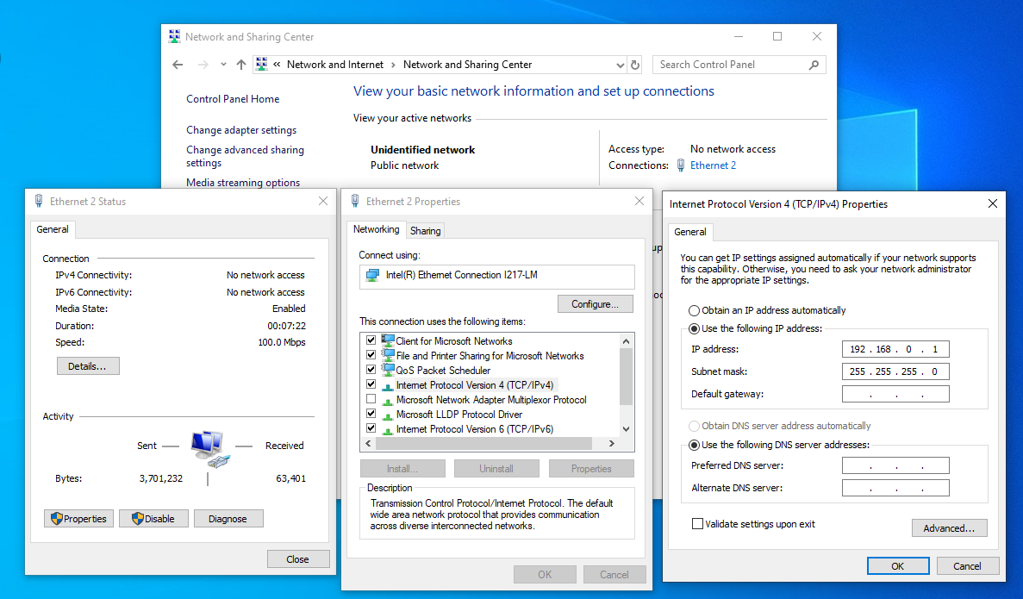
  - Click ‘Sites’, click ‘Default Web Site’
    - Double-click ‘FTP Authentication’.
      - Anonymous Authentication = enabled.
      - Basic Authentication = disabled.
  - Right-click ‘Sites’, click ‘Add FTP site’:
    - FTP Site Name = UDC;
    - Physical path = C:\AppliedBiosystems\Firmware (Click ‘Next’).
    - Popup window for Binding & SSL settings.
      - Select ‘Start FTP automatically’ and ‘No SSL’;
      - Click ‘Next’.
    - Popup window for Authentication & Authorization Information
      - Authentication = Basic.
      - Authorization for: Specific roles/groups.
      - Input ‘Administrators’, with Permissions = Read.
      - Click ‘Finish’, and exit ISS.
- Click ‘Start’ (or Windows key) and type ‘Control Panel’:
  - Click Network & Internet.
  - Click Network and Sharing center.
  - Click Ethernet connection for the Instrument (Public 100 Mbs).
  - Click on ‘Properties’.
  - Click on ‘Internet Protocol Version 4 (TCP/iPv4)’.
  - Click ‘Properties’ and input:
    - IP Address: 192.168.0.1
    - Subnet mask: 255.255.255.0

- About 15 s after you close all ‘Network’ dialog boxes, the yellow light on 3130xl should start blinking... and then go to solid Green.
- Turn Firewalls back on.
- Right-click the shortcut for the DC software (Run as Administrator).
  - Whenever system warns that Windows Defender Firewall has blocked a DC app, allow the app on public networks (seems unnecessary to unblock private networks); see Firewall note at end of document.
  - Install License (browse to license file location) and accept the terms.
    - If License install fails, existing license might be expired or locked to another pc.
    - Visit License portal or call Tech support to correct the problem.
- From Service Console, open all 4 sub-console windows (right-click yellow triangle or green square; select ‘open console’) to verify that there are no errors.
  - Make it a habit to check the 4 sub-console windows for errors EVERY time you start Data Collection and periodically before starting runs even without a re-start.
  - In Data Service, ignore messages such as “The service name is invalid.” and “The requested service has already been started.” ABI has acknowledged that these messages are glitches in the software and have no actual relevance.
  - In Data Service, if you see a message stating “System error 5 has occurred. Access is denied”... ignore it.
    - This message appears even in Windows 7 [32-bit] whenever Data Collection is started under a Standard Account (e.g., INSTR-USER; see image below).
    - The message also occurs in Windows 10 for a user-generated account that has ‘admin’ privileges (unless you first right-click & select ‘Run as Admin’).
    - Given that the DC software runs identically whether this message appears or not, my best guess is that ABI once required that the DC software be run in an Administrator status, changed it to run under a Standard Account, and then failed to remove the error message.
    - If you examine the information in the four consoles, you will find numerous cases of similar situations... flagged ‘errors’ that actually have no effect. 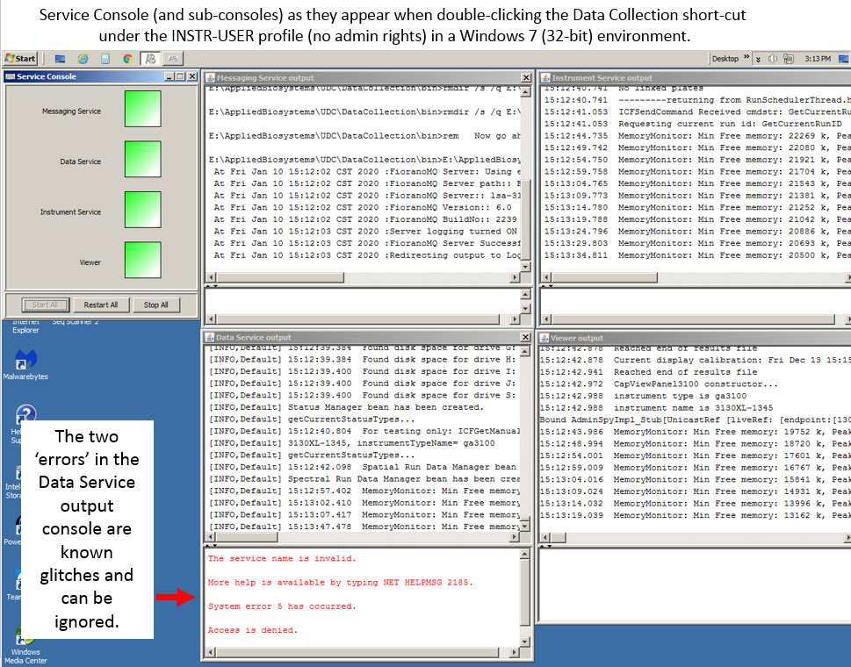
- Power Management: Go to Settings, System, Power & Sleep to create new scheme in which computer/monitor never sleep; otherwise, pc will “sleep” at some point in a run, crashing the run.
  - Click ‘Additional Power Settings’.
  - Click ‘Create a Power plan’.
    - Select ‘High Performance’.
    - Name it ‘AB Instrument Power Scheme’; click ‘Next’.
    - Select ‘Never’ for Turn off the Display.
    - Click ‘Create’.
    - Click ‘Change Plan Settings’.
    - Click ‘Change Advanced Power Settings’
      - Turn off Hard Disk: ‘Never’ (both battery and plugged in).
      - Sleep: verify that ‘Never’ is selected.
      - Display: verify that ‘Never’ is selected.
      - Click ‘Apply’ & ‘OK’; close window and ‘Settings’.
- Get the existing or a new capillary array acknowledged by the instrument:
  - System will not run an ‘Array’ wizard if Oracle database has no polymer information.
  - So, first run the Replenish Polymer Wizard with either Polymer or Water:
    - Polymer: If ready to set instrument up to run, put polymer on the instrument; works best with bottles set up for Addition of POP7 and following the associated website instructions (vs. just using the Wizard) to minimize polymer wastage.
    - Water: Otherwise, with just water, run the Replenish Polymer Wizard to add polymer information to the Oracle database. In this case, click ‘no bubbles’ both times, skip the array fill, and click ‘Finish’.
  - Installing an array can consume less polymer if you run the Update Capillary Array Wizard (and use the manual controls) rather than the Install Array Wizard.
    - Select ‘Install new array’ (it is new to the instrument, even if previously used, if you didn’t migrate an Oracle database in which the array was used for runs).
    - Input the array information:
      - Note: Be careful to select the correct array length (default is “22 cm”).
        - If you input the wrong length (e.g., fail to change default setting of 22 cm to 50 cm) you cannot just re-run the Update Capillary Array wizard.
        - Instead, you must run the “Install Array Wizard”.
          - Select ‘Discard’ array and click through a few windows.
          - Select ‘Install a new capillary array’
            - Input array serial number with some sort of deviation from reality (e.g., 59CC67531 instead of 59C67531) or system will declare that the serial number already exists.
            - Ensure that the right length is selected.
            - Click through several windows until you can click ‘Finish’. (Note: at Flush Array Port, do not bother loosening the knob; piston can be safely moved up to 1000 units with lower polymer block sealed & array port tightened).
      - After completing either process, the Instrument Status window should show Capillary array and polymer information.
- Import *.xml files
  - Notes:
    - Files must be imported one at a time (no batch file options available).
    - Module Manager files must be installed before Instrument Protocols.
    - FSA-related files must be set up fresh as the originals were tied to the old GeneMapper installation (each installation gets a new AppInstance string).
  - Import Result Groups, Module Manager files, and Instrument Protocol files.
  - Do not Import Analysis Protocol files yet; SeqA must be installed first.
- Prepare to install ancillary ABI software: SequenceAnalysis is required to make DNA Sequencing Plate Records and GeneMapper is required to make FSA plate records.
  - If you reconnected the PC to the internet, disconnect it again.
  - Turn off Firewalls.
  - Ensure that Windows Defender is still turned off (Real-Time, Cloud Delivered, Auto sample submission, Tamper Protection):
    - If you control Virus & Threat Protection, go there in Settings for verification (if you turned WD back on previously, you don’t need to use the ‘permanent’ method now because you won’t reboot the PC during these installs; thus, Real-Time Pro will not be reactivated even if you just turn it off through Virus & Threat Protection).
    - If your Virus & Threat Protection is being managed by your organization (which means you cannot adjust WD normally), go there & then click ‘Manage Providers’:
      - If it says ‘Windows Defender Antivirus is turned off’, you’re okay.
      - Otherwise, refer to the instructions above to ‘permanently’ turn off WD.
- Install Sequence Analysis 6.0 software:
  - First, open DC software; check all 4 sub-console windows for errors. If errors exist, reboot pc and/or instrument until sub-consoles are error-free. Note: At least 3 ‘error messages’ (e.g., “Service Name is Invalid”) are known bugs that exist even in Windows 7.
  - Insert SeqA installation CD; if Setup doesn’t self-initiate, open the CD-Drive and right-click “Setup.exe”, Run as Administrator.
  - Message will appear instructing you to close all running applications; however, although you should close File Explorer, you MUST leave DC software running because Sequence Analysis must be able to access the DC software during the install.
  - Click ‘yes’ to message warning that a 64-bit platform is unsupported.
  - Click ‘Next’ on various screens, accept the ‘Terms’, click ‘Finish’ when installation is done (~5-10 min), and remove the installation disc.
  - Open Sequence Analysis:
    - Register software by completing fields in the popup screen.
    - Input password, accept the terms, and close SeqA.
  - In DC,
    - Now, import Analysis Protocol *.xml files (not possible until SeqA is installed).
    - In Plate Manager, verify that you can create DNA Sequencing Plate Records.
- GeneMapper 5 software: See GeneMapper note at end of document.
  - Re-check all 4 Data Collection console windows for errors (if found, reboot pc and/or instrument until no errors are present, aside from the known glitches).
  - Insert GeneMapper installation CD; if Setup doesn’t self-initiate, open the CD-Drive and right-click “GeneMapper5.0.exe”, Run as Administrator.
  - Install window will appear; although no message to close software appears, it’s probably best to close File Explorer.
  - Click “Install GeneMapper 5.0”; message will appear notifying you that you MUST leave DC software running (GeneMapper must be able to access DC software during install).
  - Click ‘Next’ on various screens, accept the ‘Terms’, and click ‘Yes’ to notification that the GM install takes time (it’s ~20 min) and cannot be stopped.
  - After fairly quickly ramping through various parts of the install and coming to a screen with a full green bar, a popup window will appear that states “GeneMapper configurations, please wait”; screen will appear inactive for ~15 minutes… be patient.
  - Then, several notifications appear about more activities (which take <5 more minutes).
  - After software installs, click “No, I will restart my computer later”.
  - Click ‘Finish’, exit the setup screen and remove the installation CD.
  - Shut down the DC software (Note: Until software is patched, errors may appear in the Viewer Console [e.g., java.lang.InterruptedException].)
  - Reboot computer.
  - Open GeneMapper:
    - Register software by completing fields in popup screen, including Registration code.
    - User Name will popup as ‘gm’; type ‘password’ for the password.
      - Password is marked ‘pre-expired’, so must input new one.
      - Accept the terms; accept the next set of terms.
      - Close GeneMapper.
    - Re-open GeneMapper and establish ‘Administrator’ User Name account
      - Input ‘Administrator’ in the User Name box and in the Password box.
      - Password is marked ‘pre-expired’, so must input new one.
      - Accept the terms, and close GeneMapper.
  - Open DC software (right-click, Run as Administrator)
    - Verify that all 4 console windows have no errors (aside from the known bugs).
    - Add a ‘Data’ folder to the E-drive.
    - Leave DC software open for next steps.
- Open GeneMapper.
  - Go to Tools, Panel Manager (PM).
  - In PM, click Panel Manager and then File, Import Panels, Choose a panel, Apply, Ok.
- In Data Collection (Plate Manager), create a new Plate Record for Fragment Analysis:
  - Select the non-generic GeneMapper option.
    - By re-opening GeneMapper after DC software was reopened and by adding at least one Panel, the new Plate Record should show options for all fields in 28b (except for Results Group, which you will still need to create);
    - if not, then try editing, saving files, opening-closing software, adding a Panel or Analysis method until options do appear for new FA Plate Records.
  - Edit the Plate Record, inputting:
    - Sample name;
    - Sample type;
    - Size Standard;
    - Panel;
    - Analysis Method;
    - Result Group (click New & input desired settings for at least 1 new Results Group);
    - Instrument Protocol.
  - Highlight the categories above the record and select “Fill Down” or “Fill Down Special”.
  - Save the FA Plate Record.
    - Export the test plate record.
    - Open the FA Plate Record (in Notepad) to see text string for GM AppInstance.
      - This string is what ties the plate record to current installation of GeneMapper.
      - If you import an old FA Plate Record to use as a template, you must substitute the new AppInstance string or Plate Manager (DC) will not import the file.
    - You can now delete the test plate record.
  - Shut down both the DC and GeneMapper software.
- Install patches for Data Collection, SequenceAnalysis, and GeneMapper:
  - Data Collection 4.0:
    - Ensure that Data Collection and SeqA are not running.
    - Unzip Patch_Installer_UDC_4.0_1029 files and follow installation instructions in the Release Notes (basically, right-click the *.bat file and Run as Administrator).
    - Reboot computer.
  - SeqA 6.0:
    - Ensure that SequenceAnalysis is not running.
    - Unzip SeqA6.2_Patch_Installer files and follow installation instructions in the ReadMe file (basically, right-click the *.bat file and Run as Administrator).
    - Reboot computer.
  - GeneMapper 5.0:
    - Ensure GeneMapper is not running.
    - Unzip GeneMapper5.1_Full_Patch_Installer files and follow installation instructions in the ReadMe file (basically, right-click the *.bat file and Run as Administrator).
(Note: There is a Client patch for ‘stand-alone’ installations of GeneMapper.)
    - Reboot computer.
  - For backups, save patch files to a specific folder on the pc (e.g., on ABService partition).
- Using the CD, install 31xx Family Service Tools (optional):
  - These tools are useful for service engineer; also,
  - an FSE can tell user how to operate the software to diagnose issues by phone.
- Ancillary software (no internet required): Using a virus/malware-free flashddrive, install any desired ancillary software. Here, I use:
  - SequenceScanner (works with 64-bit configuration).
  - Microsoft Office 2016 64-bit: Custom-install only Excel, Word, PowerPoint, OneDrive, Office Tools, Shared Office files... and possibly Skype.
  - Notepad+ (for editing *.xml files).
  - Mouse-drive macro: used to clean capillary arrays.
    - Macro Toolworks: I have just begun to use Macro Toolworks, but the freeware version seems to work okay... although it is not particularly intuitive.
    - Workspace Macro: Unfortunately, this is now ‘orphan’ software with no support or updates; if you install Workspace Macro anyway, set Updates to ‘Manual’ to prevent an annoying repeating-popup window notification of an ‘error’.
  - PerfectDisk Pro:
    - Activate license.
      - Adjust Stealthpatrol settings: Turn OFF for all but the C-drive.
      - Warnings/Comments:
        - Drives D & F: NEVER defragment these drives while Data Collection is running as doing so will likely corrupt the Oracle database.
        - I have never had a problem with defragmenting D & F with DC turned off.
          - Still, I recommend defragmenting D & F only when these drives are significantly fragmented as any defragmentation activity on these disks poses some risk of corrupting the Oracle database.
          - I regard Oracle-corruption risks as being roughly equivalent when choosing between leaving a badly fragmented D or F drive alone or running PerfectDisk on the drives with DC turned off.
      - Drive E: Run PerfectDisk on Drive E: only when the 3130xl is idle; however, Data Collection software can be running.
- Restore all Windows Defender aspects
  - Reverse the changes made to ‘permanently’ turn off WD (revert to ‘not configured’).
  - Turn on Firewalls (do NOT undo any changes made to let ABI software work).
  - Turn on Virus & Threat Protection (Settings>Windows Security).
  - Reboot PC and verify that all Windows Defender protections are turned on.
- Reconnect to the internet.
  - Activate Microsoft Office (may need to run an activation file; see IT if needed).
  - Go to Settings, Windows Update, and Advanced Options
    - Choose to also update other Microsoft products.
    - Select notification when a restart is needed to complete an update.
  - Run Windows Update, repeatedly until there are no further updates.
  - Check all ancillary software for updates.
- Install remaining ancillary software (internet required). Here, I use:
  - Chrome.
  - TeamViewer.
  - Malwarebytes Premium:
    - Activate License.
    - Adjust settings:
      - Security: Select Scan for rootkits.
      - Exploit Protection (prevent treating instrument communication as ‘exploits’):
        - Manage Protected Settings: Select ‘Off’ for Javaw.exe.
        - Advanced Settings: >> Java Protection: Deselect ‘Java Malicious Inbound Shell Protection’.
        - Allow List: In the default configuration, MB will quarantine “Mouse-driven” Macro Software, so add such programs (e.g., C:\Program Files (x86)\ Macro Toolworks) to the ‘Allow’ list.
    - Windows Defender automatically deactivates when installing 3rd party antivirus programs; thus, edit Windows Defender settings for Virus and Threat Protection by scrolling to bottom of that screen and selecting ‘Periodic Scanning’.
- Configure Windows Updates by editing the group policy.
  - Note: With the standard settings, preventing auto-restarts of Windows is awkward at best given that ‘active hours’ cannot exceed 18 hours/day, Pause Updates is limited to 7 days, and update delays are limited to no more than 30 days.
  - To regain full control over updates (& thus auto-restarts), open an Admin Cmd Prompt:
    - Type: gpedit.msc
    - In the Group Policy Edit screen, navigate to:
      - Administrative Templates
      - Windows Components
      - Windows Update
        - Select “Configure Automatic Updates”, edit,:
          - ‘Enable’
          - In Configure automatic updating, select Option 3 (“Auto download & notify for install”).
          - Scroll down & select “Install updates for other Microsoft updates”.
          - Click Apply, OK.
        - Select “No auto-restart with logged on users...”, edit:
          - Select ‘Enable’.
          - Apply, OK.
      - Exit GP Edit screen;
  - Exit Cmd prompt.
- Set up computer to create Restore points through the Control Panel:
  - Click System, System Protection, Configure, and Turn on System Protection.
  - In the future, create a Restore point prior to any significant change to pc’s software.
  - Note: To significantly defragment ‘excluded files’ in PerfectDisk, you must first DISABLE the System Restore option; doing so will eliminate existing stored ‘Restore Points’.
- Re-establish any desired User accounts through Computer Management:
  - When setup by an ABI FSE, the following User accounts exist:
    - Administrator (member: Administrators, ora_dba)
    - 3130User (member: Administrators, Users; user cannot change password)
    - INSTR-ADMIN (member: Administrators)
    - INSTR-USER (member: Users)
    - ABService (member: Administrators)
  - Passwords: With exception of ABService, the default passwords are identical to the user names; for ABService, both instances of the letter ‘e’ are replaced by a ‘3’.
  - Optional vs. Required Accounts:
    - The Administrator account is built-in by Windows 10, although you should add it to the ora_dba membership.
    - I am fairly certain that the 3130User account is essential to the operation of the 3130xl software; it is established by the DC install process.
    - I think the other accounts are non-essential.
  - What account should be used to run your computer?
    - The computer is safest from malware and viruses if logged in under a Standard account (i.e., without Admin privileges).
    - Thus, it’s probably best to set up the account for normal operation of the instrument as a Standard User account.
    - However, doing so will require you to input an Administrator password anytime an action requires Administrative privileges.
- Delete any unwanted software:
  - Most software can be deleted through Settings, Apps & Features.
  - ‘Locked’ software will require extra IT expertise or a program such as O&O AppBuster.
- Delete unwanted files from C: (e.g., Click ‘Disk Cleanup’ under ‘Properties’ for C:)
- Defragment the C-drive.
- Tweak settings as desired for Windows and any ancillary software.
- Data Collection: Initially, there are no Data folders on the E-drive; here, we send results to a Custom location (a folder called “Data”) on the E-drive.
  - To see how your files are being routed, select a Result Group, click ‘Edit’, click the ‘Destination’ panel, and check the path (e.g., E:\Data\ClientName).
  - In our case, I manually created the folder “Data” on the E-drive; the sub-folders for each Result Group are created when Plate Records call for them.
  - Alternatively, to create the sub-folders upfront, I could edit each Result Group by clicking ‘Test’ for each destination folder.
- On an external drive, make images of all 5 partitions (C, D, E, F, S):
  - Save images with names distinguishing them from Windows 7 (32-bit) partition images.
  - If the Win7 or Win10 images are ever needed, consult sites such as Capture and apply Windows, system, and recovery partitions and have your IT folks assist you.
- Prepare the 3130xl for running samples.
  - Add polymer, if needed.
  - Perform a Spatial.
  - Perform all needed Spectrals.
- FINIS... aside from various tweaks/adjustments to get your 3130xl pc outfitted per your own style!
Questions/Suggestions: Use email link at Contact on the LSU Genomics Facility website.

Notes:
- Antivirus: The draconian approach to antivirus software might not be necessary... if you are willing to install Malwarebytes. Installing 3rd Party Antivirus software automatically turns off Windows Defender (perhaps better than all the tweaks described above); further, you can add folders and even drives (e.g., your CD drive) to Malwarebytes “Allow List” to prevent it from checking them for viruses during the installation process. You can identify specific folders (e.g., Temp folders) that need to be added by viewing Task Manager during the install process.
- Firewalls: (a) Rather than turning ‘off’ all Firewalls, you might consider temporarily allowing “all inbound connections”. (b) ABI recommends simply turning off the Firewalls permanently. Of course, this raises security concerns, so we have chosen to allow the apps through the firewalls instead. However, there are scenarios in which an organization’s IT group might push a change in how Firewall rules are enforced and break communication between the 3130xl and the computer. For instance, a few weeks ago, upon rebooting our 3130xl's which had been successfully updated to Windows 10, I found the instruments once again unable to communicate with their computers (i.e., a solid yellow light). Ultimately, the solution was to add the FTP Server through the Public Firewall.
- GeneMapper: (a) If your GeneMapper installation fails for any reason, instructions for repeating the installation process can be found at this GeneMapper LinkedIn post. (b) Based on my experience with installing GeneMapper on the separate non-3130xl computer, it appears likely that the install process is so slow due to Windows Defender... even though WD has allegedly been turned completely off by the tweaks described above. Although not tested with a full 3130xl installation, the solution used for the ‘free-standing’ GM installation might also work here.

