Math Test—Calculator
25 Questions

Turn to Section 4 of your answer sheet to answer the questions in this section.

Directions
For questions 1 through 21, solve each problem, choose the best answer from the choices provided, and indicate your answer choice on your answer sheet. For questions 22 through 25, solve the problem and indicate your answer, which is to be recorded in the spaces provided on the answer sheet. Please refer to the directions before question 22 on how to record your answers in the spaces provided. You may use scratch paper for scratch work.

Notes
1. The use of a calculator is permitted.
2. All variables and expressions used represent real numbers unless otherwise indicated.
3. Figures provided in this test are drawn to scale unless otherwise indicated.
4. All figures lie in a plane unless otherwise indicated.
5. Unless otherwise indicated, the domain of a given function f is the set of all real numbers x for which 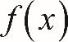 f of x is a real number.

Reference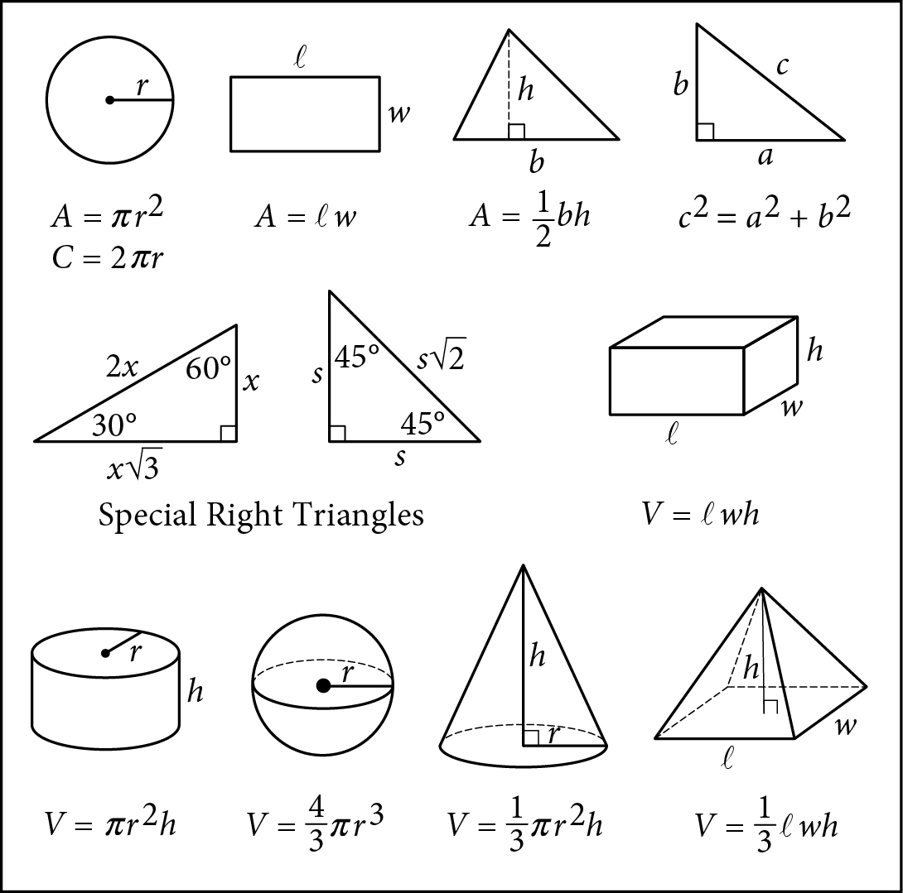

Begin skippable figure descriptions.
The figure presents information for your reference in solving some of the problems.

Reference figure 1 is a circle with radius r. Two equations are presented below reference figure 1.
A equals pi times the square of r.
C equals 2 pi r.

Reference figure 2 is a rectangle with length ℓ and width w. An equation is presented below reference figure 2.
A equals ℓ w.

Reference figure 3 is a triangle with base b and height h. An equation is presented below reference figure 3.
A equals one-half b h.

Reference figure 4 is a right triangle. The two sides that form the right angle are labeled a and b, and the side opposite the right angle is labeled c. An equation is presented below reference figure 4.
c squared equals a squared plus b squared.

Special Right Triangles
Reference figure 5 is a right triangle with a 30-degree angle and a 60-degree angle. The side opposite the 30-degree angle is labeled x. The side opposite the 60-degree angle is labeled x times the square root of 3. The side opposite the right angle is labeled 2 x.

Reference figure 6 is a right triangle with two 45-degree angles. Two sides are each labeled s. The side opposite the right angle is labeled s times the square root of 2.

Reference figure 7 is a rectangular solid whose base has length ℓ and width w and whose height is h. An equation is presented below reference figure 7.
V equals ℓ w h.

Reference figure 8 is a right circular cylinder whose base has radius r and whose height is h. An equation is presented below reference figure 8.
V equals pi times the square of r times h.

Reference figure 9 is a sphere with radius r. An equation is presented below reference figure 9.
V equals four-thirds pi times the cube of r.

Reference figure 10 is a cone whose base has radius r and whose height is h. An equation is presented below reference figure 10.
V equals one-third times pi times the square of r times h.

Reference figure 11 is an asymmetrical pyramid whose base has length ℓ and width w and whose height is h. An equation is presented below reference figure 11.
V equals one-third ℓ w h.

End skippable figure descriptions.

Additional Reference Information
The number of degrees of arc in a circle is 360.
The number of radians of arc in a circle is 2 pi.
The sum of the measures in degrees of the angles of a triangle is 180.

Question 1.
Charissa ordered 3 cans of lemonade for each person at her party. She also ordered 1 pizza for every 4 people. If she ordered 6 pizzas, which of the following could be the number of cans of lemonade she ordered?
A. 36
B. 48
C. 60
D. 72

Question 2.
A bakery sells trays of cookies. Each tray contains at least 50 cookies but no more than 60. Which of the following could be the total number of cookies on 4 trays of cookies?
A. 165
B. 205
C. 245
D. 285

Question 3 refers to the following information.
A survey taken by 1,000 students at a school asked whether they played school sports. The following table summarizes all 1,000 responses from the students surveyed.
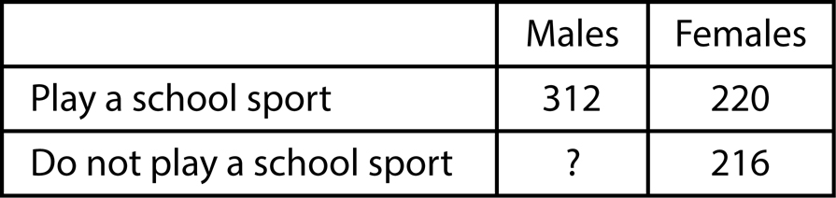

Begin skippable figure description.
The figure presents a 3-column table with 2 rows of data. The first column has no heading. The heading for the second column is “Males,” and the heading for the third column is “Females.” The data are as follows.

Row 1. Play a school sport: Males, 312. Females, 220.
Row 2. Do not play a school sport: Males, question mark. Females, 216.

End skippable figure description.

Question 3.
How many of the males surveyed responded that they do not play a school sport?
A. 109
B. 252
C. 468
D. 688

Question 4.
A waiter receives tips from each customer. On average, the tip is 15% of the customer’s bill. At this rate, which of the following is closest to the tip the waiter can expect when a customer has a bill that is $78.20 ?
A. $8.00
B. $10.00
C. $12.00
D. $14.00

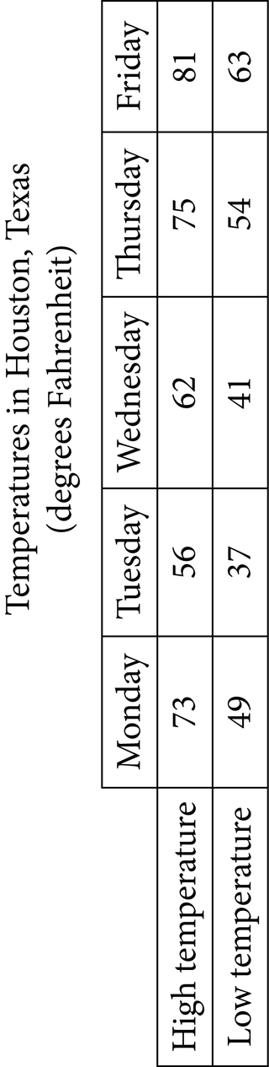
Question 5 refers to the following information.
The following table shows the high and low temperatures in Houston, Texas, during a five-day period.

Begin skippable figure description.
The figure presents a 6-column table, with two rows of data, titled “Temperatures in Houston, Texas,” in degrees Fahrenheit. The first column has no heading. Columns 2 through 6 have the following headings: Monday, Tuesday, Wednesday, Thursday, and Friday. The 2 rows of data are as follows.

Row 1. High temperature, in degrees Fahrenheit, for Monday through Friday, respectively: 73, 56, 62, 75, 81.
Row 2. Low temperature, in degrees Fahrenheit, for Monday through Friday, respectively: 49, 37, 41, 54, 63.

End skippable figure description.

Question 5.
What was the mean low temperature, in degrees Fahrenheit, during the five-day period?
A. 48.8
B. 49
C. 59
D. 59.1

Question 6.
A random sample of 50 people from a town with a population of 14,878 were asked to name their favorite flavor of ice cream. If 7 people in the sample named chocolate as their favorite ice-cream flavor, about how many people in the town would be expected to name chocolate?
A. 350
B. 2,100
C. 7,500
D. 10,500

Question 7 refers to the following information.
A study was done to determine a new car’s stopping distance when it was traveling at different speeds. The study was done on a dry road with good surface conditions. The results are given as follows, along with the graph of a quadratic function that models the data.
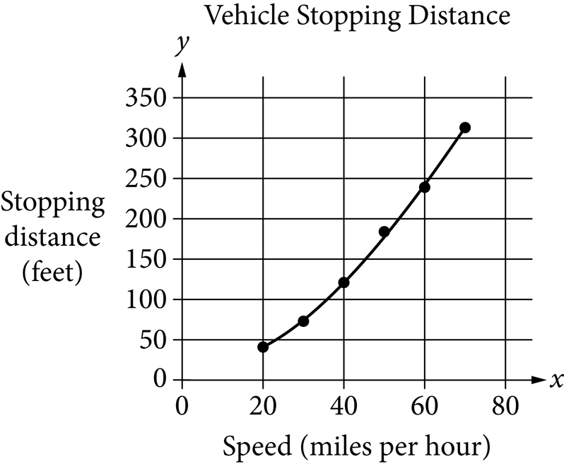

Begin skippable figure description.
The figure presents a graph in the x y-plane titled “Vehicle Stopping Distance.” The x-axis is labeled “Speed, in miles per hour,” and the numbers 0 through 80, in increments of 20, are indicated. The y-axis is labeled “Stopping distance, in feet,” and the numbers 0 through 350, in increments of 50, are indicated. In the graph, there are six data points indicated from left to right with each point strictly to the right of and above the preceding point. From left to right, the approximate coordinates of the six points are as follows.

Point 1: 20 comma 40.
Point 2: 30 comma 75.
Point 3: 40 comma 120.
Point 4: 50 comma 185.
Point 5: 60 comma 240.
Point 6: 70 comma 315.

A quadratic curve is shown on the graph. The curve begins at point 1 and curves upward and to the right, passing through point 2 and point 3. It then passes slightly below point 4 and slightly above point 5, ending at point 6.

End skippable figure description.

Question 7.
According to the model, which of the following is the best estimate for the stopping distance, in feet, if the vehicle was traveling 55 miles per hour?
A. 25
B. 30
C. 210
D. 250

Question 8 refers to the following information.
The following equations show the total amount of water in gallons, y, that has flowed through two different types of showerheads after x minutes of use.
Type A: 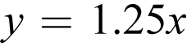 y equals 1.25 x
Type B: 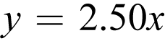 y equals 2.50 x

Question 8.
Based on these equations, which of the following statements is a correct comparison?
A. For each minute of use, the amount of water that flowed through Type B is twice the amount that flowed through Type A.
B. For each minute of use, the amount of water that flowed through Type A is twice the amount that flowed through Type B.
C. The amount of water that flowed through Type A per minute increased at a faster rate than the amount of water that flowed through Type B per minute.
D. The amount of water that flowed through Type B per minute increased at a faster rate than the amount of water that flowed through Type A per minute.

Question 9.
A certain number of cubic yards of concrete will be poured to form a driveway. The concrete will fill a space that is a right rectangular prism that is 18 feet wide, 42 feet long, and 6 inches thick. What are the dimensions of this space (width by length by thickness) in yards? (Note: 1 foot = 12 inches and 1 yard = 3 feet)
A. 6 yards by 14 yards by one sixth yard
B. 6 yards by 14 yards by one half yard
C. 54 yards by 126 yards by 72 yards
D. 54 yards by 126 yards by 216 yards

Question 10 refers to the following information.
The charges for a parking garage are shown in the following table.
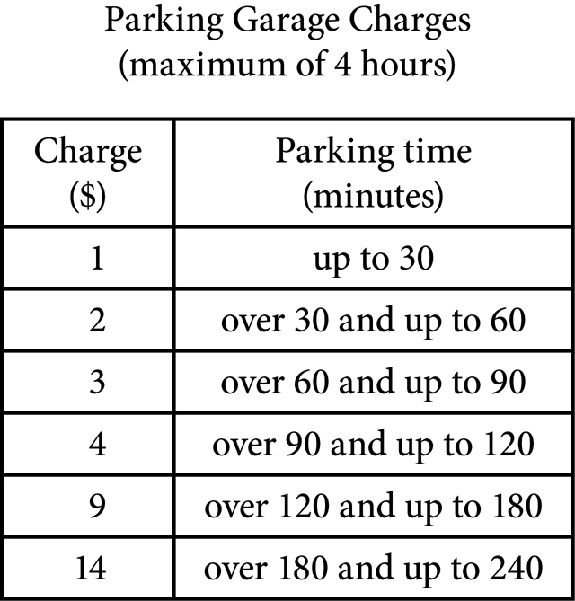

Begin skippable figure description.
The figure presents a 2-column table, with 6 rows of data, titled “Parking Garage Charges, maximum of 4 hours.” The heading of the first column is “Charge, in dollars,” and the heading of the second column is “Parking time, in minutes.” The 6 rows of data are as follows.

Row 1. 1 dollar for a parking time up to 30 minutes.
Row 2. 2 dollars for a parking time of over 30 minutes and up to 60 minutes.
Row 3. 3 dollars for a parking time of over 60 minutes and up to 90 minutes.
Row 4. 4 dollars for a parking time of over 90 minutes and up to 120 minutes.
Row 5. 9 dollars for a parking time of over 120 minutes and up to 180 minutes.
Row 6. 14 dollars for a parking time of over 180 minutes and up to 240 minutes.

End skippable figure description.

Question 10.
Which graph shows the relationship between the parking time, in minutes, and the charge, in dollars?
Each option presents the graph of a step function in the coordinate plane. The horizontal axis is labeled “Parking time, in minutes,” and the numbers 0 through 300, in increments of 60, are indicated. Vertical grid lines, in increments of 20, are also indicated. The vertical axis is labeled “Charge, in dollars,” and the numbers 0 through 15, in increments of 3, are indicated. Horizontal grid lines, in increments of 1, are also indicated. The functions are made up of several horizontal line segments. The starting point for each line segment is indicated by an open circle, and the ending point is indicated by a closed circle.
A. 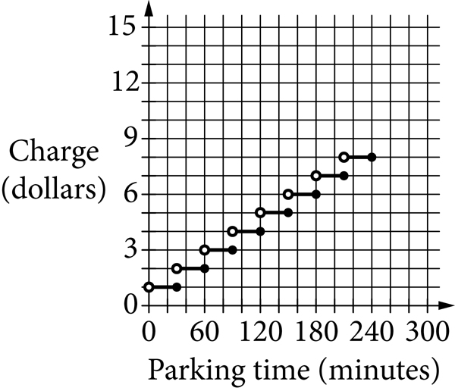

Begin skippable figure description.
Eight horizontal line segments are shown as follows. From left to right, the first line segment starts at 0 comma 1, and ends at 30 comma 1. The second line segment starts at 30 comma 2, and ends at 60 comma 2. The third line segment starts at 60 comma 3, and ends at 90 comma 3. The fourth line segment starts at 90 comma 4, and ends at 120 comma 4. The fifth line segment starts at 120 comma 5, and ends at 150 comma 5. The sixth line segment starts at 150 comma 6, and ends at 180 comma 6. The seventh line segment starts at 180 comma 7, and ends at 210 comma 7. The eighth line segment starts at 210 comma 8, and ends at 240 comma 8.

End skippable figure description.
B. 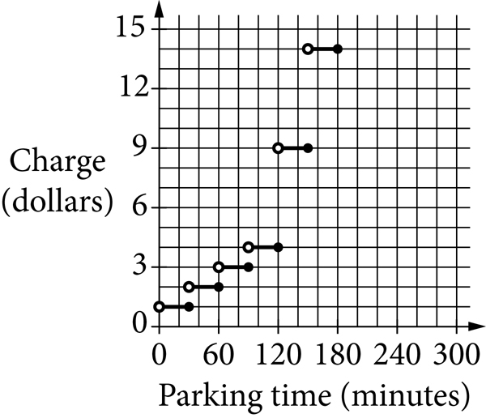

Begin skippable figure description.
Six horizontal line segments are shown as follows. From left to right, the first line segment starts at 0 comma 1, and ends at 30 comma 1. The second line segment starts at 30 comma 2, and ends at 60 comma 2. The third line segment starts at 60 comma 3, and ends at 90 comma 3. The fourth line segment starts at 90 comma 4, and ends at 120 comma 4. The fifth line segment starts at 120 comma 9, and ends at 150 comma 9. The sixth line segment starts at 150 comma 14, and ends at 180 comma 14.

End skippable figure description.
C. 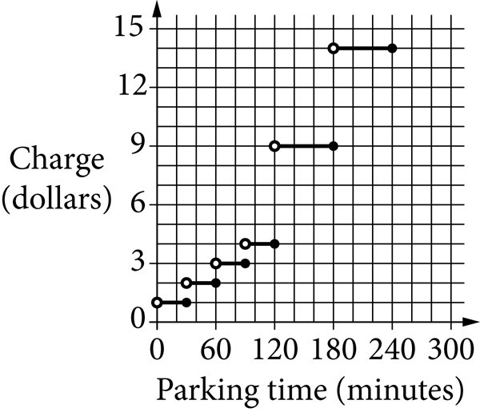

Begin skippable figure description.
Six horizontal line segments are shown as follows. From left to right, the first line segment starts at 0 comma 1, and ends at 30 comma 1. The second line segment starts at 30 comma 2, and ends at 60 comma 2. The third line segment starts at 60 comma 3, and ends at 90 comma 3. The fourth line segment starts at 90 comma 4, and ends at 120 comma 4. The fifth line segment starts at 120 comma 9, and ends at 180 comma 9. The sixth line segment starts at 180 comma 14, and ends at 240 comma 14.

End skippable figure description.
D. 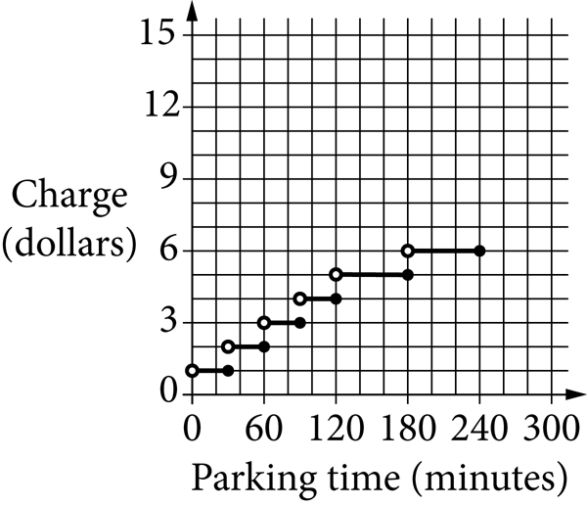

Begin skippable figure description.
Six horizontal line segments are shown as follows. From left to right, the first line segment starts at 0 comma 1, and ends at 30 comma 1. The second line segment starts at 30 comma 2, and ends at 60 comma 2. The third line segment starts at 60 comma 3, and ends at 90 comma 3. The fourth line segment starts at 90 comma 4, and ends at 120 comma 4. The fifth line segment starts at 120 comma 5, and ends at 180 comma 5. The sixth line segment starts at 180 comma 6, and ends at 240 comma 6.

End skippable figure description.

Question 11.
A sterling silver platter is made up of a mixture of silver and copper. The ratio of silver to copper is 37 to 3 by mass. If the platter has a mass of 600 grams, what is the mass, in grams, of the copper in the platter?
A. 18
B. 45
C. 222
D. 555

Questions 12 through 14 refer to the following information.
Rocco is saving money to buy his first car. He works 15 hours each week and saves $10 for each hour he works. Rocco has already saved $3,500 and plans to save at least $5,300. He knows there will be an 8.5% sales tax on the purchase price of the car and a title transfer fee of $15. He will use the following formula to determine his gas mileage, y, in miles per gallon, from the number of miles, m, the car can be driven using g gallons of gas.
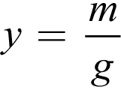 y equals the fraction m over g

Question 12.
Rocco will need to pay a total of $5,246.87 for the car, including the sales tax and transfer fee. To the nearest dollar, what is the purchase price of the car Rocco plans to buy?
A. $4,787
B. $4,822
C. $5,223
D. $5,708

Question 13.
Which formula can Rocco use to determine the number of miles he can expect to drive using a certain number of gallons of gas?
A. 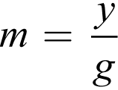 m equals the fraction y over g
B. 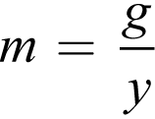 m equals the fraction g over y
C. 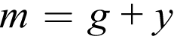 m equals g plus y
D. m equals g y

Question 14.
Which inequality can Rocco use to model the number of weeks remaining, x, that he will need to work before he has saved at least $5,300 ?
A. 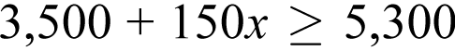 3,500 plus 150 x, is greater than or equal to 5,300
B. 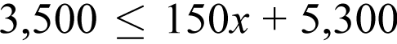 3,500 is less than or equal to 150 x plus 5,300
C. 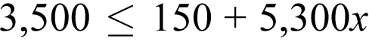 3,500 is less than or equal to 150 plus 5,300 x
D. 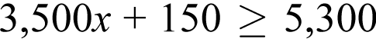 3,500 x plus 150, is greater than or equal to 5,300

Question 15.
The following table shows the lengths in centimeters (c m) of a sample of 5 leaves from a tree.
Leaf | Length (centimeters)
1 | 14.2
2 | 13.8
3 | 12.6
4 | 13.4
5 | 11.5
6 | question mark

A 6th leaf is added to the sample and its length is measured. Its measure increases the mean value of the sample of leaves but decreases the median value of the sample of leaves. What is a possible measurement for the length of the 6th leaf?
A. 13.1 centimeters
B. 13.3 centimeters
C. 13.4 centimeters
D. 13.7 centimeters

Question 16 refers to the following information.
A theater is showing one movie today. A media research company randomly selected people coming out of the theater to rate, on a 5-star scale, the movie they just saw. The results of the survey are shown in the following table.
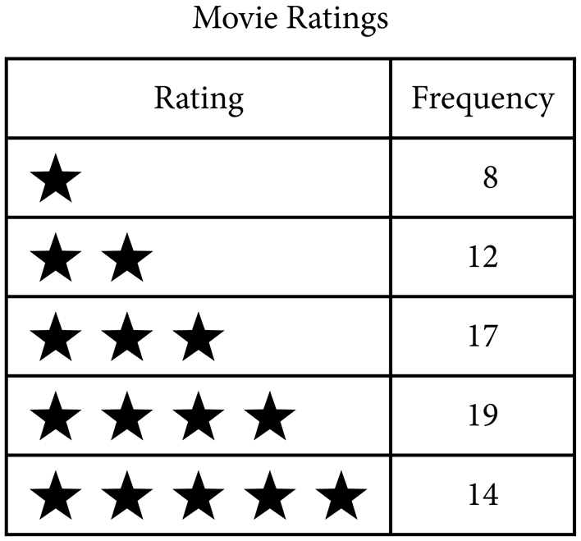

Begin skippable figure description.
The figure presents a 2-column table, with 5 rows of data, titled “Movie Ratings.” The heading for the first column is “Rating,” and the heading for the second column is “Frequency.” The 5 rows of data are as follows.

Row 1. 1 star; 8.
Row 2. 2 stars; 12.
Row 3. 3 stars; 17.
Row 4. 4 stars; 19.
Row 5. 5 stars; 14.

End skippable figure description.

Question 16.
A total of 325 people saw the movie in that theater. Based on the survey results, about how many of the people who saw the movie would have rated it with 3 or more stars?
A. 50
B. 80
C. 230
D. 305

Questions 17 and 18 refer to the following information.
Experts say vitamin C is a nutrient that provides many health benefits. The amount of vitamin C, in milligrams (m g), found in 100 grams (g) of each of several fruits is shown in the following table.
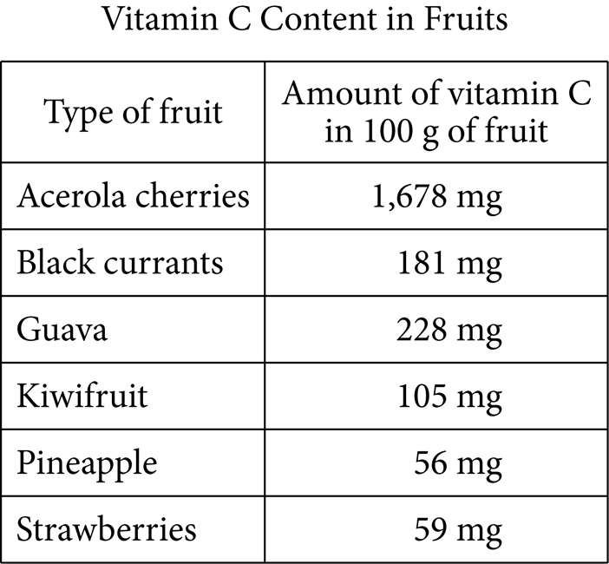

Begin skippable figure description.
The figure presents a 2-column table, with 6 rows of data, titled “Vitamin C Content in Fruits.” The heading of the first column is “Type of fruit,” and the heading for the second column is “Amount of vitamin C in 100 grams of fruit.” The 6 rows of data are as follows.

Row 1. Acerola cherries, 1,678 milligrams.
Row 2. Black currants, 181 milligrams.
Row 3. Guava, 228 milligrams.
Row 4. Kiwifruit, 105 milligrams.
Row 5. Pineapple, 56 milligrams.
Row 6. Strawberries, 59 milligrams.

End skippable figure description.

Question 17.
Which quantity of fruit contains an amount of vitamin C closest to the combined amount of vitamin C in 50 grams of acerola cherries and 150 grams of kiwifruit?
A. 2,000 grams of black currants
B. 800 grams of guava
C. 1,800 grams of pineapple
D. 600 grams of strawberries

Question 18.
A fruit salad was prepared containing 100 grams of acerola cherries, 100 grams of kiwifruit, 300 grams of pineapple, and 200 grams of strawberries. What is the total amount of vitamin C, in grams, that is contained in the listed fruits?
A. 0.7 gram
B. 2.069 grams
C. 700 grams
D. 2,069 grams

Question 19.
A quality-control specialist for an electronics manufacturer estimates that 0.25% of the televisions produced each day by her company are defective. If the manufacturer produces an average of 450 televisions each day, which of the following is the best estimate of the total number of defective televisions produced in 30 working days?
A. 1
B. 34
C. 113
D. 3,375

Question 20 refers to the following figure.
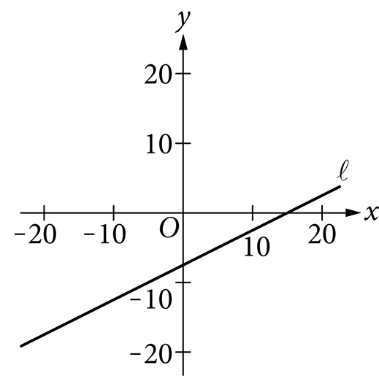

Begin skippable figure description.
The figure presents line l in the x y-plane with the origin labeled O. The numbers negative 20 through 20, in increments of 10, are indicated on the x- and y-axes. Line l is slanted upward and to the right. It begins in quadrant three, crosses the y-axis between 0 and negative 10, then crosses the x-axis between 10 and 20 and extends to quadrant one.

End skippable figure description.

Question 20.
Line l is shown on the preceding x y-plane. If the corresponding equation for line l is 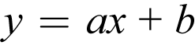 y equals a x plus b, where a and b are constants, which set of inequalities is true about a and b ?
A. 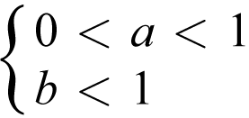 open brace, 0 is less than, a, which is less than 1, and, b is less than 1
B. 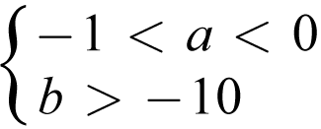 open brace, negative 1 is less than, a, which is less than 0, and, b is greater than negative 10
C. 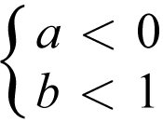 open brace, a, is less than 0, and, b is less than 1
D. 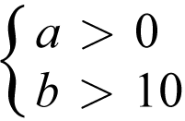 open brace, a, is greater than 0, and, b is greater than 10

Question 21.
Mr. LePage spent $25,000 to buy a new truck for his construction business. He estimated the value of the truck after each of the next 5 years, as shown in the following table.
Truck Value after Each Year of Ownership
Year (x) | Truck Value (y)
1 | $22,000
2 | $19,000
3 | $16,000
4 | $13,000
5 | $10,000

If the line passing through the points defined by the values in the table is graphed in the x y-plane, which of the following is the best interpretation of the y-intercept in the context of the problem?
A. The number of years for which the value of the truck will decrease
B. The amount that the value of the truck is decreasing each year
C. The value of the truck after the sixth year of ownership
D. The value of the truck when it was new

Directions
For questions 22 through 25, solve the problem and record your answer in the spaces provided on the answer sheet, as described in the following directions and examples.

1. Although not required, it is suggested that your answer be recorded in the boxes at the top of the columns to help fill in the circles accurately. You will receive credit only if the circles are filled in correctly.
2. Mark no more than one circle in any column.
3. No question has a negative answer.
4. Some problems may have more than one correct answer. In such cases, indicate only one answer.
5. Mixed numbers such as 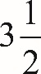 three and one half must be recorded as 3.5 or seven slash two. (If 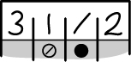 three, one, slash, two, is recorded in the spaces provided on the answer sheet, it will be interpreted as 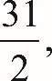 thirty one halves, not 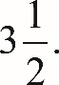 three and one half.)
6. Decimal answers: If you obtain a decimal answer with more digits than the spaces on the answer sheet can accommodate, it may be either rounded or truncated, but it must fill all four spaces.

The following are four examples of how to record your answer in the spaces provided. Keep in mind that there are four spaces provided to record each answer.

Examples 1 and 2
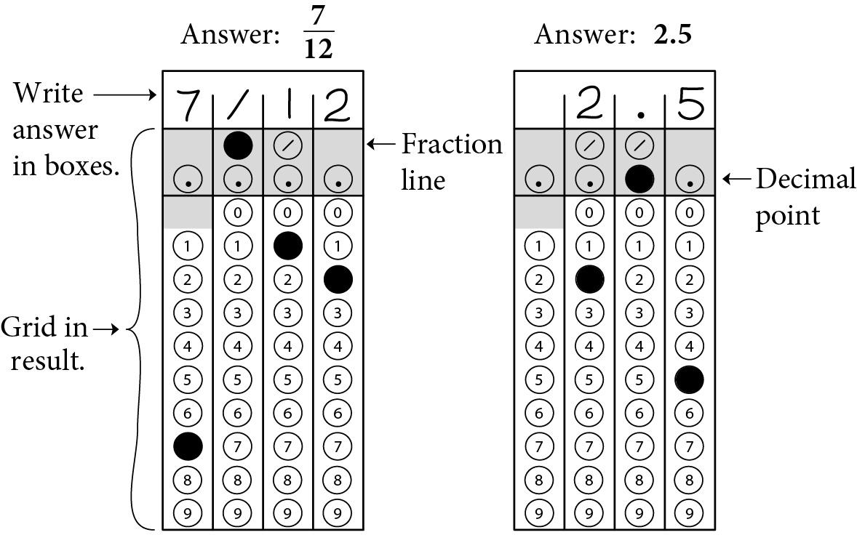

Begin skippable figure description.
Example 1: If your answer is a fraction such as seven-twelfths, it should be recorded as follows. Enter 7 in the first space, the fraction bar (a slash) in the second space, 1 in the third space, and 2 in the fourth space. All four spaces would be used in this example.

Example 2: If your answer is a decimal value such as 2.5, it could be recorded as follows. Enter 2 in the second space, the decimal point in the third space, and 5 in the fourth space. Only three spaces would be used in this example.

End skippable figure description.

Example 3
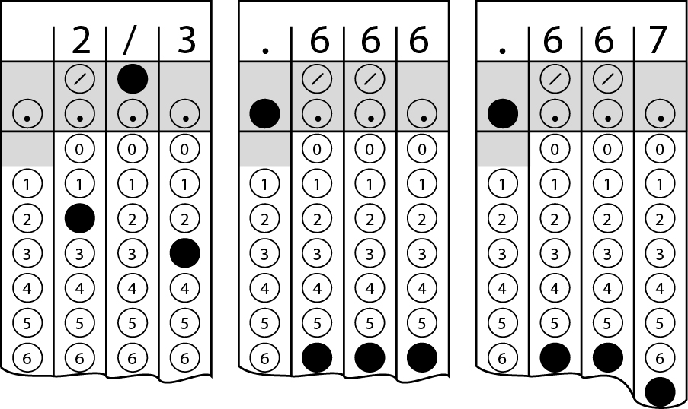

Begin skippable figure description.
Example 3: Acceptable ways to record two-thirds are: 2 slash 3, .666, and .667.

End skippable figure description.

Example 4
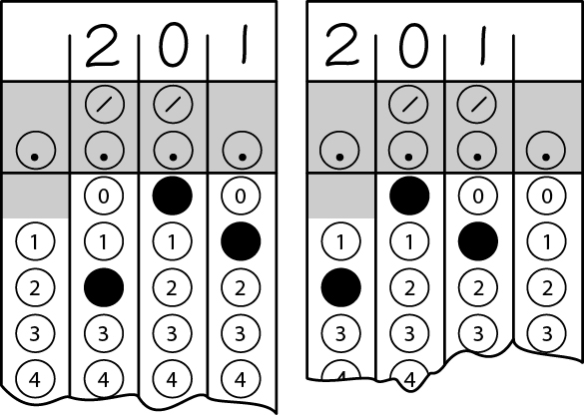
Note: You may start your answers in any column, space permitting. Columns you don’t need to use should be left blank.

Begin skippable figure description.
Example 4: It is not necessary to begin recording answers in the first space unless all four spaces are needed. For example, if your answer is 201, you may record 2 in the second space, 0 in the third space, and 1 in the fourth space. Alternatively, you may record 2 in the first space, 0 in the second space, and 1 in the third space. Spaces not needed should be left blank.

End skippable figure description.

Question 22.
The solution to the following system of equations is 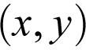 the ordered pair x comma y.
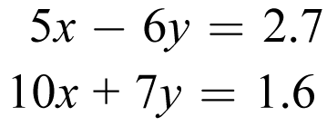
5 x minus 6 y equals 2.7, and
10 x plus 7 y equals 1.6
What is the value of x ?

Question 23.
A dinner was held to raise money for a children’s museum. A ticket for one person cost $200 and a ticket for a couple (two people) cost $350. A total of 130 people attended the dinner, and the ticket sales total was $24,000. What is the total number of tickets that were sold?

Questions 24 and 25 refer to the following information.
The United States Senate first convened in the year 1789. From 1789 through 2013, a total of 44 women served as U S senators. The following partially completed table shows the number of women senators by political party and geographical region.
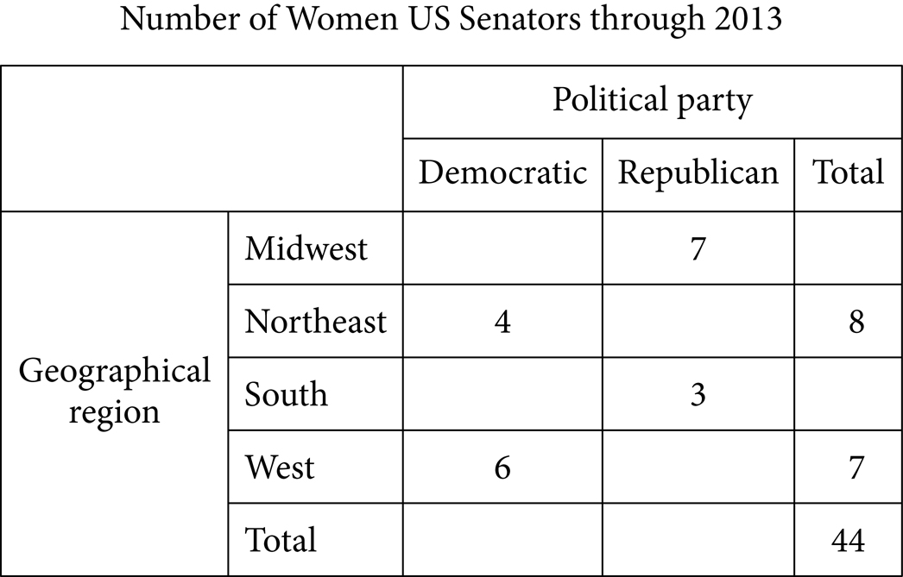

Begin skippable figure description.
The figure presents a 5-column table, with 5 rows of data, titled “Number of Women U S Senators through 2013.” There is no heading for columns 1 and 2. The heading for columns 3 through 5 is “Political party.” Columns 3 through 5 also have the following subheadings: “Democratic,” “Republican,” and “Total.” Column 1 contains the row heading “Geographical region,” which pertains to rows 1 through 5. The 5 rows of data in the table are as follows. Note that some cells have been left blank.

Row 1. Midwest: Democratic, blank; Republican, 7; Total, blank.
Row 2. Northeast: Democratic, 4; Republican, blank; Total, 8.
Row 3. South: Democratic, blank; Republican, 3; Total, blank.
Row 4. West: Democratic, 6; Republican, blank; Total, 7.
Row 5. Total: Democratic, blank; Republican, blank; Total, 44.

End skippable figure description.

Question 24.
What is the total number of women from the Democratic Party who served as U S senators from 1789 through 2013 ?

Question 25.
From 1789 through 2013, of the women from only the Democratic Party who served as U S senators, 34.5% have been from the South region. What is the total number of Democratic and Republican women U S senators who represented the Midwest in this time period?

Stop.
If you finish before time is called, you may check your work on this section only. You may not work on any other section.

