NGPF Case Study
Budgeting

Budget or Bust?

“What am I going to do?”

Carrie frantically called her best friend, Bethany.

“My landlord just called to let me know my rent is going to increase $300.00 in the next two months! He said something about an increase in HOA fees and taxes, so he has to increase the rent. What am I going to do? I love this apartment!! It is close to work, close to my boyfriend, and has so many great amenities. With my student loans and other bills, I can’t afford to continue living here!”

“Try to relax, Carrie” Bethany reassured her friend. “I’m in my car now. I’ll drive over and we can take a look at your budget to see where you can come up with the extra money.”

“Budget?” Carrie responded. “I...I...don’t have a budget.” Carrie was a little embarrassed to admit that although she lived on her own and recently graduated from college, she knew nothing about managing money. She has a good job and tries to save money each month, but at times ignores her finances because she gets easily frustrated and overwhelmed with them.

“I’ll help you.” Bethany said. “I’ll be there soon. Start getting your financial documents together.”

Bethany arrived within 30 minutes and was ready to help Carrie get started on creating her budget.

“In order to figure out if you can afford this increase in rent, you have to create a budget.” Bethany instructed.

“But why?” Carrie questioned. “Can’t we just look at my bank account? I’m so frustrated already Bethany. I’m not sure I can do this.”

Answer This:

1. What response should Bethany give to Carrie’s last question? Why create a budget?

2. What documents and information will Bethany need to see in order to help Carrie create a personal budget?

Carrie recently graduated from college and has a full-time job working at a hospital close to her current apartment. She has had this job for one year and really enjoys it. She really wants to continue living in her current apartment because of its proximity to work, her boyfriend’s apartment, and all of the amenities it offers. Carrie’s parents live out of state and visit her multiple times during the year. She loves that she has a 2-bedroom apartment, so her parents (and other family members) can stay with her when they visit.

Bethany knows Carrie loves her current apartment and is certain that creating a budget will be very helpful to Carrie. The first step in creating a personal budget is to calculate income. Carrie is on salary and is paid bi-weekly, so her paychecks are the same each pay period. She logs online and pulls up her most recent pay stub for Bethany to view.

Exhibit 1: Carrie’s Paystub
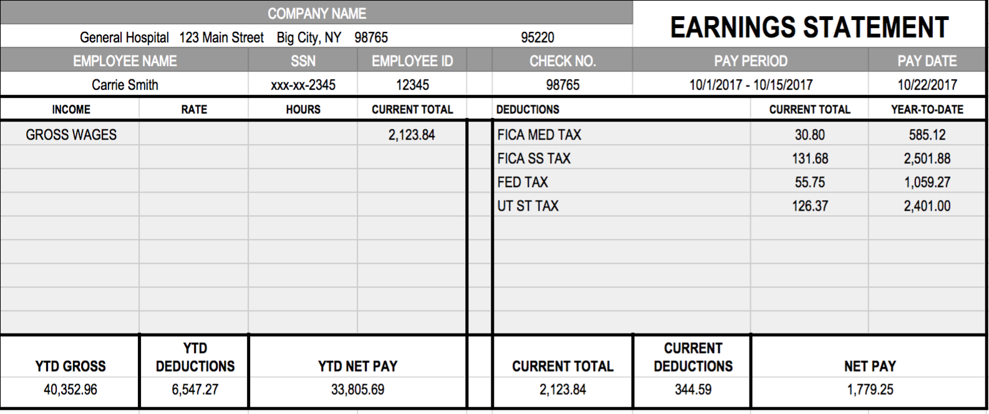

Answer This:

3. What information from Carrie’s paystub is important to know and use when creating Carrie’s budget?

Bethany explains that a budget is the foundation of personal finance. If Carrie wants to make better financial decisions, save more money, and continue to afford her apartment, she has to create and stick to a budget. Bethany is really good with money, lives by a strict budget, and was able to pay off her student loans in only four years! Bethany then explains that the next step in creating an effective budget is to track expenses. Carrie typically does this by saving all of her receipts and reviewing her bank statement for debit card transactions. She wonders if there is an app that would better help her track her expenses on a monthly basis. Bethany uses an app called Mint, but Carrie is not convinced it is the best one for her.

Exhibit 2: Screenshot of Bethany’s Mint Account
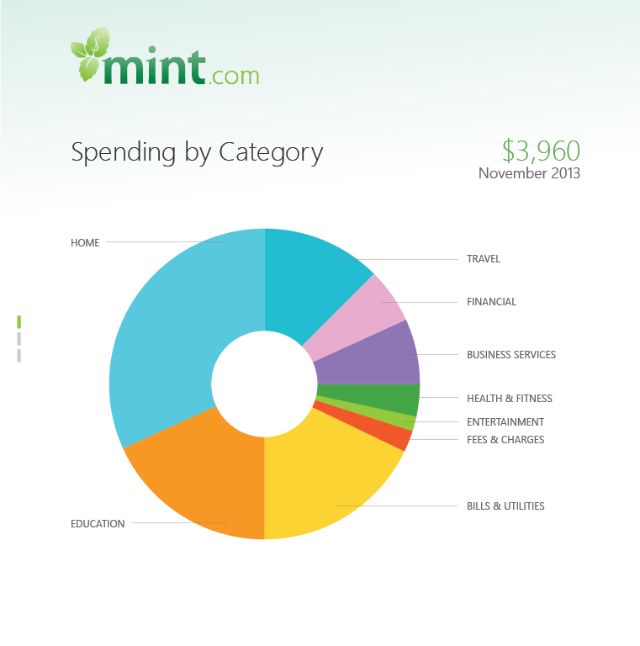

Answer This:

4. Based on Bethany’s screenshot, what you do see as some of the benefits of this resource?

5. What do you think are advantages of using an any app to track monthly expenses? What do you think are the disadvantages?

6. Conduct a quick online search for budgeting apps. Create a list of 5 apps/resources that you found. Choose ONE from your list to research further. List details (and fees) of this app.

7. What questions should Carrie find answers to before choosing to use any financial app?

Carrie uses her debit card for most purchases, so she can somewhat easily track her monthly spending by looking at her bank account transactions. Carrie prints her last bank statement, credit card statement, and pulls out her most recent receipts to give to Bethany. Bethany explains to Carrie that in order to create a budget and see where Carrie can find the extra money for her rent, they have to see where Carrie spends her money each month.

Carrie loves to shop, so her clothing expenses are a bit high. She charges an average of $300.00 per month on a credit card to her favorite store - Clothes, Clothes, Clothes. Her minimum monthly payment on this account is approximately $20.00 (she must pay at least this amount each month, but strives to always pay it off in full).

Exhibit 3: Carrie’s Bank Statement & Store Credit Card Statement
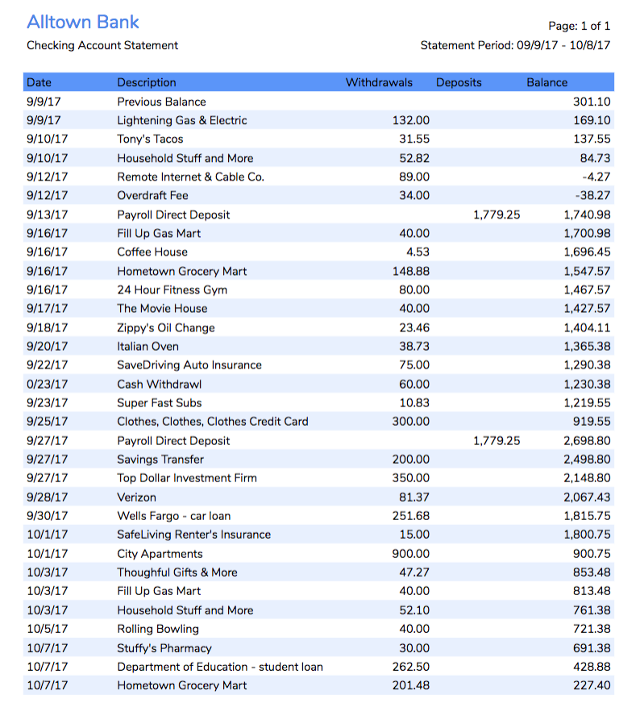
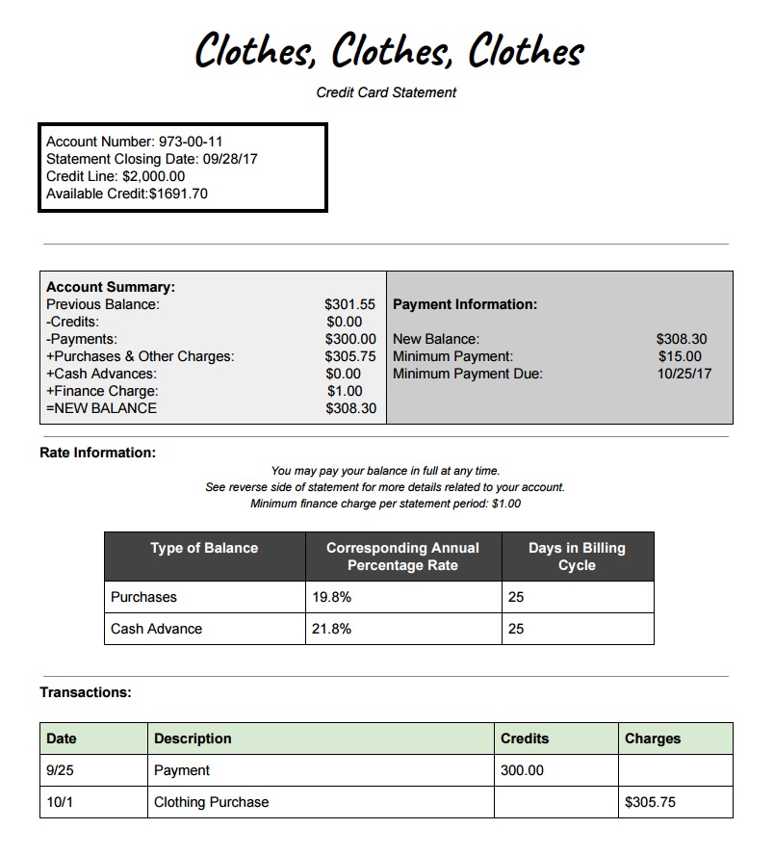

Answer This:
8. Analyze Carrie’s bank statement and credit card statement. How would you describe Carrie’s spending habits?

9. Do you think Carrie is frivolously in spending on clothing by charging an average of $300.00 to her store credit card? Or, is that a reasonable clothing budget? Explain your opinion.

10. Create a list of Carrie’s fixed and flexible expenses.

Fixed | Flexible

11. Carrie questions whether she should be paying her credit card in full each month. That $300.00 payment would help cover her rent increase. She questions whether she should start making minimum payments on her credit card and use the remaining money toward her rent. If you were Bethany, how would you respond? What advice would you give Carrie?

12. Carrie and Bethany have a mutual friend, Allie, who is moving back to the area for a job. Carrie mentions the idea of taking on a roommate to help save money and compensate the rent increase. Bethany explains that this will help with the cost, but there are several factors to consider before taking on a roommate. To help make a decision, Allie recently sent her this article on the pros and cons of having a roommate. Help Carrie generate a list of positive and negative reasons for having a roommate.

Before Carrie can make a decision on whether to take on a roommate, or where she can get the extra money for her rent, she has to create a monthly budget. Bethany and Carrie work hard at going over Carrie’s fixed and flexible expenses and generate the budget below.

Exhibit 4: Carrie’s Budget
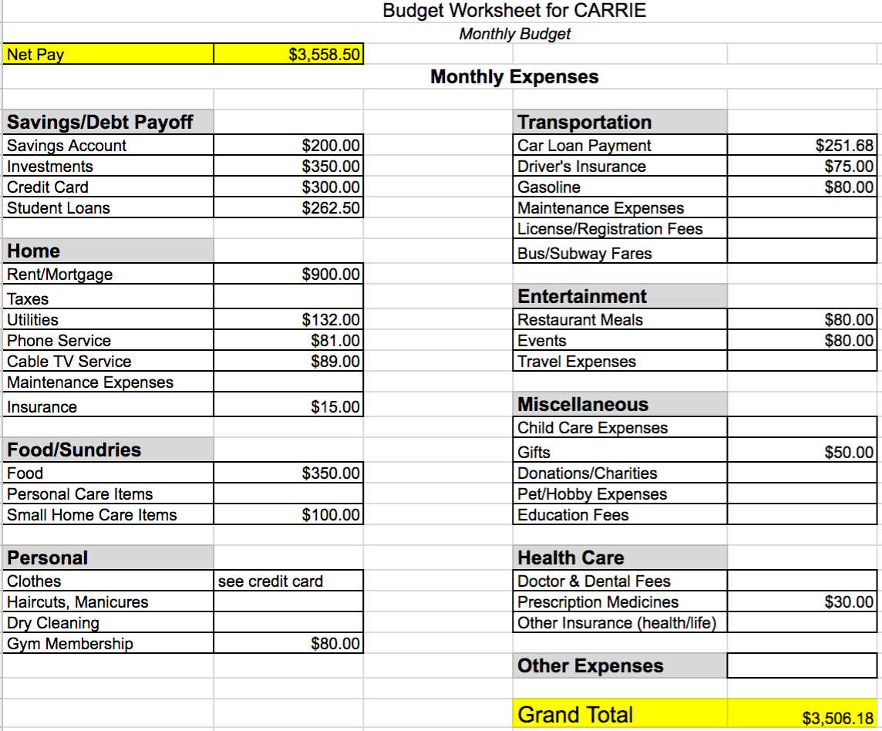

Answer This:
13. If Carrie decides to continue living on her own, how can she alter her monthly budget to pay for the $300.00 rent increase? Give specific suggestions.

14. If Carrie decides to have her friend, Allie, move in as her roommate, how would this alter her current budget? Approximately how much money would that save Carrie per month?

15. Are there any other solutions Carrie and Bethany did not think of?

16. What do you think Bethany should tell Carrie to do in order to best handle the rent increase and stay in her apartment? Explain your answer.

